

DATA STRUCUTRES AND ALGORITHMS
23CSE203
LAB MANUAL

Submitted by

Name | MUTTABATHULA HANSINI SARORA
Roll No | AV.SC.U4CSE25041
Year/Sem/Section | 2nd year/Sem-3/CSE-A
Credits | 05

Submitted to

Name | Dr. RAJ KUMAR BATCHU
Department | School of Computing
Designation | Asst. Professor (SI Grade)

S.NO | TITLE | PAGE NO | REMARKS
1. | WEEK 1: 1a. Recursive countdown from n to Launch.  1b. Recursive calculation of compound growth factor.  1c. Recursive search for employee ID in list.  1d. Recursive factorial calculation for parcel arrangements.  1e. Recursive Fibonacci series generation. | 4 - 12
2. | WEEK 2: 2a. Write a python program to perform linear search on the give input.  2b. Write a python program to perform binary search on the given. Verify by taking sorted array as an input.  2c. Write a python program to perform binary search on the given. Verify by taking unsorted array as an input. | 13 – 19
3. | WEEK 3: 3a. Write a program to perform Bubble Sort technique on the user given input.  3b. Write a program to perform Insertion Sort technique on the user given input.  3c. Write a program to perform Selection Sort technique on the user given input.  3d. Write a program to perform Merge Sort technique on the user given input.  3e. Write a program to perform Quick Sort technique on the user given input. | 20- 31
4. | WEEK 4: 4a. Write a python program to implement a single linked list which would perform the below operations, by taking an input from the user.  a. Create a linked list. | 32 - 40
4. | b. Insert at beginning. c. Insert at end.  d. Insert at a specific index.  e. Delete by value. f. Delete 1st node.  g. Delete last node. h. Count no. of nodes i. Display. j. Exit.  4b. Write a python program to implement a double linked list which would perform the below operations, by taking an input from the user.  4c. Write a python program to implement a circular linked list which would perform the below operations, by taking an input from the user. Also add these two options accordingly.  - Display head and tail.  - Print data from tail to head. | 40 - 61
5. | WEEK 5: Write a python program to implement a stack using an Array, Linked list. Implement the stack operations such as push, pop, peak and also display the stack elements. | 62 - 69
6. | WEEK 6: To implement Queue and its operations such as Enqueue, Dequeue, Peek, Display with a menu driven approach.  6a. Using Array, Linked list, Data structures.  6b. Circular Queue. | 70 - 80
7. | WEEK 7: Write a python program to implement binary tree  7a. Using Array, and  7b. Linked List  With all of its operation. | 81 - 92
8. | WEEK 8: Write a python program to implement Binary Search tree with its operation. | 93 - 98

WEEK – 1
1a. AIM: A rocket launch system displays a countdown before launch. Instead of using a loop, implement the countdown using recursive. Write a recursive python program to display a countdown from n to 1, followed by “Launch”.
PROGRAM:
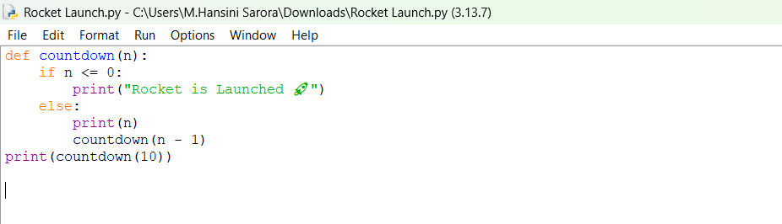

OUTPUT:
Positive Case;
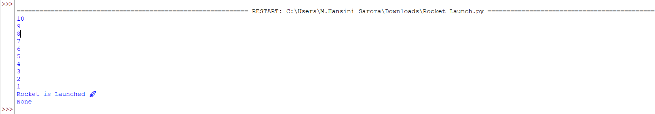
Negative Case;

EXPLANATION:
Condition 1: Positive Input (n > 0)
- The function checks if n <= 0. Since n is positive, this condition is False.
- It executes the else block:
  - Prints the current value of n.
  - Calls itself recursively with n - 1.
- This repeats until n becomes 0.
- Finally, when n = 0, the condition n <= 0 becomes True.
- After the recursive calls finish, the function returns None (since no return is defined).
- The calling print (countdown (10)) will display the countdown, the launch message, and then None.
Condition 2: Negative Input (n <= 0)
- The condition if n <= 0 is immediately True.
- It directly prints:
Rocket is Launched 🚀
- No recursion happens because the else block is skipped.
- The function ends and returns None.
- The calling print (countdown (-1)) will display:
Rocket is Launched 🚀
None
ERROR TABLE:

S.NO | Error Obtained | Rectification
1. | Syntax Error  Forgot to give “:” in the control statement. | Later it was rectified by giving the “:”
2. | Type Error  I have entered a non – integer. | It was rectified by passing only the integers.

1b. AIM: Banks calculate the growth of an investment using compound interest. The formula requires calculating powers, which can be implemented recursively. Write a recursive program to calculate P^{n}(power), Where p = principal growth factor, n = number of years.
PROGRAM:
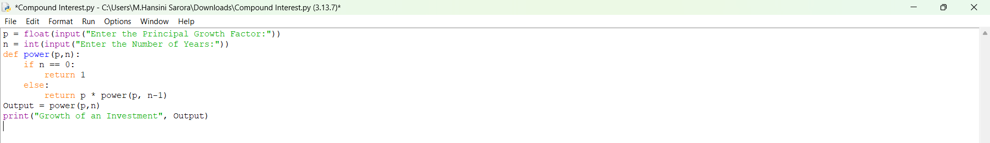

OUTPUT:
Positive Case;
Negative Case; 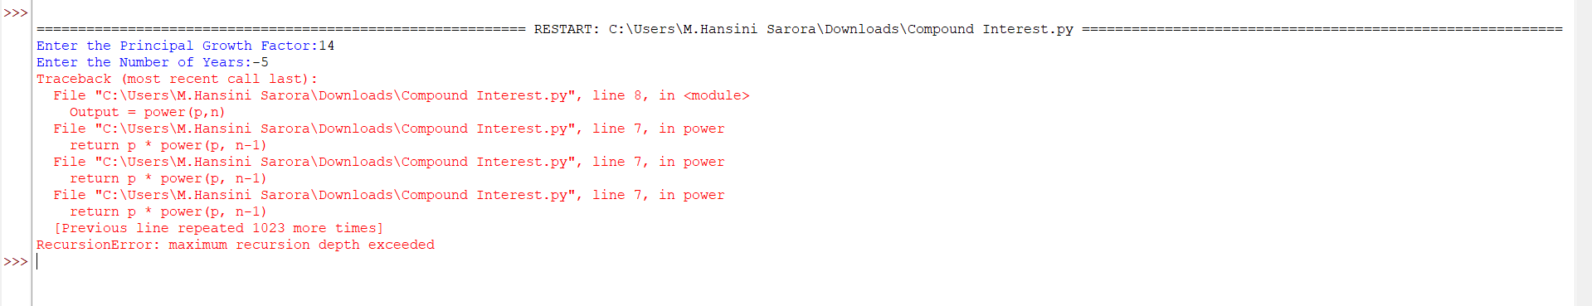

EXPLANATION:
Condition 1: Positive Input (n ≥ 0)
- User enters a positive number of years (e.g., n = 3).
- The function checks if n == 0. Since n is positive, this is False.
- It executes the else block:
  - Multiplies p by the result of power (p, n-1).
- Recursion continues until n becomes 0.
- At n = 0, the base case returns 1.
- The recursive calls unwind, multiplying p repeatedly.
- The output is $p^{n}$, i.e., the growth factor raised to the number of years.
Condition 2: Negative Input (n < 0)
- User enters a negative number of years (e.g., n = -2).
- The function checks if n == 0. Since n is negative, this is False.
- It executes the else block:
  - Calls power (p, n-1) with an even smaller negative number.
- Recursion continues indefinitely (-2 → -3 → -4 → …).
- The base case (n == 0) is never reached.
- Python raises a “Recursion Error: maximum recursion depth exceeded.”
ERROR TABLE:

S.NO | Error Obtained | Rectification
1. | Floating-Point  I have entered a floating-point value in the years. | Later it was rectified by giving the integer value.
2. | Large Input Error  I have given a huge input value. | It was rectified by passing default limit of Python.

1c. AIM: An HR department stores employee IDs in a list. Develop a recursive program to search for a given employee ID. Write a recursive function to search for an employee ID in a list.

PROGRAM:
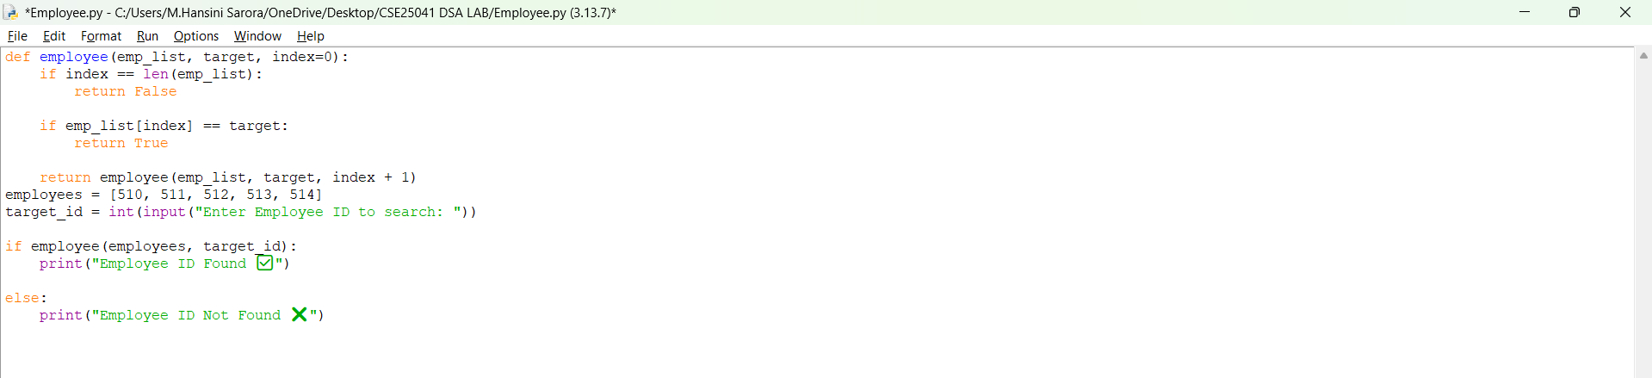

OUTPUT:
Positive Case;
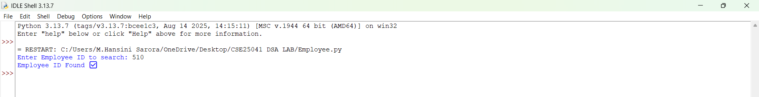
Negative Case; 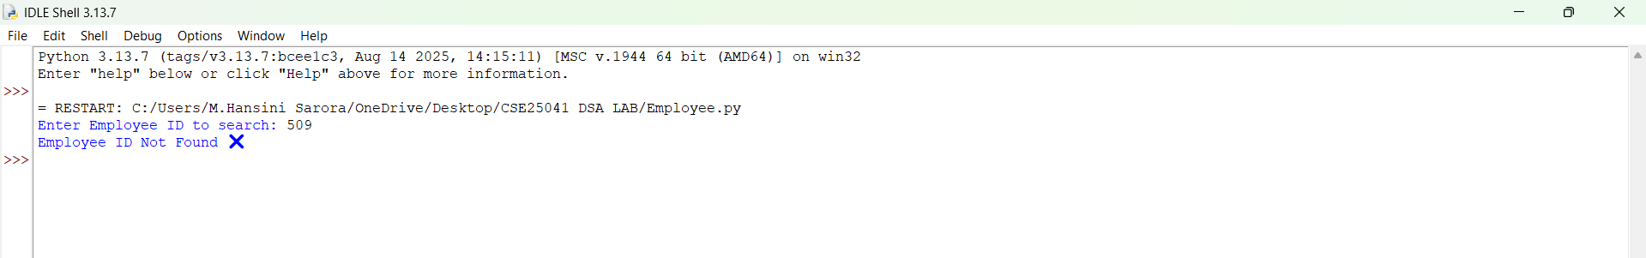

EXPLANATION:
Condition 1: Employee ID Found
- The function starts at index 0.
- It compares emp_list[index] with the target.
- If a match is found, the function immediately returns True.
- The recursion stops early — no need to check further elements.
- The main program prints:
Employee ID Found ✅
Condition 2: Employee ID Not Found
- The function checks each element recursively.
- If the end of the list is reached (index == len(emp_list)), the base case returns False.
- The recursion unwinds, propagating False back to the main program.
- The main program prints:
Employee ID Not Found ❌
ERROR TABLE:

S.NO | Error Obtained | Rectification
1. | Empty List  I haven’t entered the values in the list. | The empty list was filled with the emp IDs.
2. | Logical Error  I have entered the duplicate values. | It was rectified by removing the duplicates.

1d. AIM: In a logistics company, the number of possible ways to arrange n different parcels is calculated using the factorial formula (n!). Develop a recursive program to calculate the factorial of a given number.
PROGRAM:

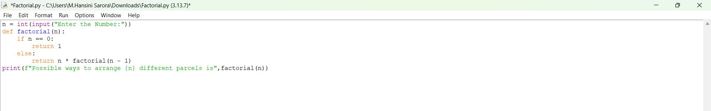

OUTPUT:
Positive Case;
Negative Case; 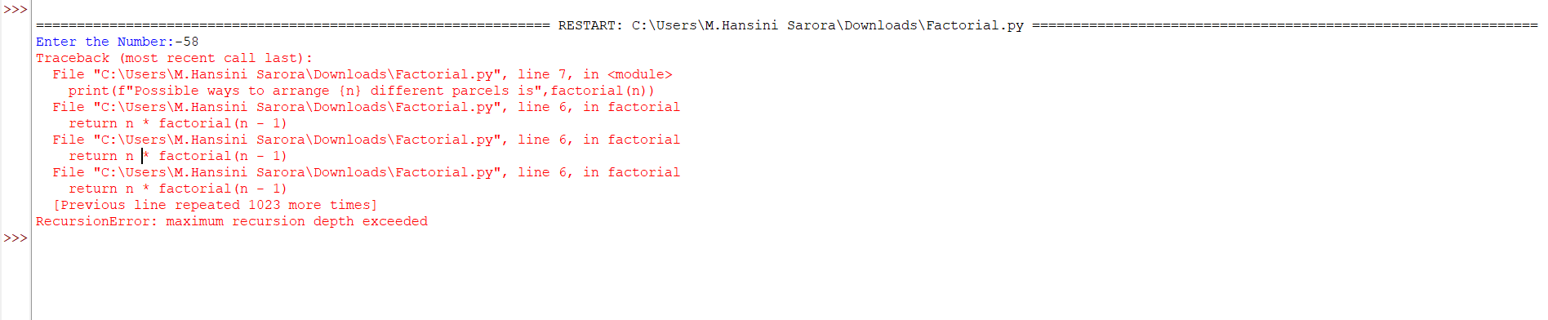

EXPLANATION:
Condition 1: When n == 0
- The function checks:
if n == 0:
return 1
- By definition, $0!=1$.
- So if the user enters 0, the program outputs:
Possible ways to arrange 0 different parcels is 1
Condition 2: When n > 0
- The function executes:
else:
return n * factorial(n - 1)
- This means the function calls itself with a smaller number until it eventually reaches n == 0.
- Uses recursion to multiply numbers down to 1.

ERROR TABLE:

S.NO | Error Obtained | Rectification
1. | Negative Input  I haven’t entered the negative value. | Later, It was rectified by entering positive values.
2. | Large Input Error  I have entered a very large number. | It was rectified by entering limited values.

1e. AIM: Write a recursive python program to print the first n yerms of the Fibonacci Series.
PROGRAM:
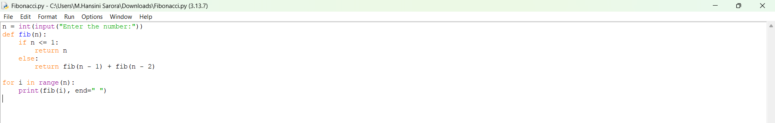

OUTPUT:
Positive Case;
Negative Case;

EXPLANATION:
Condition 1: When n <= 1

- Inside the function:
if n <= 1:
return n
- This is the base case of recursion.
- If n = 0, it returns 0.
- If n = 1, it returns 1.
- These are the starting points of the Fibonacci sequence..
Condition 2: When n > 1
- The function executes:
python
else:
return fib(n - 1) + fib(n - 2)
- This means the Fibonacci number at position n is the sum of the two previous numbers.
- The recursion keeps breaking down until it reaches the base case (n <= 1).
ERROR TABLE:

S.NO | Error Obtained | Rectification
1. | Negative Input  I haven’t entered the negative value. | Later, it was rectified by entering positive values.
2. | Very large input  Recursion depth exceeded. | It was rectified by entering limited values.

WEEK – 2
2a. AIM: Write a python program to perform linear search on the give input.
PROGRAM:
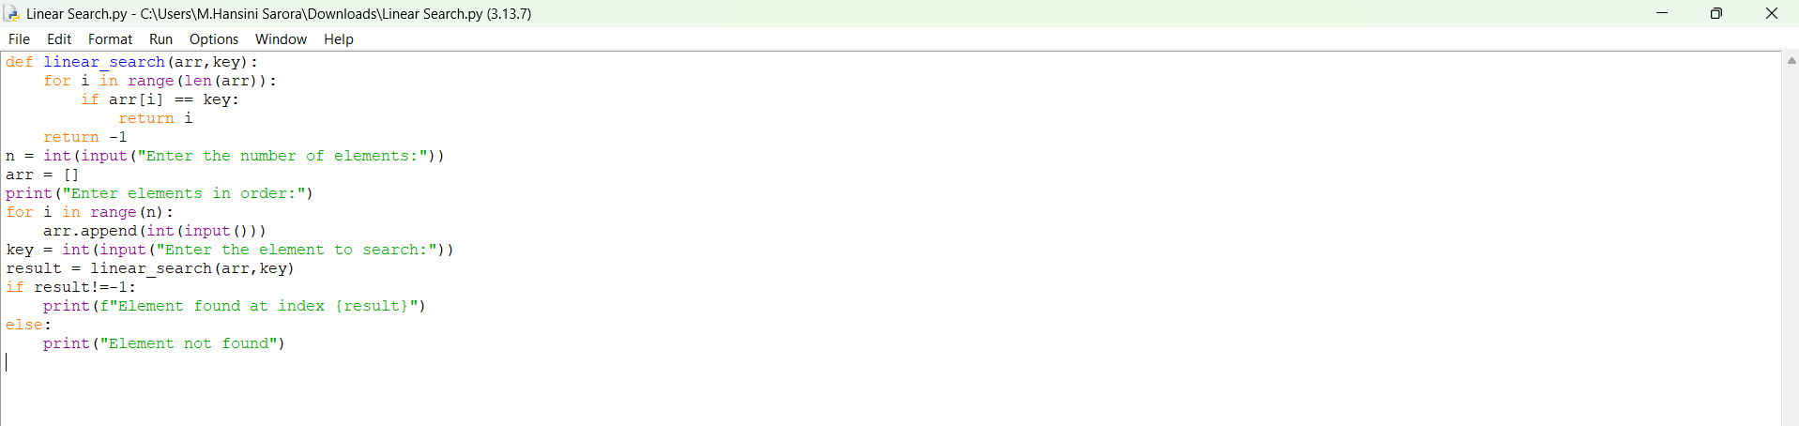

OUTPUT:
Positive Case;
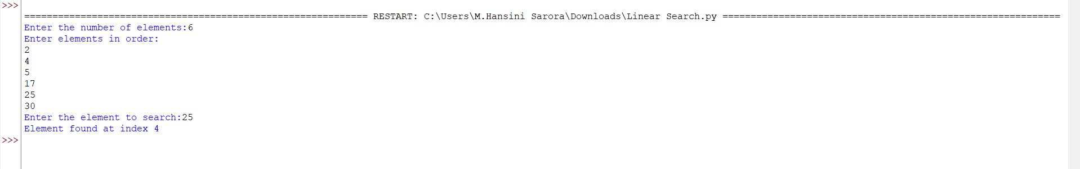
Negative Case;
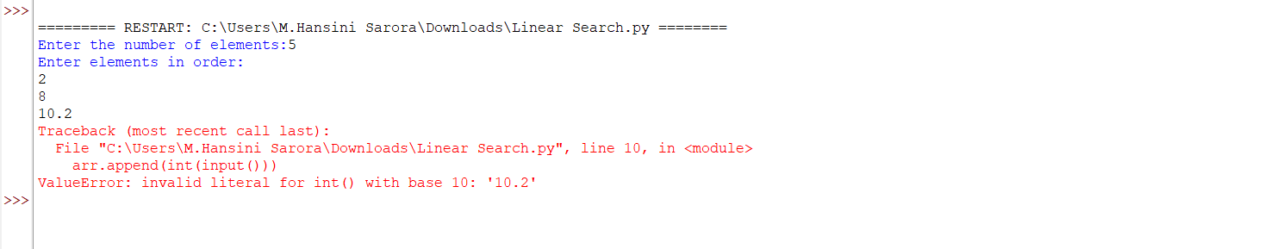

EXPLANATION:
Condition 1: Element Found
- The program takes an array of numbers from the user.
- It then asks for a key (the element to search).
- The linear_search function goes through the array one element at a time.
- If the current element matches the key, the function returns its index.
- In this case, the program prints:
Element found at index <position>
Example:
- Input array: [10, 20, 30, 40]
- Key: 30
- Output: Element found at index 2
Condition 2: Element Not Found
- If the loop finishes and no element matches the key, the function returns -1.
- The program then prints:
Element not found
ERROR TABLE:

S.NO | Error Obtained | Rectification
1. | Indentation error  Return -1 was typed inside the if loop condition. | Later, it was rectified by typing it outside the if loop and inside the for loop.
2. | Syntax error  Invalid syntax,  ! == -1 | It was rectified by re-typing,  ! = -1.

2b. AIM: Write a python program to perform binary search on the given. Verify by taking sorted array as an input.

PROGRAM:
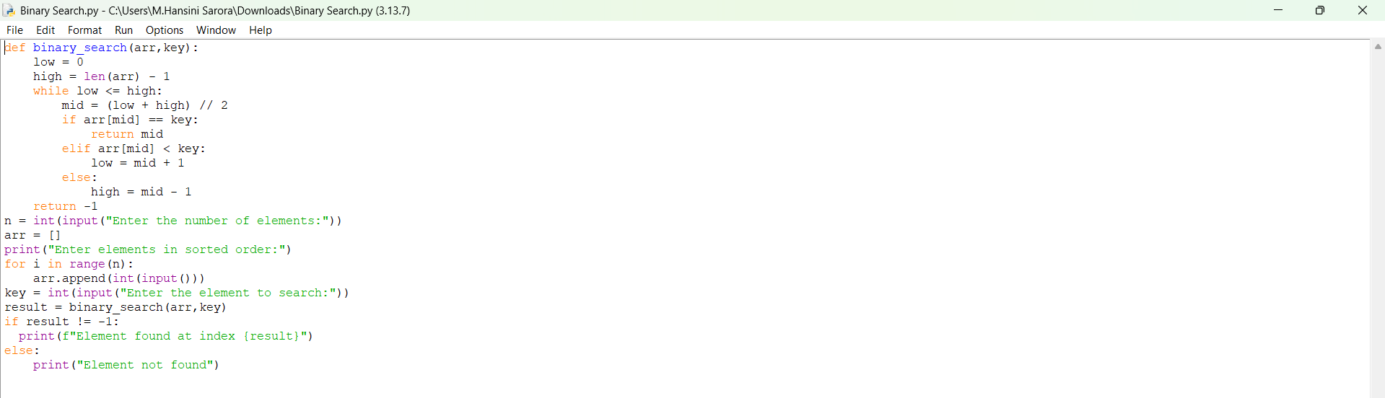

OUTPUT:
Positive Case;
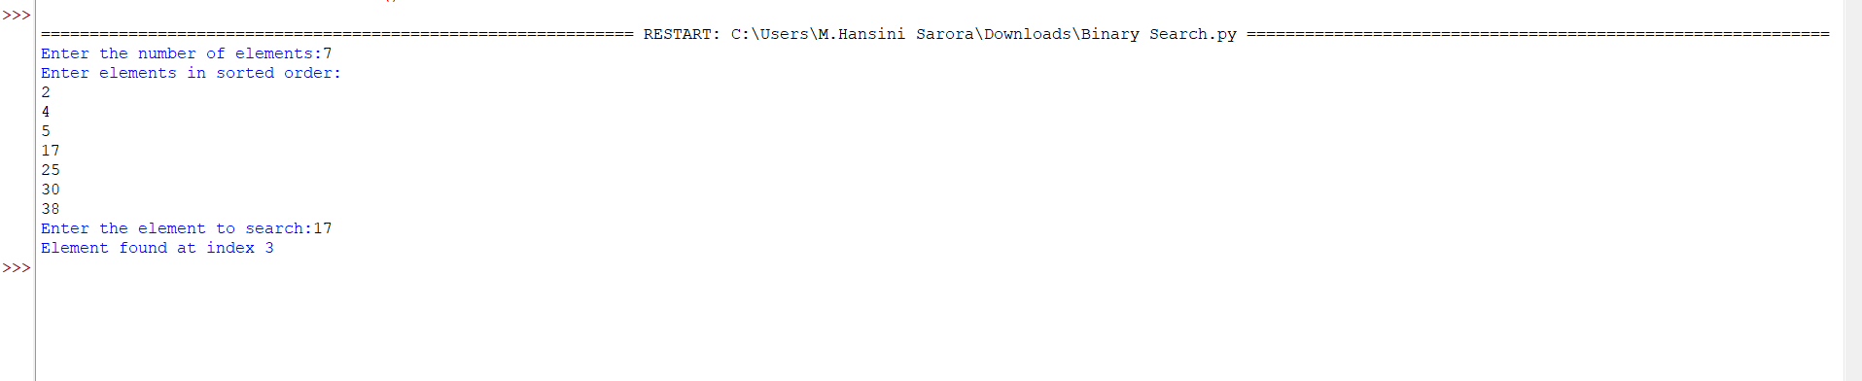
Negative Case;
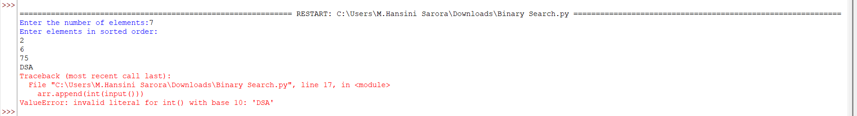

EXPLANATION:
Condition 1: Element Found
- The program asks the user to enter elements in sorted order (binary search only works on sorted arrays).
- The binary_search function starts with two pointers:
- low → beginning of the array
- high → end of the array
- It calculates the middle index mid = (low + high) // 2.
- If the middle element equals the key, the function returns that index.
- The program then prints:
Element found at index <position>
Example:
- Input array: [5, 10, 15, 20, 25]
- Key: 20
- Output: Element found at index 3
Condition 2: Element Not Found
- If the key is not equal to the middle element, the algorithm adjusts the search range:
  - If arr[mid] < key, search continues in the right half (low = mid + 1).
  - If arr[mid] > key, search continues in the left half (high = mid - 1).
- This process repeats until low > high.
- If the key is not found, the function returns -1.
- The program then prints:
Element not found
Example:
- Input array: [5, 10, 15, 20, 25]
- Key: 30
- Output: Element not found

ERROR TABLE:

S.NO | Error Obtained | Rectification
1. | Incorrect loop condition  low < high | Later, it was rectified by writing as  low <= high.
2. | Wrong middle calculation  mid = (low + high) / 2 | It was rectified by re-typing,  mid = (low + high) // 2.

2c. AIM: Write a python program to perform binary search on the given. Verify by taking unsorted array as an input.
PROGRAM:
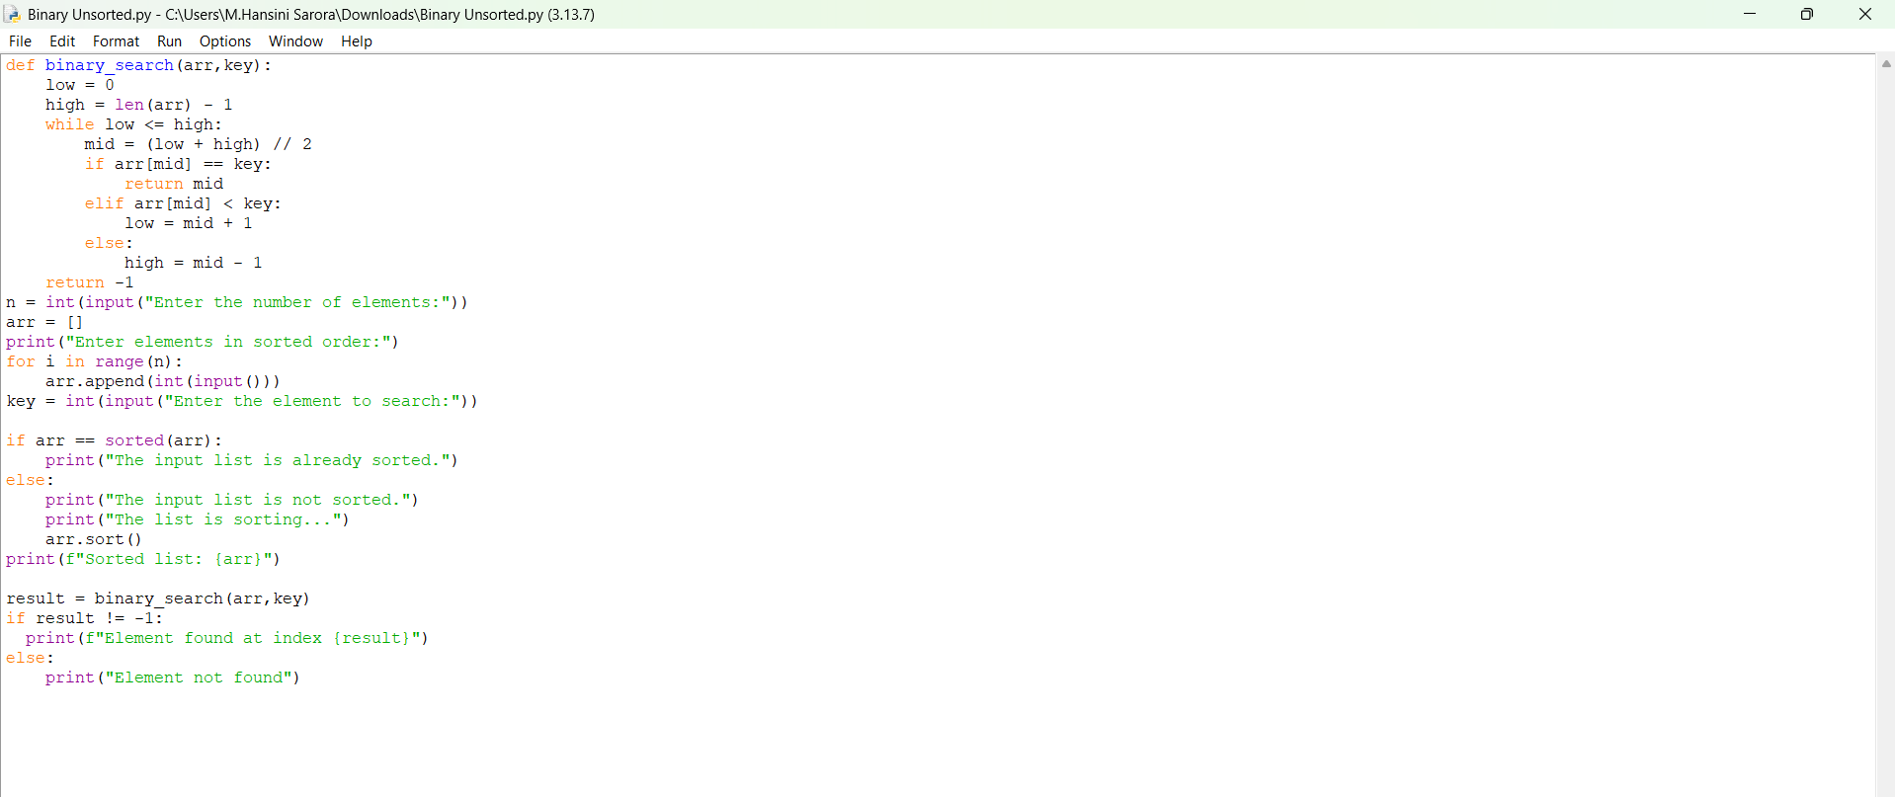

OUTPUT:
Positive Case;
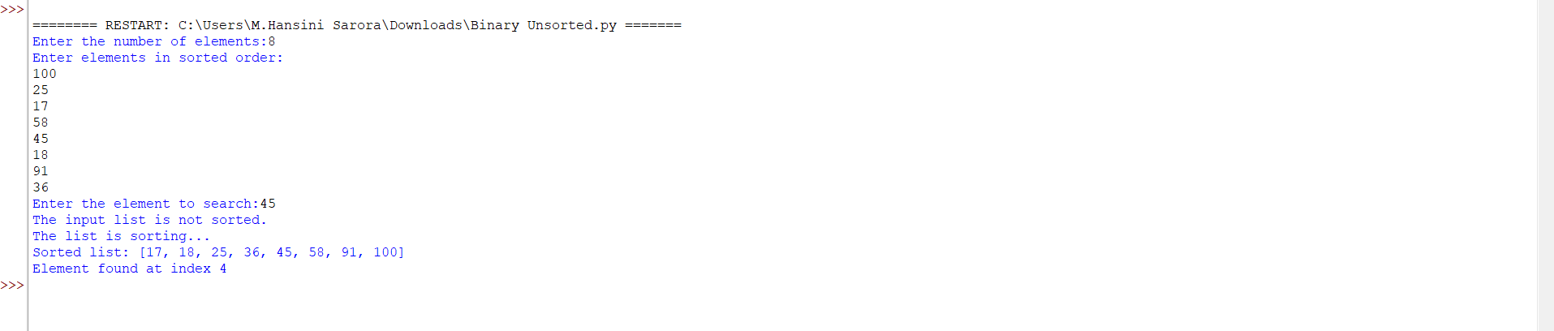
Negative Case;
A semantic error occurs in this case,

EXPLANATION:
Condition 1: Input List Already Sorted
- The program first checks if the entered list is already sorted or not.
- If true, it prints:
The input list is already sorted.
- Then it directly applies binary search on the given list.
- If the key is found, it prints the index:
Element found at index <position>
- Otherwise, it prints:
Element not found
Example:
- Input array: [5, 10, 15, 20]
- Key: 15
- Output:
The input list is already sorted.
Sorted list: [5, 10, 15, 20]
Element found at index 2
Condition 2: Input List Not Sorted
- If the entered list is not sorted, the program prints
The input list is not sorted.
The list is sorting...
- It then sorts the list using:
arr.sort()
- After sorting, it prints the sorted list and applies binary search.
- If the key is found, it prints the index in the sorted list.
- Otherwise, it prints:
Element not found
Example:
- Input array: [20, 5, 15, 10]
- Key: 10
- Output:
The input list is not sorted.
The list is sorting...
Sorted list: [5, 10, 15, 20]
Element found at index 1

ERROR TABLE:

S.NO | Error Obtained | Rectification
1. | Duplicate elements  It does not guarantee the 1st or last occurrence | Later, it was rectified by not entering the duplicate values.
2. | Semantic error  Given an empty list | It was rectified by entering the values in the list.

WEEK – 3
3a. AIM: Write a program to perform Bubble Sort technique on the user given input.
PROGRAM:
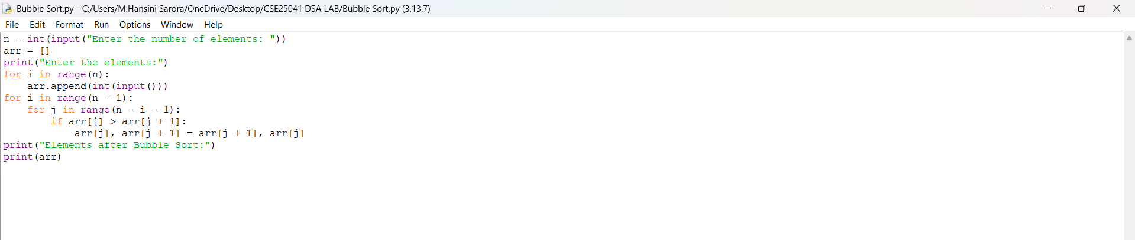

OUTPUT:
Positive Case;
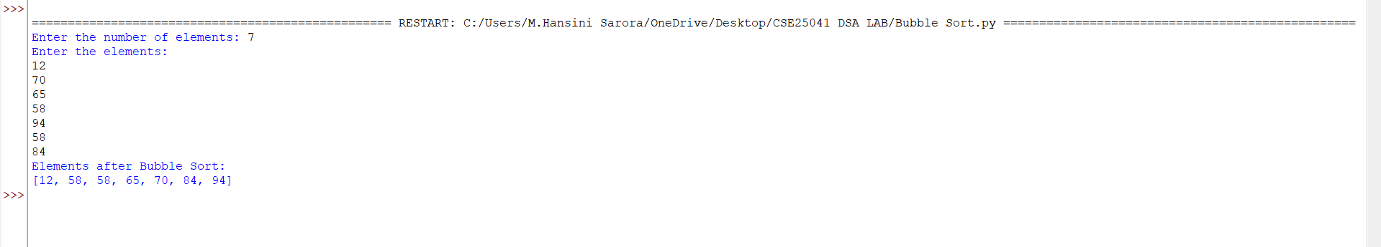
Negative Case;
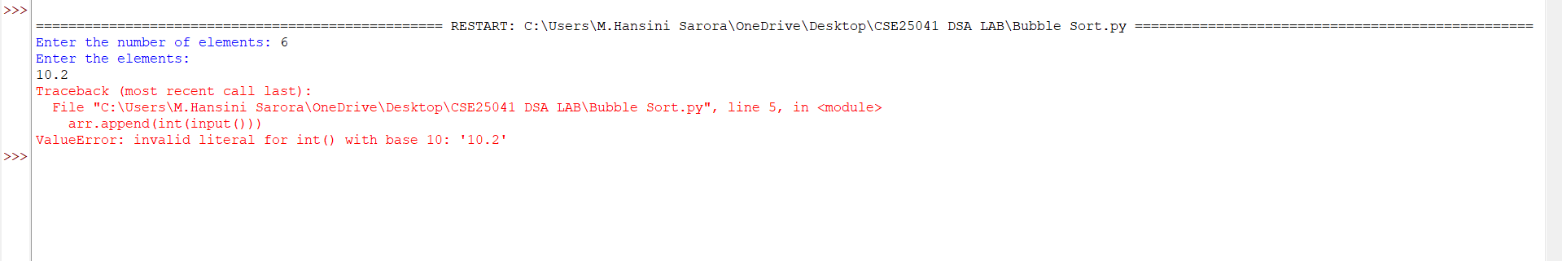

EXPLANATION:
1. Start by taking input size,
The program first asks how many elements (n) the user wants to sort. This sets the boundary for loops.
2. Input the elements into the list,
The user enters n numbers, which are stored in the list arr.
3. Begin Bubble Sort process,
Sorting starts with two nested loops:
- Outer loop (i) → Controls the number of passes. Runs n-1 times because after each pass one element is placed correctly at the end.
- Inner loop (j) → Compares adjacent elements in each pass.
4. Condition check inside inner loop,
- The condition is: if the current element is greater than the next element (arr[j] > arr[j+1]).
- If this condition is true, the two elements are swapped.
- If the condition is false, no swap is made and the loop continues.
5. Effect of condition and swapping,
- Each time the condition is true, larger elements move step by step toward the end of the list.
- After the first pass, the largest element is at the last position.
- After the second pass, the second-largest is in its correct position, and so on.
6. Completion of sorting,
When all passes are finished, the list is sorted in ascending order. The program then prints the sorted list.

ERROR TABLE:

S.NO | Error Obtained | Rectification
1. | Logical Error  if arr[j] > arr[j + 1]: | It will sort in descending order, so it was rectified by changing it to “<” this.
2. | Semantic error  Given an empty list | It was rectified by entering the values in the list.
3b. AIM: Write a program to perform Insertion Sort technique on the user given input.
PROGRAM:
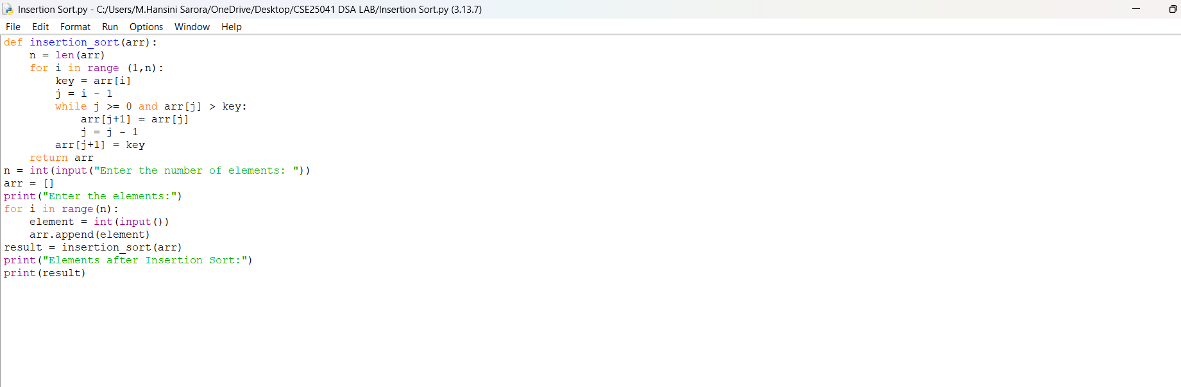

OUTPUT:
Positive Case;
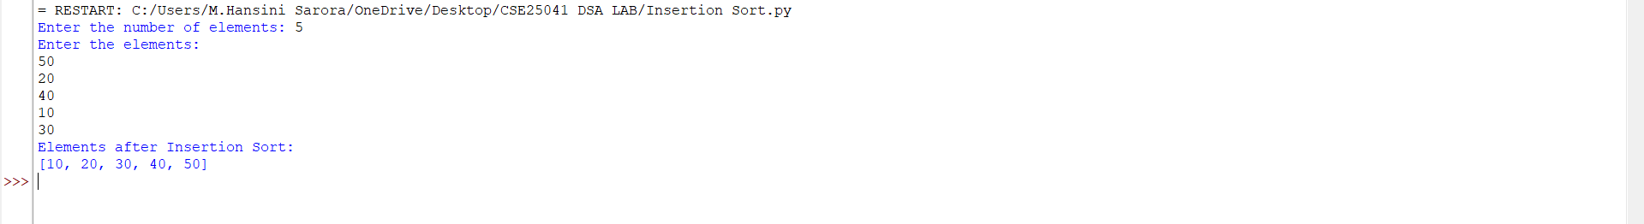
Negative Case;
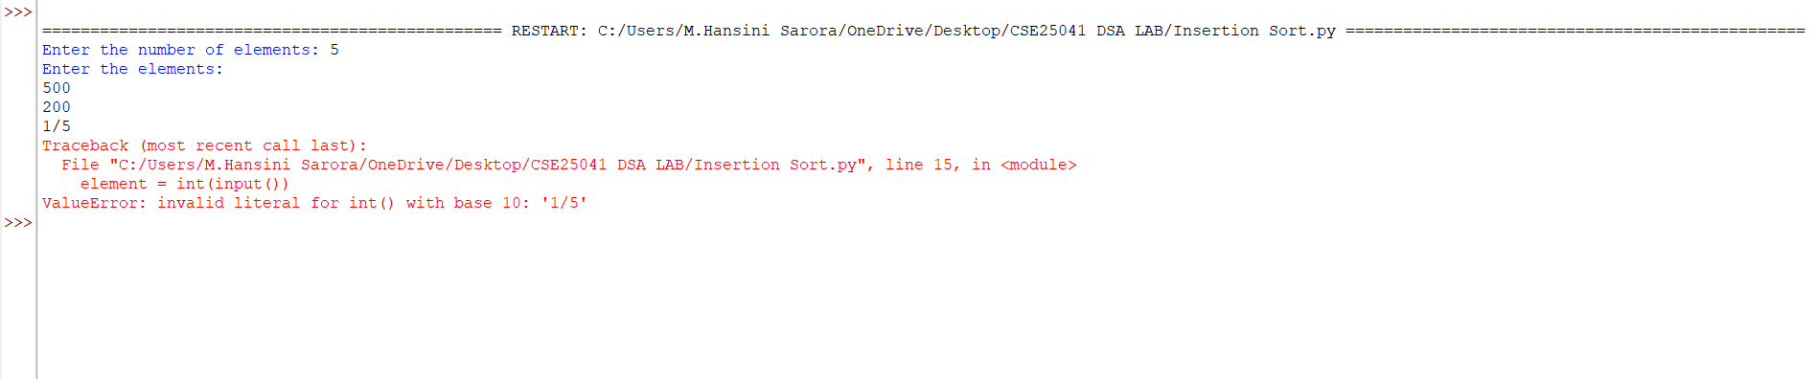

EXPLANATION:
1. Input Phase,
- The program first asks the user for the number of elements (n).
- Then it takes n integer inputs one by one and stores them in the list arr.
2. Insertion Sort Process,
Insertion Sort works by building the sorted list one element at a time:
- Outer loop (i from 1 to n-1): Starts from the second element because the first element is trivially sorted. Each iteration picks the current element (key) and tries to place it in the correct position among the already sorted part of the list.
- Condition check inside while loop:
  - The condition is: while j >= 0 and arr[j] > key
  - Meaning: As long as the previous element (arr[j]) is greater than the current element (key), shift it one position to the right.
  - If the condition is true, shifting happens.
  - If the condition is false, the correct position for key is found.
- Placement of key: After shifting larger elements, the key is placed at its correct position (arr[j+1] = key).
3. Output Phase,
- After all passes, the list is fully sorted in ascending order.
- The program prints the sorted list.

ERROR TABLE:

S.NO | Error Obtained | Rectification
1. | Syntax error | Later, it was rectified by typing it as ‘:’ in loop.
2. | Condition check  j <= 0 | It was rectified by correcting it with ‘>’.  It could cause negative indexing errors.
3c. AIM: Write a program to perform Selection Sort technique on the user given input.
PROGRAM:
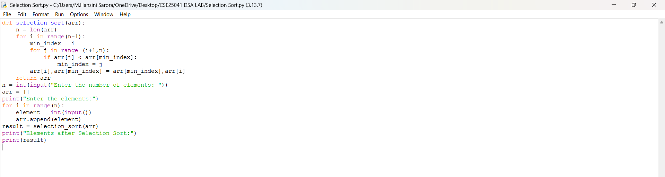
OUTPUT:
Positive Case;
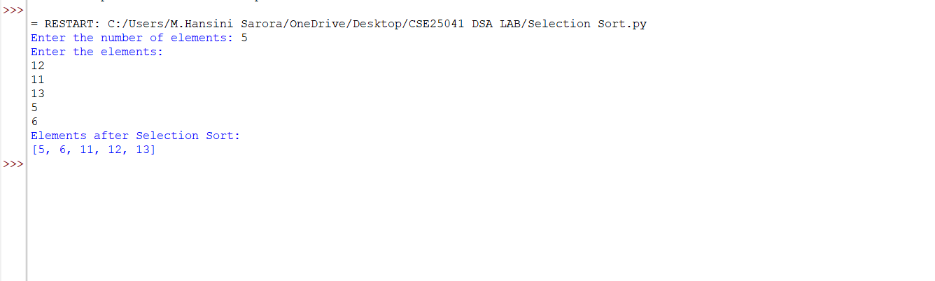
Negative Case;
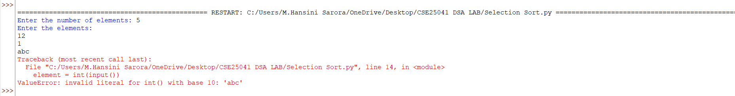
EXPLANATION:
1. Input Phase
- The program first asks the user for the number of elements (n).
- Then it takes n integer inputs one by one and stores them in the list arr.

2. Selection Sort Process
Selection Sort works by repeatedly finding the smallest element from the unsorted part of the list and placing it at the beginning.
- Outer loop (i from 0 to n-2): Each iteration selects the position where the next smallest element should be placed.
- Initialize minimum index: At the start of each pass, min_index = i. This assumes the current element is the smallest.
- Inner loop (j from i+1 to n-1): Compares the current minimum element with the rest of the unsorted elements.
  - Condition check: if arr[j] < arr[min_index]
    - If true, update min_index = j (a new smaller element is found).
    - If false, keep the current min_index.
    - Swap after inner loop: After checking all elements, swap the smallest element found (arr[min_index]) with the element at position i. This places the correct element in its sorted position.
3. Output Phase
- After all passes, the list is fully sorted in ascending order.
- The program prints the sorted list.

ERROR TABLE:

S.NO | Error Obtained | Rectification
1. | Syntax error | Later, it was rectified by typing it as ‘:’ in loop.
2. | Meaningless behaviour when n = 0 or negative | Add a condition: if n <= 0, print "No elements to sort" and skip sorting.
3d. AIM: Write a program to perform Merge Sort technique on the user given input.
PROGRAM:
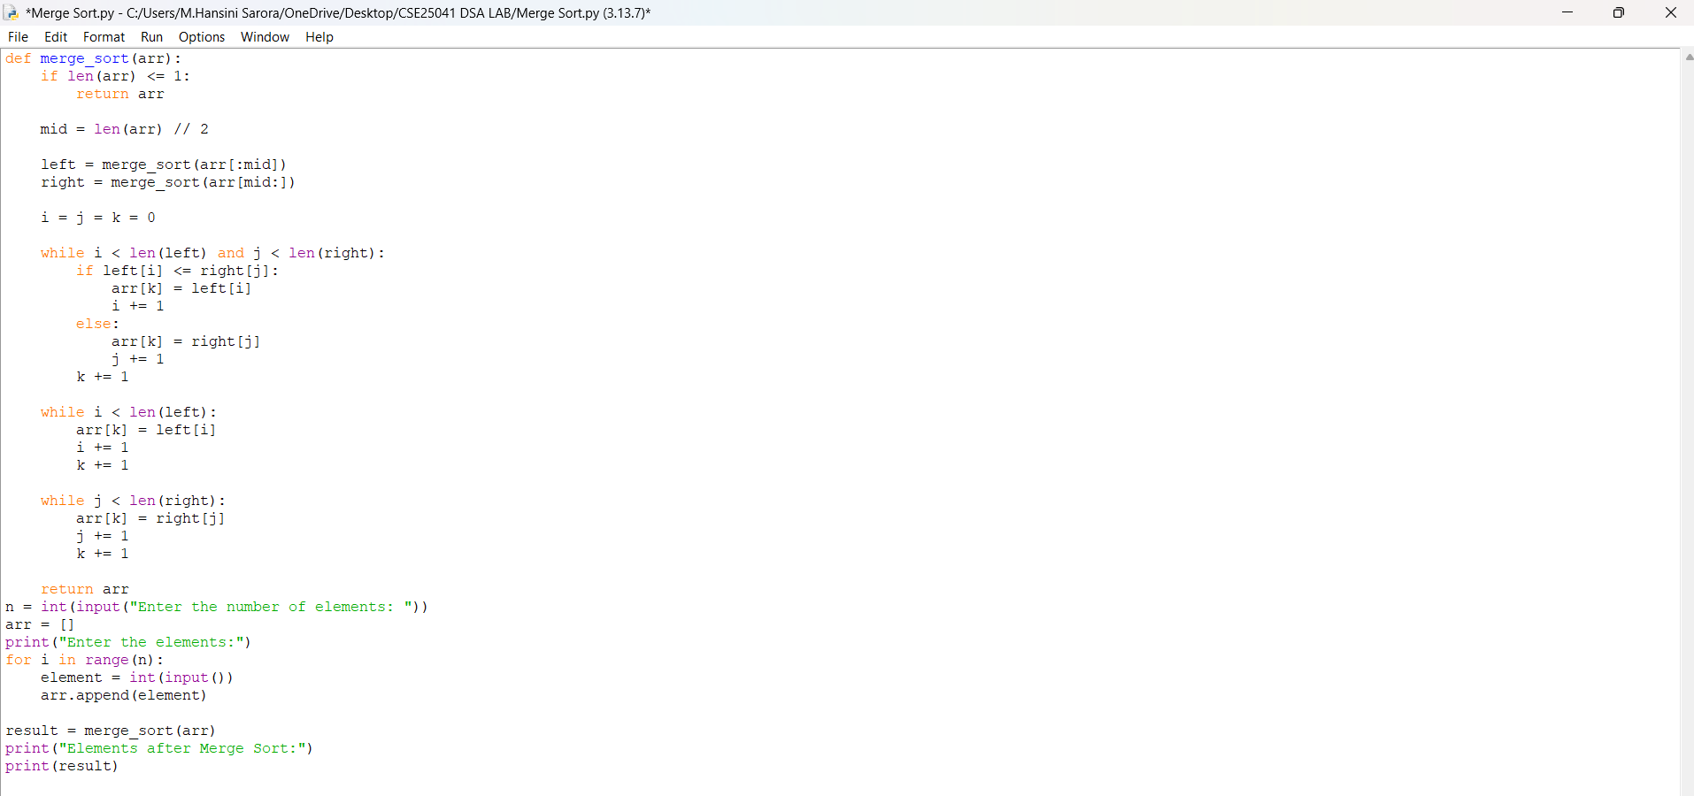

OUTPUT:
Positive Case;
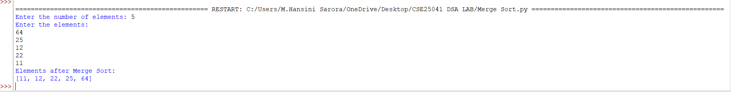
Negative Case;
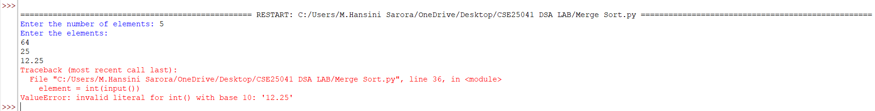

EXPLANATION:
Step 1: Input Phase
- The program first asks the user for the number of elements (n).
- Then it takes n integer inputs one by one and stores them in the list arr.
Step 2: Merge Sort Process
Merge Sort is a divide and conquer algorithm. It divides the list into smaller parts, sorts them individually, and then merges them back together.
Condition 1: Base Case
- If the list has one or zero elements, it is already sorted.
  - Condition: if len(arr) <= 1:
  - Action: Return the list as it is.
Condition 2: Divide Step
- Find the middle index: mid = len(arr) // 2
- Split the list into two halves:
  - Left half → arr[:mid]
  - Right half → arr[mid:]
- Recursively call merge_sort() on both halves:
  - left = merge_sort(arr[:mid])
  - right = merge_sort(arrr[mid:])
Step 3: Merge Step
After both halves are sorted, they are merged together in ascending order.
Condition 3: Comparing elements
- Initialize three counters: i, j, and k to 0.
- While both halves have elements left:
  - Condition: while i < len(left) and j < len(right):
  - Compare elements:
    - If left[i] <= right[j] → place left[i] in the merged list.
    - Else → place right[j] in the merged list.
  - Increment counters accordingly.
Condition 4: Copy remaining elements
- If one half finishes early, copy the remaining elements from the other half.
  - Condition: while i < len(left): → copy remaining left elements.
  - Condition: while j < len(right): → copy remaining right elements.
Step 4: Return Sorted List
- After merging, return the sorted list to the previous recursive call.
- Finally, print the sorted list after all recursive merges are complete.

ERROR TABLE:

S.NO | Error Obtained | Rectification
1. | Index error  List index out of range | Later, it was rectified by few corrections in while loop.
2. | Syntax error | Later, it was rectified by typing it as ‘:’ in loop.

3e. AIM: Write a program to perform Merge Sort technique on the user given input.

PROGRAM:
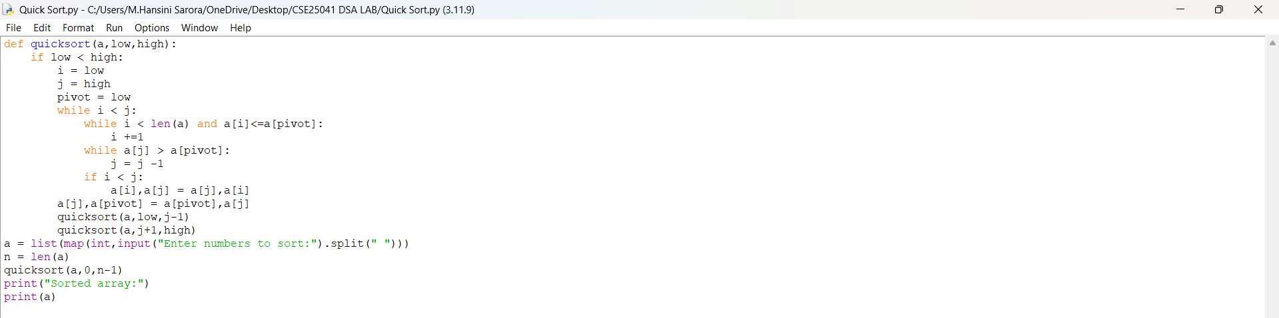
OUTPUT:
Positive Case;
Negative Case;

EXPLANATION:
Step 1: Input Phase
- The program asks the user to enter numbers separated by spaces.
- These numbers are converted into integers and stored in the list a.
- The length of the list (n) is calculated.
Step 2: Quick Sort Function
Quick Sort is a divide and conquer algorithm. It works by choosing a pivot element, partitioning the list around the pivot, and then recursively sorting the partitions.
Condition 1: Base Case
- The function runs only if low < high.
- If this condition is false (meaning the sublist has one or zero elements), the recursion stops because the list is already sorted.
Condition 2: Partitioning
- Variables i = low, j = high, and pivot = low are initialized.
- The pivot is chosen as the first element of the sublist.
Inner conditions:
- while i < len(a) and a[i] <= a[pivot]: i += 1
  - Condition checks if the current element is less than or equal to the pivot.
  - If true, move i forward.
  - If false, stop and prepare for a swap.
- while a[j] > a[pivot]: j -= 1
  - Condition checks if the current element is greater than the pivot.
  - If true, move j backward.
  - If false, stop and prepare for a swap.
- Swap condition:
  - If i < j, swap a[i] and a[j].
  - This ensures smaller elements move to the left of the pivot and larger ones to the right.
Condition 3: Pivot Placement
- After partitioning, swap the pivot element with a[j].
- This places the pivot in its correct sorted position.
Step 3: Recursive Calls
- After placing the pivot, Quick Sort is called recursively on the two partitions:
  - Left sublist: quicksort (a, low, j-1)
  - Right sublist: quicksort (a, j+1, high)
- Each recursive call applies the same conditions until the entire list is sorted.

Step 4: Output Phase
- Finally, the sorted list is printed.

ERROR TABLE:

S.NO | Error Obtained | Rectification
1. | Index Error  When j becomes negative if pivot is very small compared to other elements. | Add boundary check:  while j >= low and a[j] > a[pivot]: j -= 1.
2. | Unnecessary swaps  When i and j point to the same element. | Add condition check before swapping:  only swap if i < j.

WEEK – 4
4a. AIM: Write a python program to implement a single linked list which would perform the below operations, by taking an input from the user.
a. Create a linked list. b. Insert at beginning. c. Insert at end.
d. Insert at a specific index. e. Delete by value. f. Delete 1st node.
g. Delete last node. h. Count no. of nodes i. Display.
j. Exit.
PROGRAM:
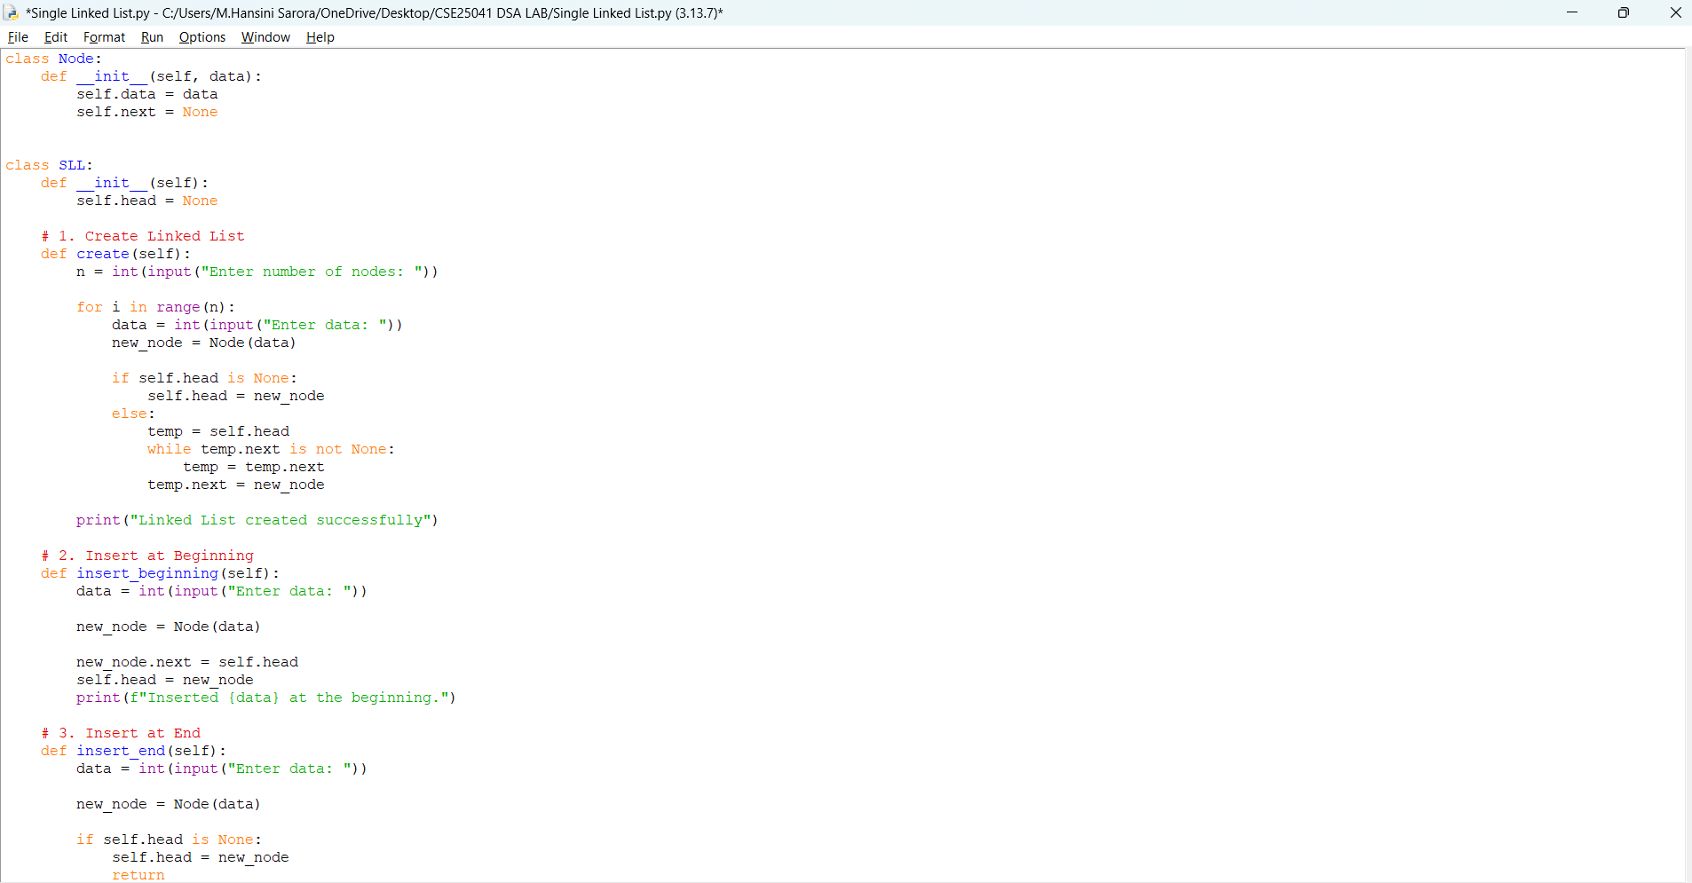
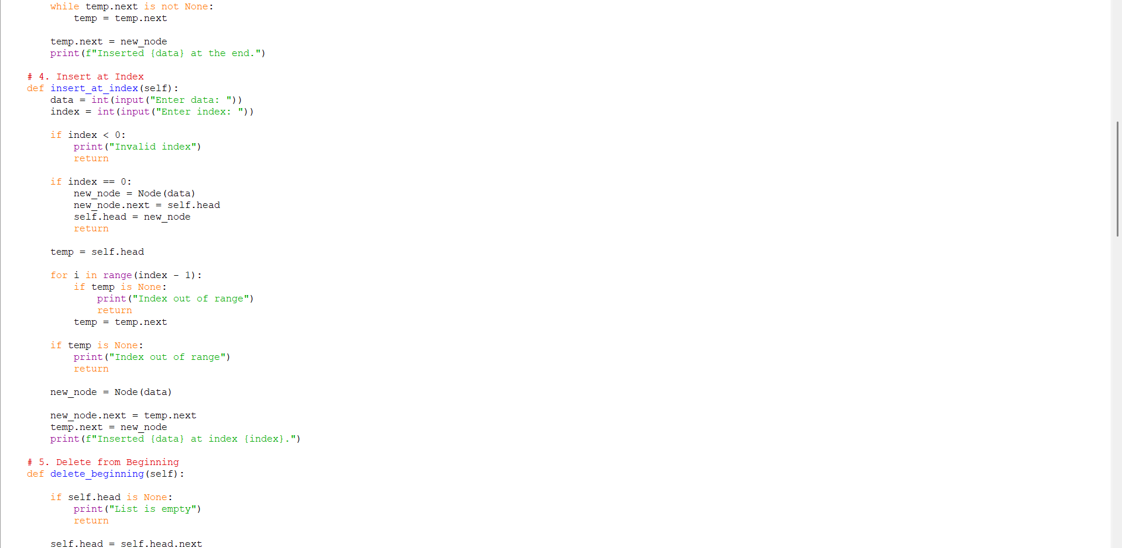
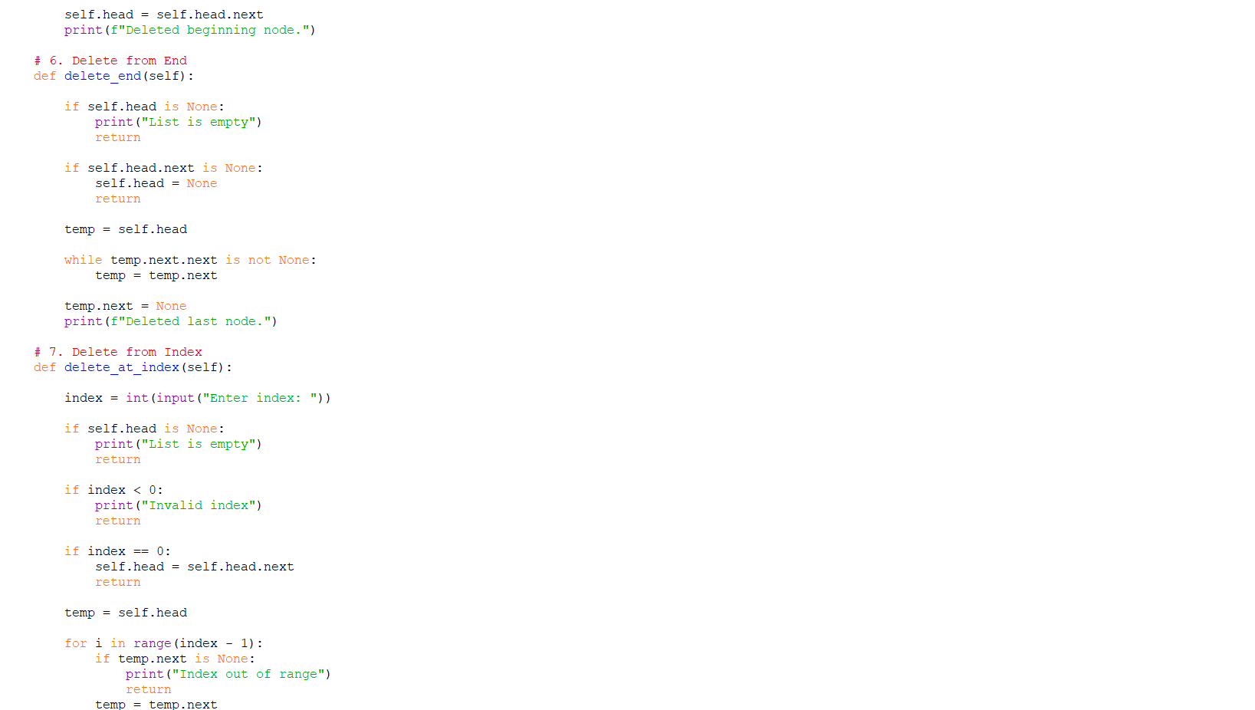
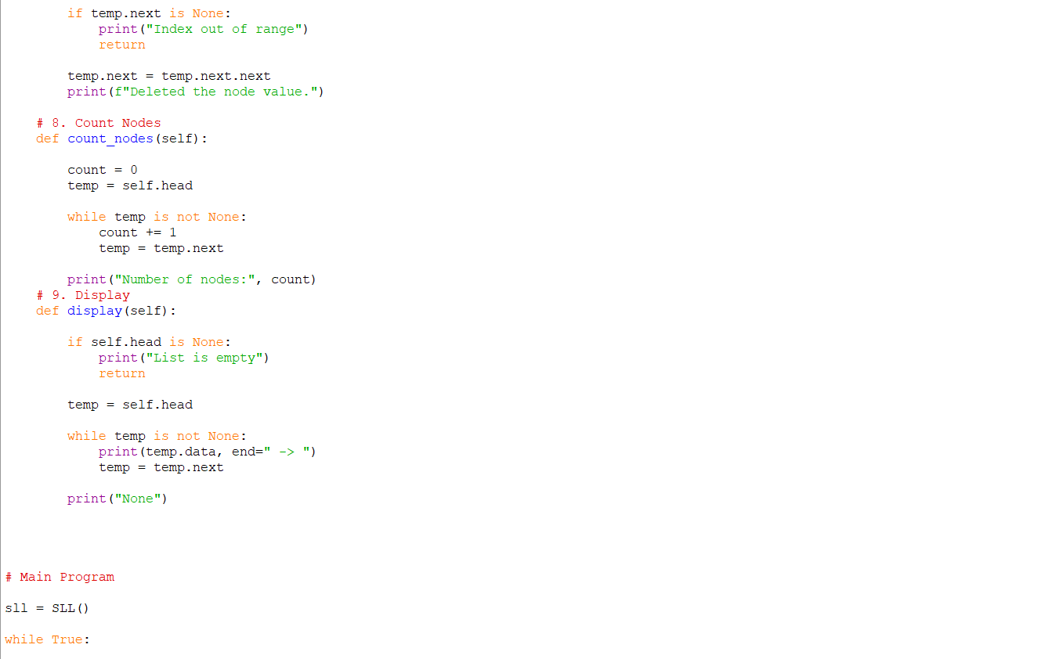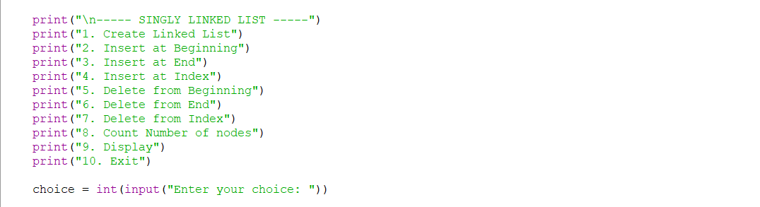

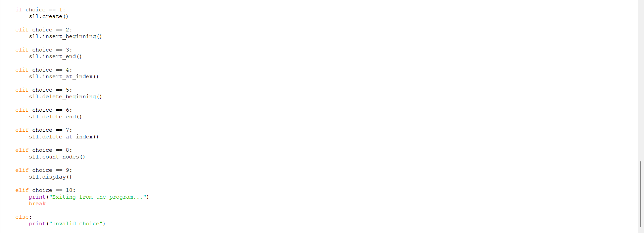

OUTPUT:
Positive Case;
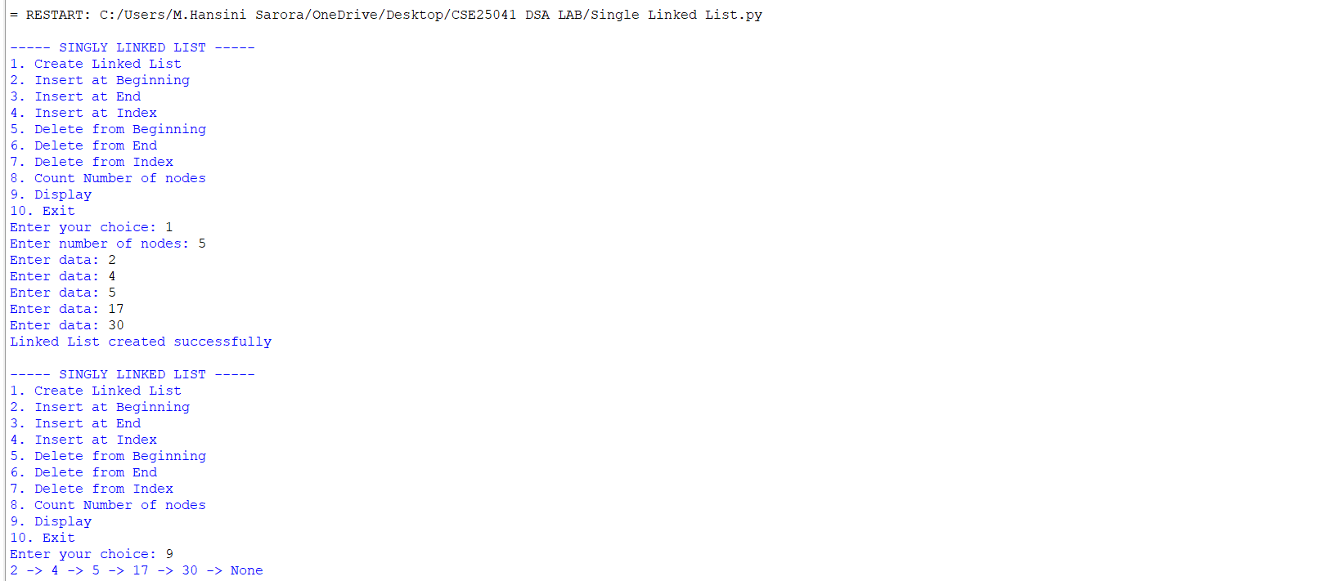
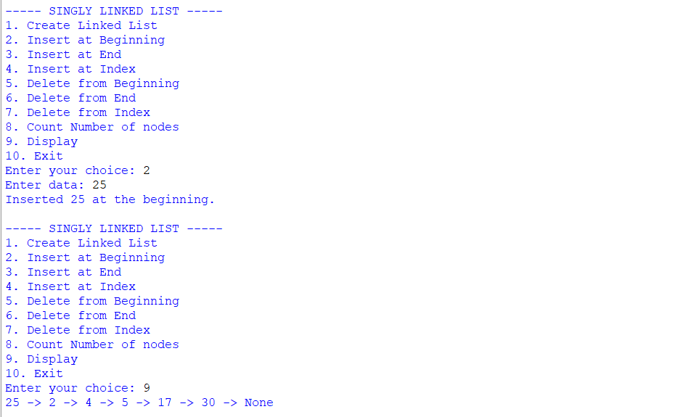
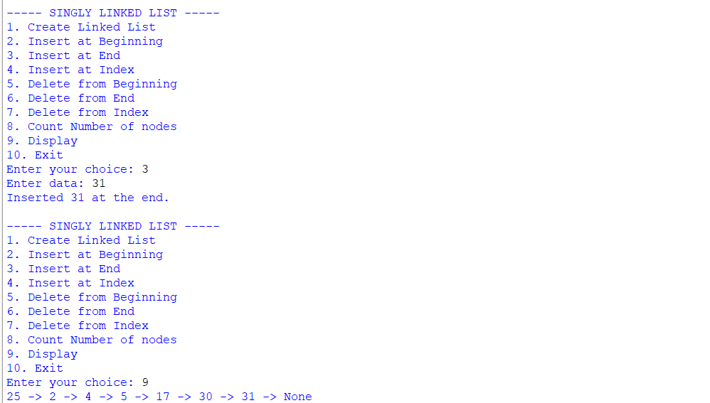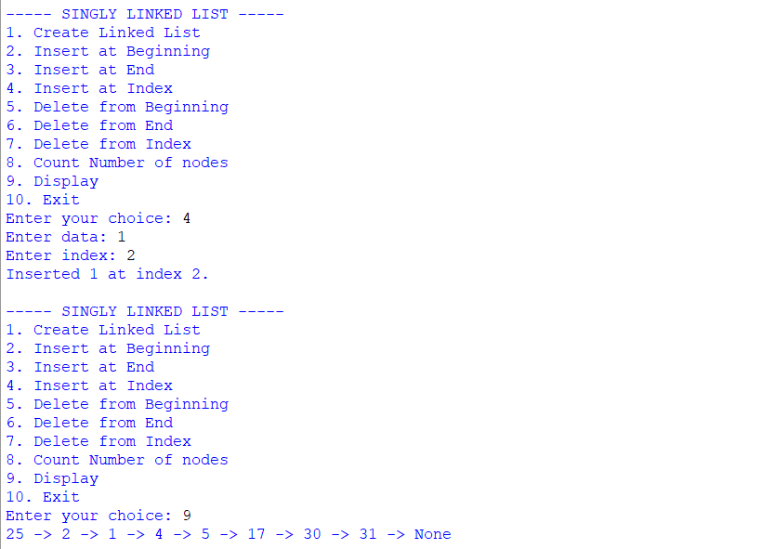

Below is the continution of the output for a program.,

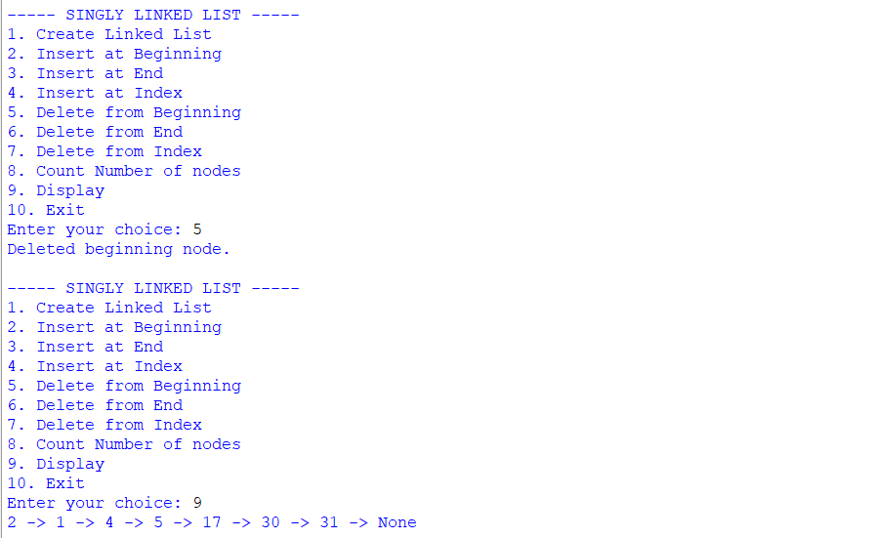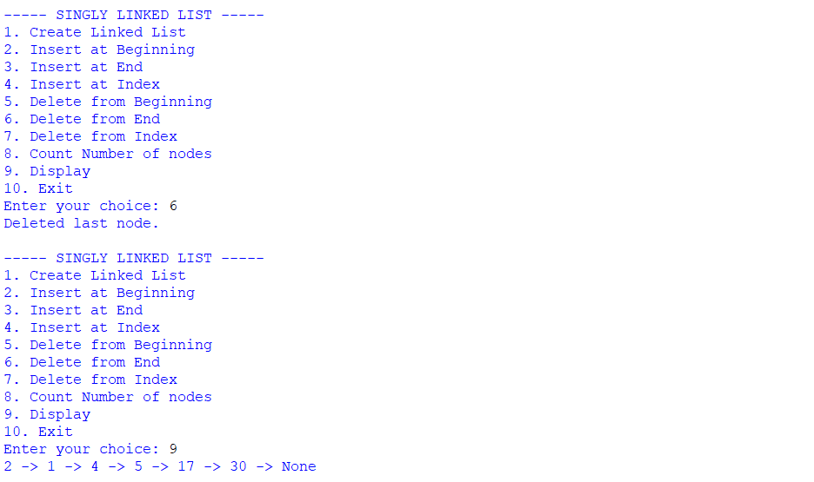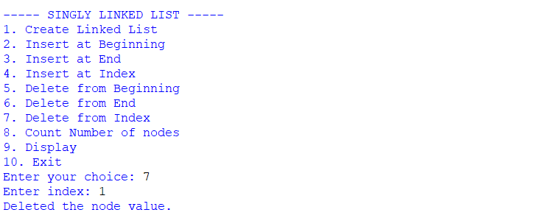
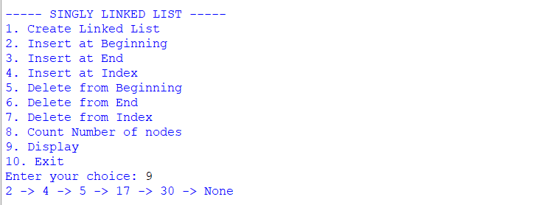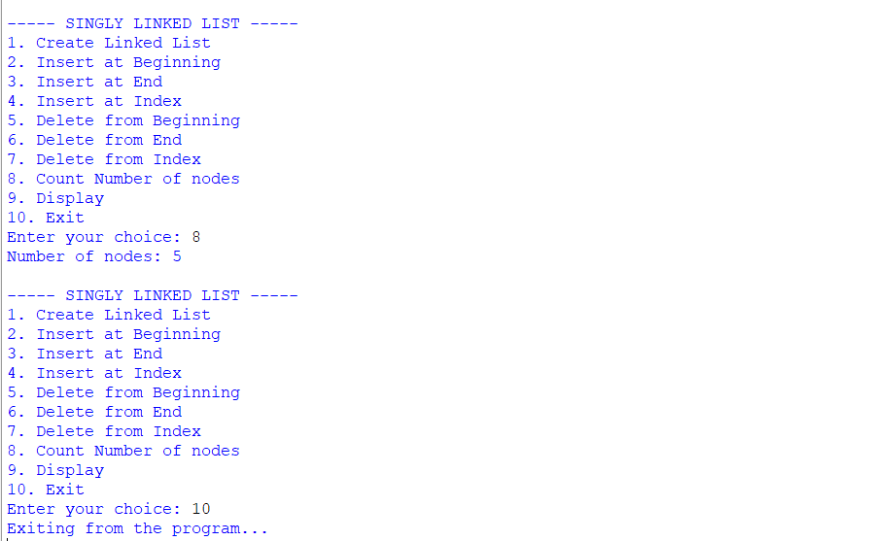
Negative Case;
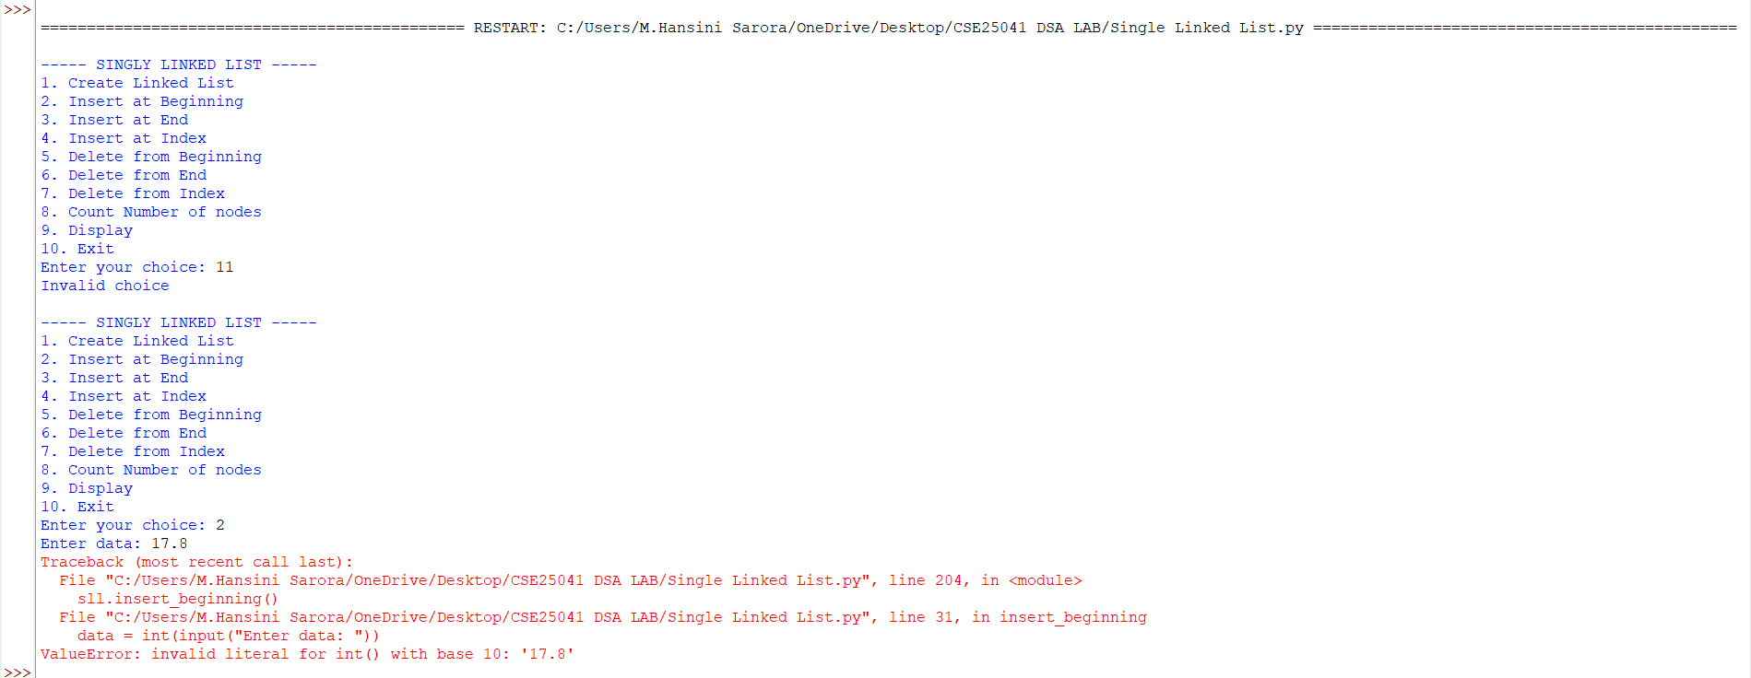

EXPLANATION:
🔹 Class Definitions
- Node class
  - Represents a single node in the linked list.
  - Each node has:
    - data → stores the value.
    - next → pointer to the next node (initially None).
- SLL class
  - Manages the linked list operations.
  - Has a head pointer (initially None) that points to the first node.
🔹 Operations in SLL
1. Create Linked List
- Asks user for number of nodes.
- For each node:
  - Creates a new Node.
  - If list is empty → new node becomes head.
  - Otherwise → traverses to the end and attaches the new node.
2. Insert at Beginning
- Creates a new node.
- Points its next to current head.
- Updates head to new node.
3. Insert at End
- Creates a new node.
- If list is empty → new node becomes head.
- Otherwise → traverses to last node and attaches new node.
4. Insert at Index
- Asks for index and data.
- If index = 0 → behaves like "insert at beginning".
- Otherwise → traverses to (index-1) node and inserts new node in between.
5. Delete from Beginning
- Moves head to head.next.
- Effectively removes the first node.
6. Delete from End
- If list empty → prints "List is empty".
- If only one node → sets head = None.
- Otherwise → traverses to second-last node and sets its next = None.
7. Delete from Index
- Asks for index.
- If index = 0 → removes head.
- Otherwise → traverses to (index-1) node and skips the next node.
8. Count Nodes
- Traverses through list.
- Counts nodes until None.
9. Display
- Traverses from head to end.
- Prints each node’s data in data -> data -> None format.
🔹 Main Program
- Runs an infinite loop with a menu:
  - Options 1–9 → perform linked list operations.
  - Option 10 → exits program.
- Uses if-elif to call respective methods.

ERROR TABLE:

S.NO | Error Obtained | Rectification
1. | Index out of range  When inserting/deleting at an index greater than the number of nodes. | Traverse carefully;  if temp becomes None before reaching index, print "Index out of range" and stop.
2. | Logical error in insertion  if index is negative. | Validate index: if index < 0: print ("Invalid index").
3. | Wrong output format  In display (missing None at end). | After traversal, always print "None" to mark end of list.
4. | Indentation Error  In the Count node part | It was rectified later,  By maintaining proper indentation.

4b. AIM: Write a python program to implement a double linked list which would perform the below operations, by taking an input from the user.
a. Create a linked list. b. Insert at beginning. c. Insert at end.
d. Insert at a specific index. e. Delete by value. f. Delete 1st node.
g. Delete last node. h. Count no. of nodes i. Display.
j. Exit.
PROGRAM:
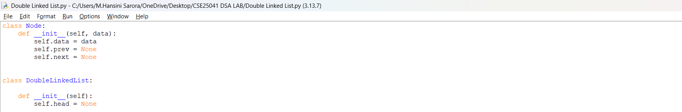

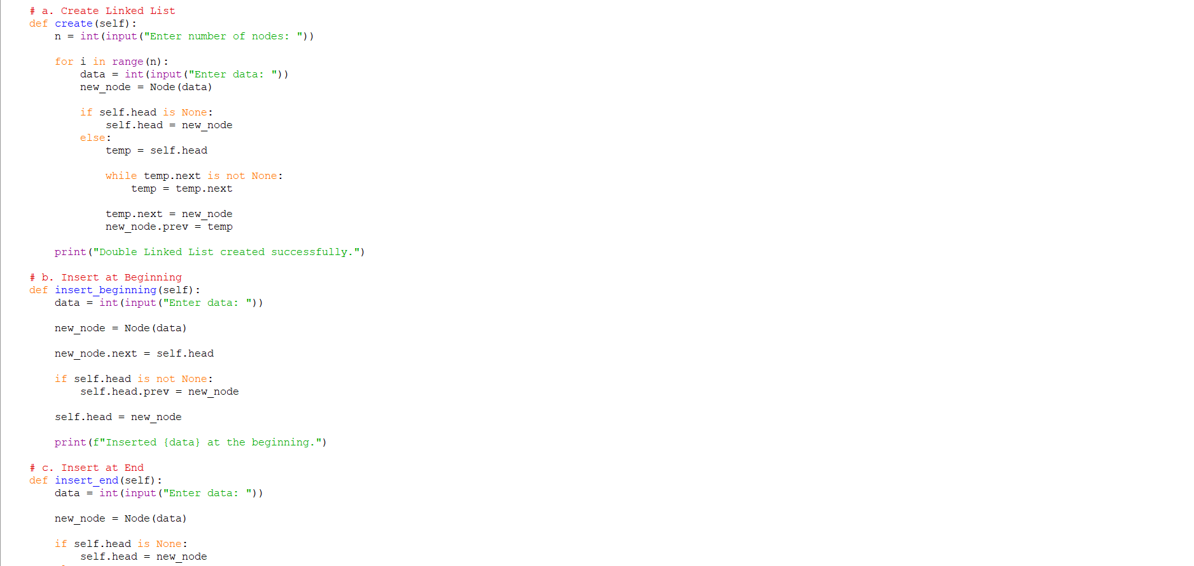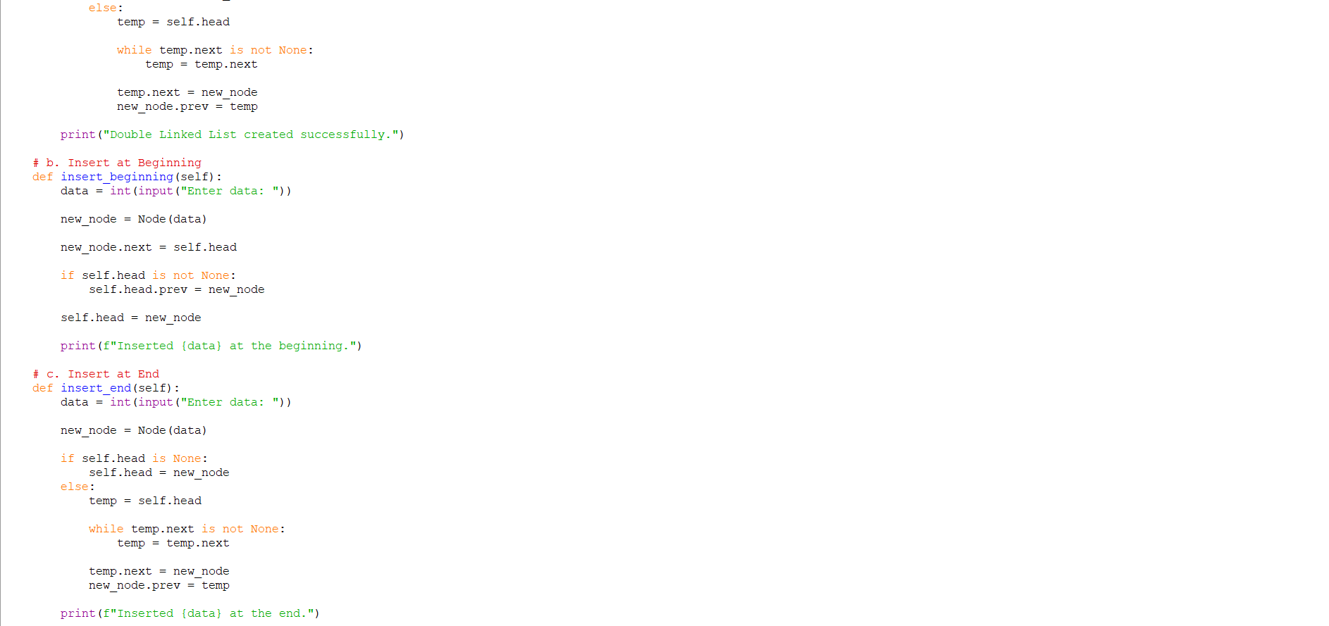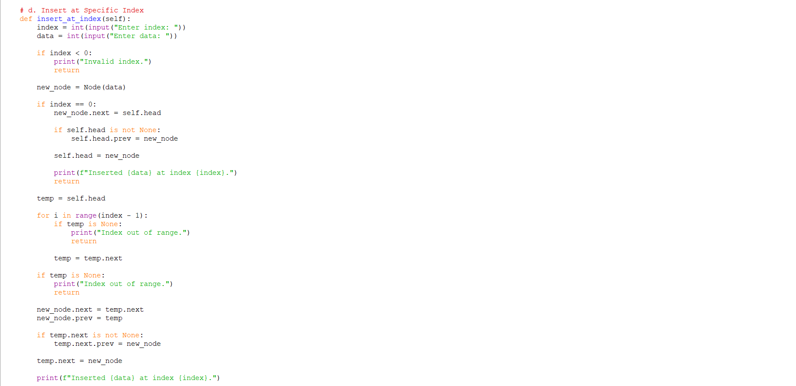

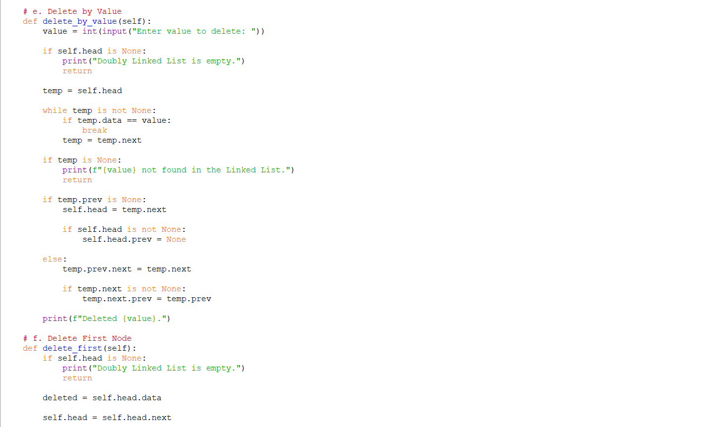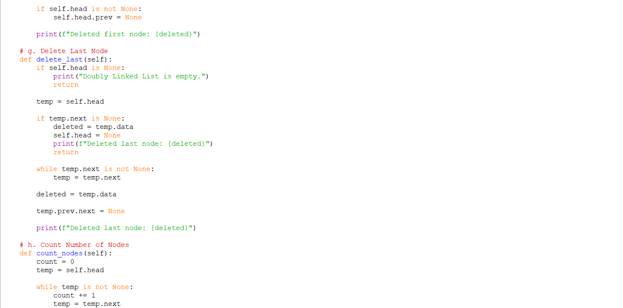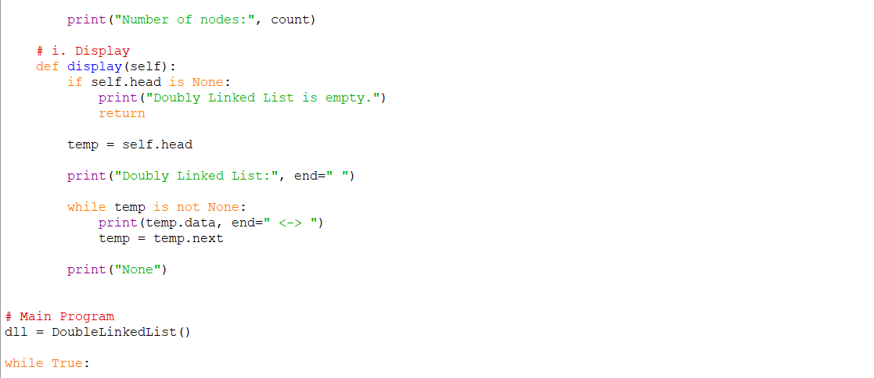
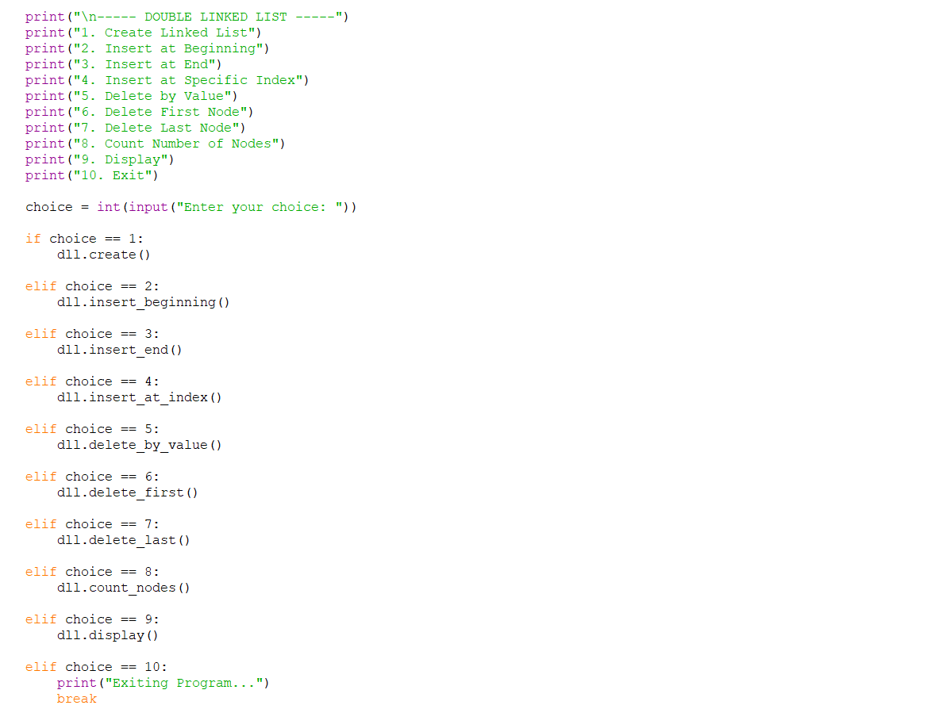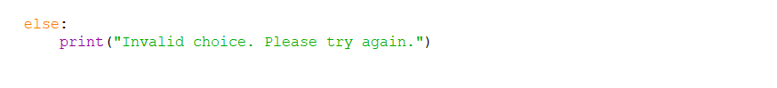
OUTPUT:
Positive Case;
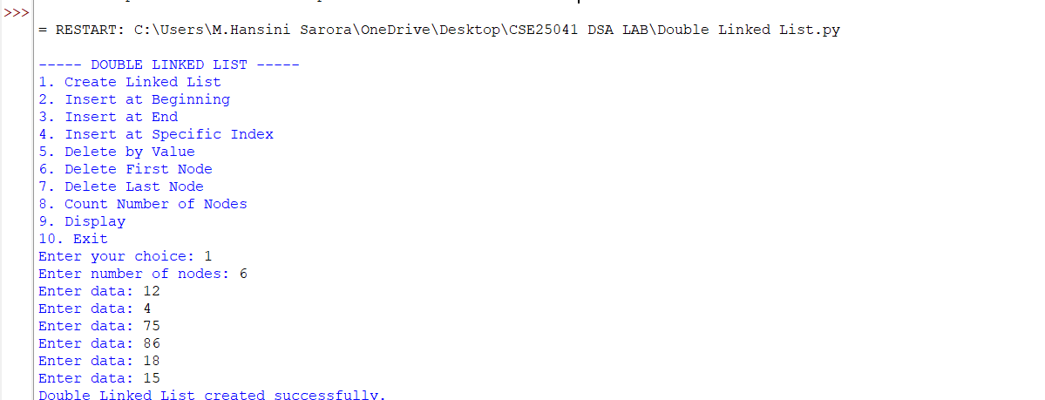

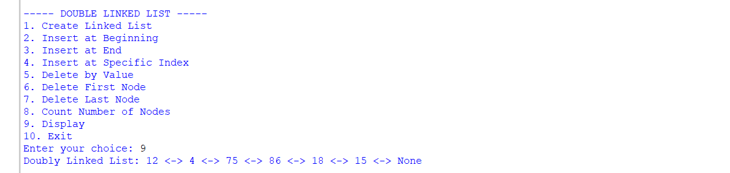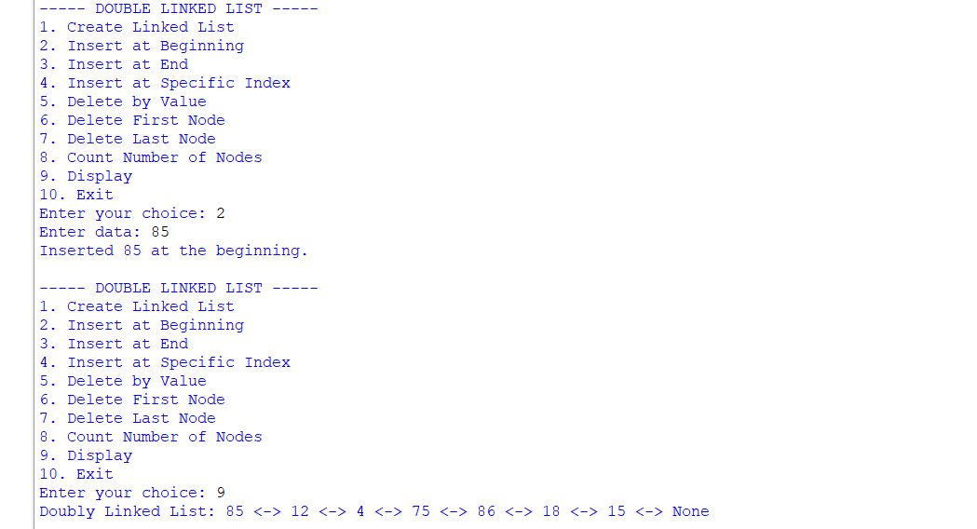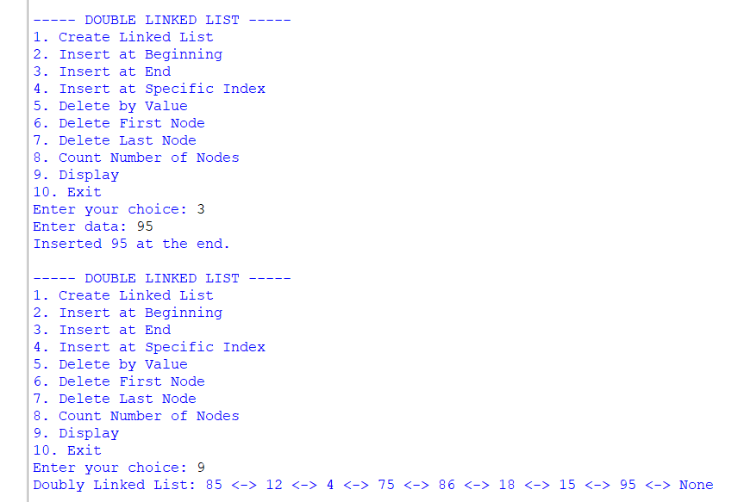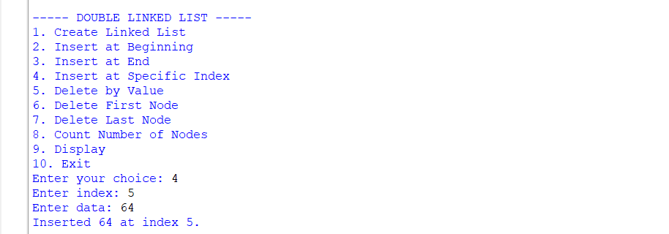

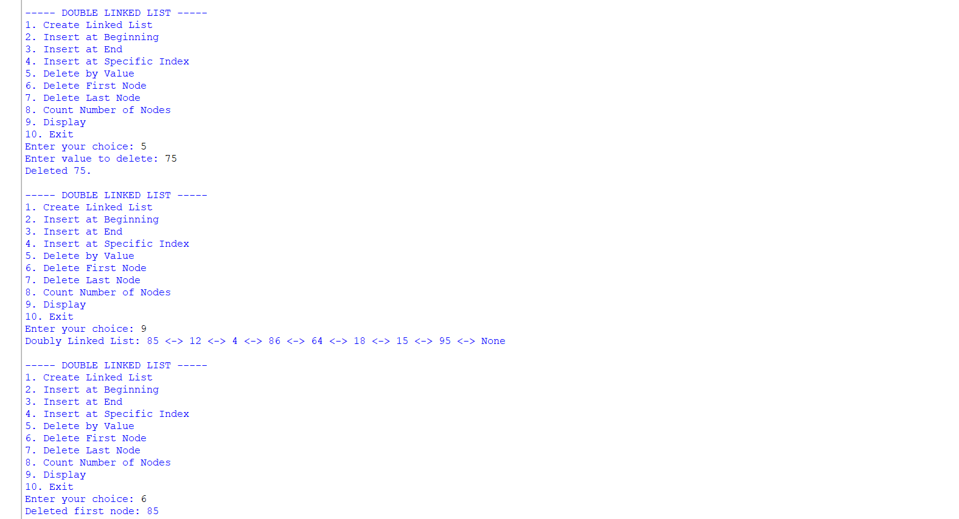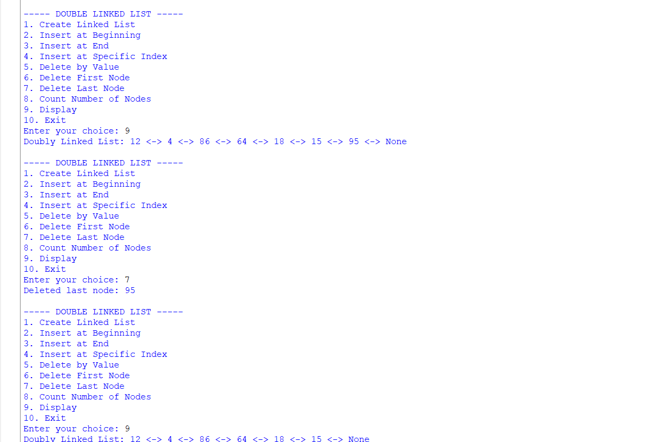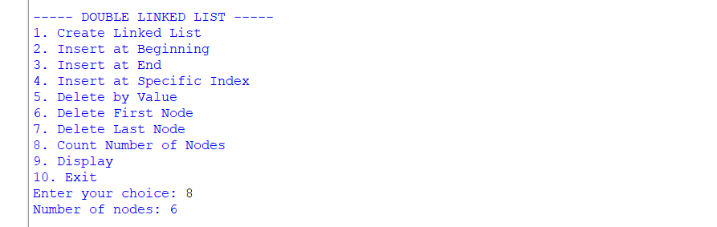

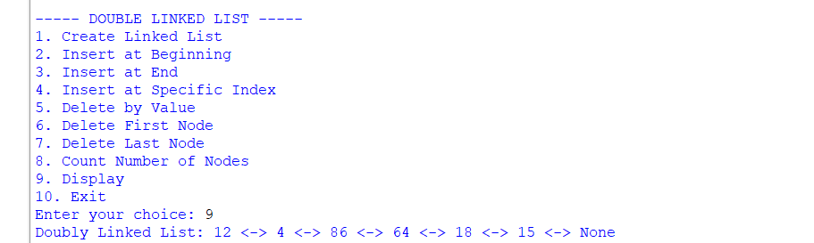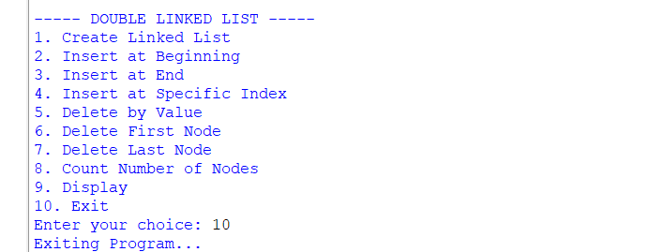
Negative Case;
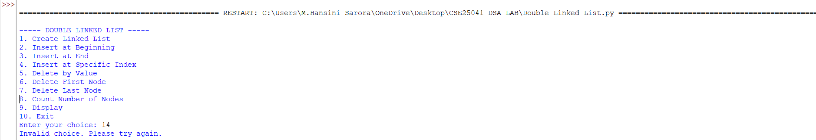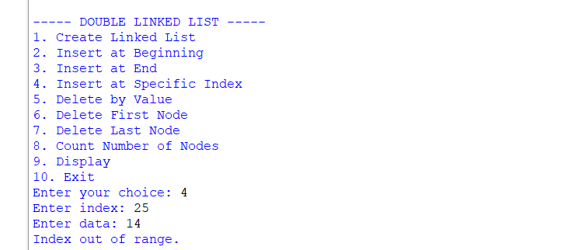

EXPLANATION:
1. Node Class
- Each node stores:
  - data: the actual value.
  - prev: pointer to the previous node.
  - next: pointer to the next node.
- This structure allows traversal in both directions (forward and backward).
2. Double Linked List Class
This class manages the linked list. It starts with self.head = None (empty list). It provides several operations:
a. Create Linked List
- User specifies how many nodes to create.
- Each new node is linked at the end.
- prev pointer connects the new node to the previous one.
b. Insert at Beginning
- A new node is created.
- Its next points to the current head.
- The old head’s prev points back to the new node.
- The new node becomes the head.
c. Insert at End
- Traverse to the last node.
- Attach the new node at the end.
- Update prev of the new node to point to the last node.
d. Insert at Specific Index
- Traverse until the given index.
- Insert the new node between two nodes.
- Adjust both next and prev pointers to maintain the chain.
e. Delete by Value
- Search for the node with the given value.
- If found:
  - If it’s the head, move head to the next node.
  - Otherwise, adjust prev.next and next.prev to bypass the node.
- This removes the node from the chain.
f. Delete First Node
- Move head to the second node.
- Set its prev to None.
g. Delete Last Node
- Traverse to the last node.
- Remove it by setting its previous node’s next to None.
h. Count Nodes
- Traverse the list, incrementing a counter.
- Prints the total number of nodes.
i. Display
- Traverse from head to end.
- Print each node’s data in the format: data <-> data <-> ... None
3. Main Program (Menu-Driven)
- Runs an infinite loop with options:
  - Create Linked List
  - Insert at Beginning
  - Insert at End
  - Insert at Specific Index
  - Delete by Value
  - Delete First Node
  - Delete Last Node
  - Count Nodes
  - Display
10.Exit
- Based on user choice, the corresponding method is executed.

ERROR TABLE:

S.NO | Error Obtained | Rectification
1. | Invalid index entered (negative or too large). | Add a check: if index < 0 → print "Invalid index"; if traversal reaches None before index → print "Index out of range".
2. | Deleting from an empty list. | Before deletion, check if self.head is None: → print "Doubly Linked List is empty."
3. | Value not found during deletion by value. | Traverse list; if node not found → print "value not found in the Linked List."
4. | Insertion at index when list is empty but index > 0. | Handle separately: if self.head is None and index! = 0 → print "Index out of range."

4c. AIM: Write a python program to implement a circular linked list which would perform the below operations, by taking an input from the user.
a. Create a linked list. b. Insert at beginning. c. Insert at end.
d. Insert at a specific index. e. Delete by value. f. Delete 1st node.
g. Delete last node. h. Count no. of nodes i. Display.
j. Display head and tail. k. Print data from tail to head. l. Exit.
PROGRAM:

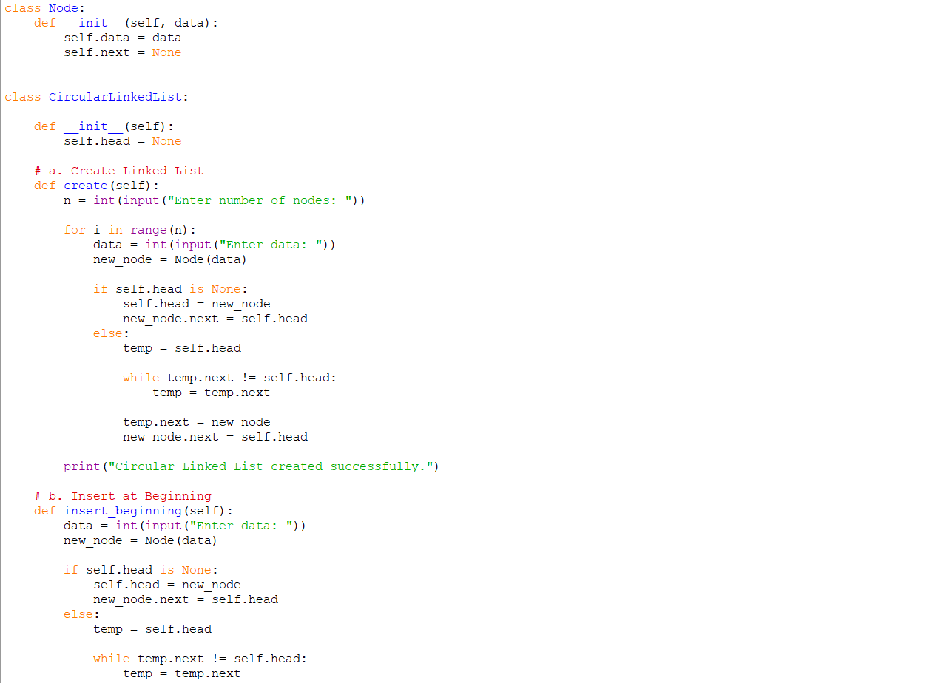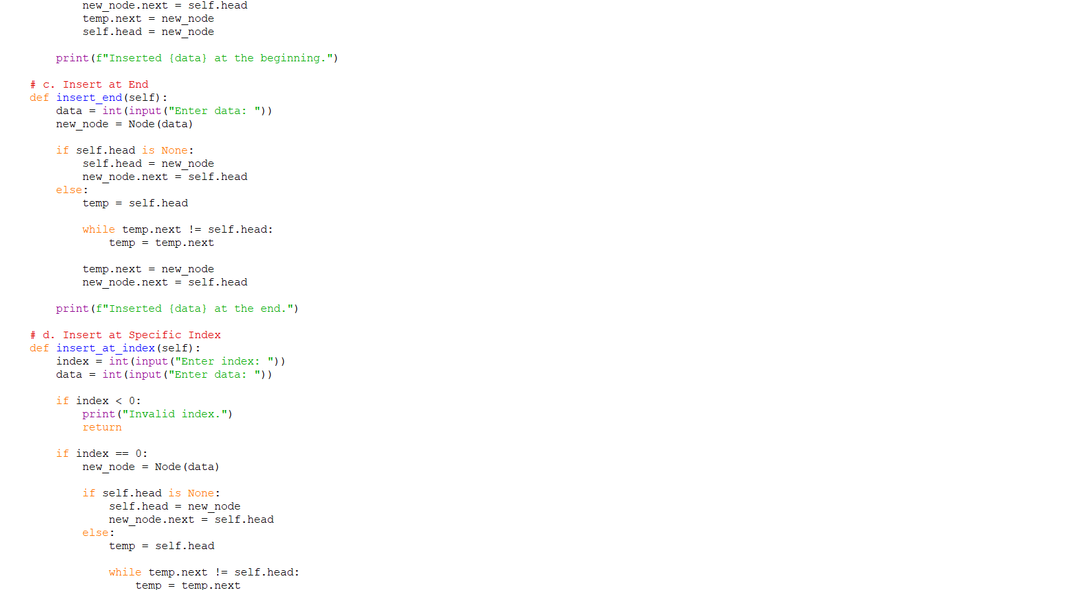

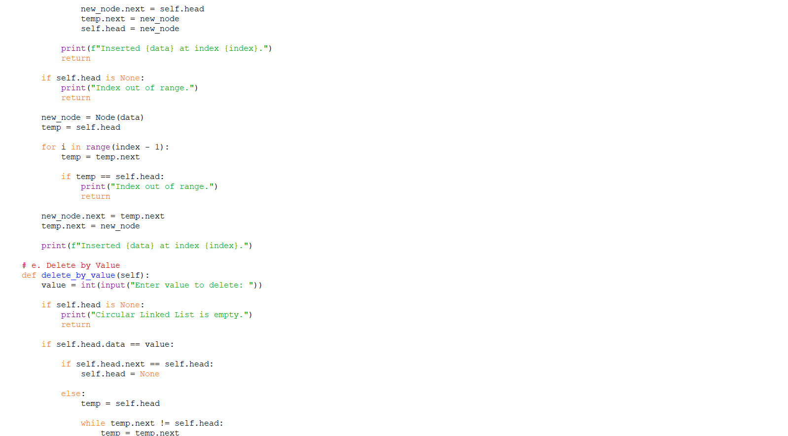
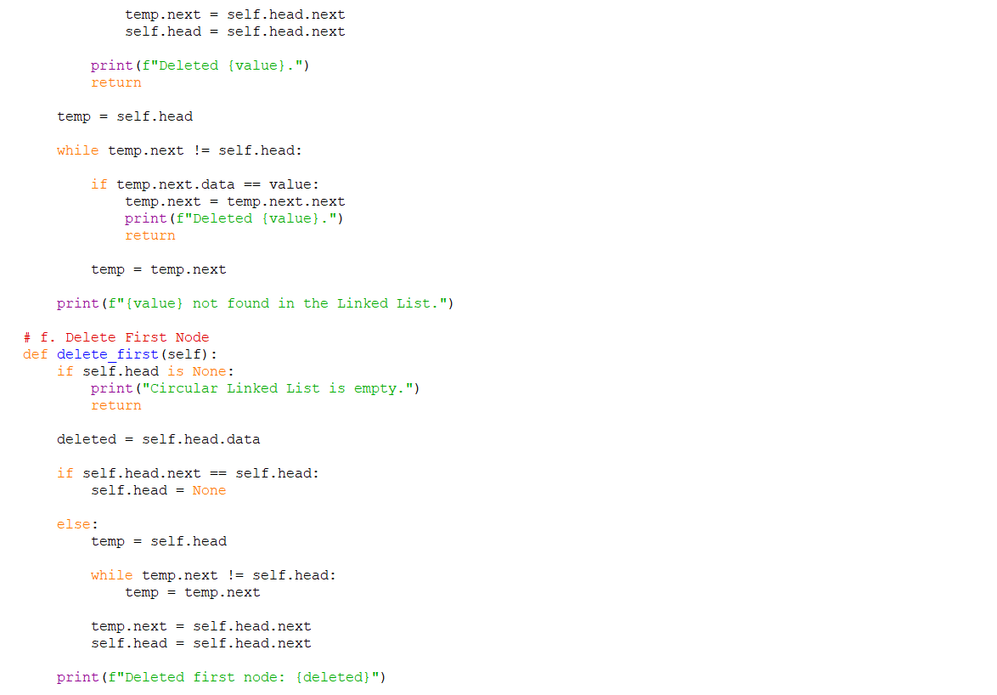
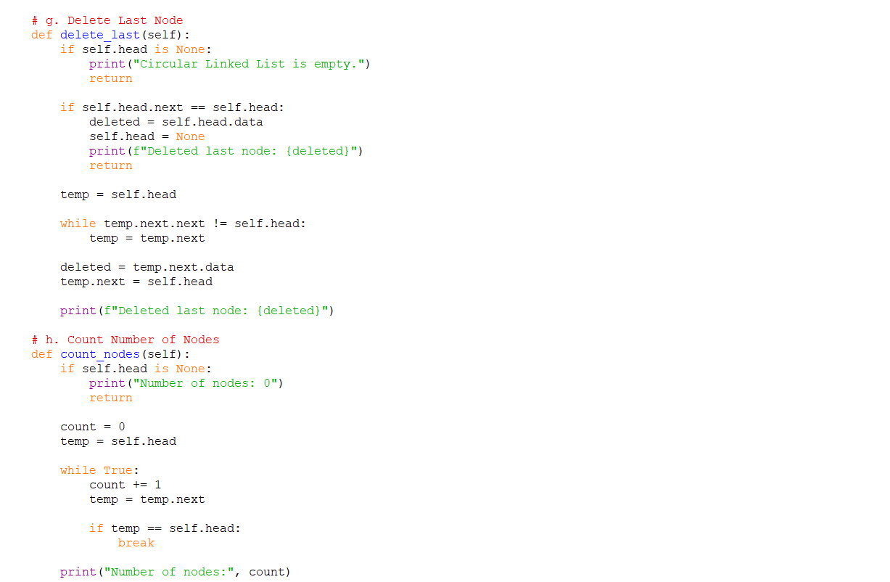
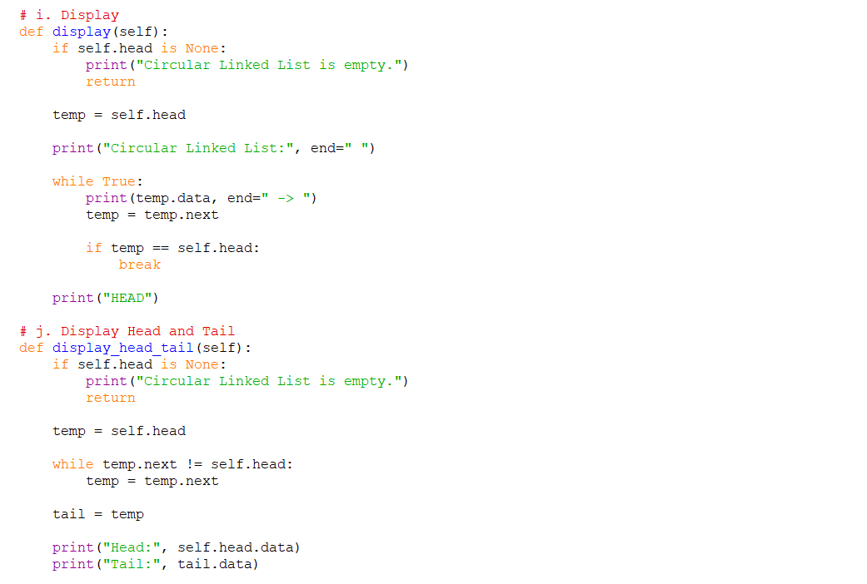
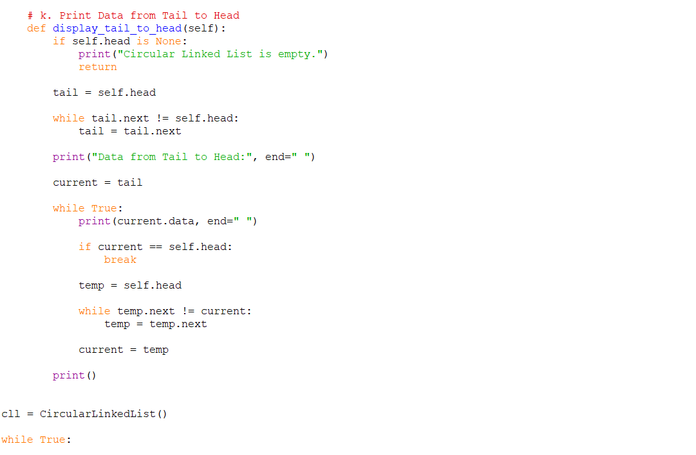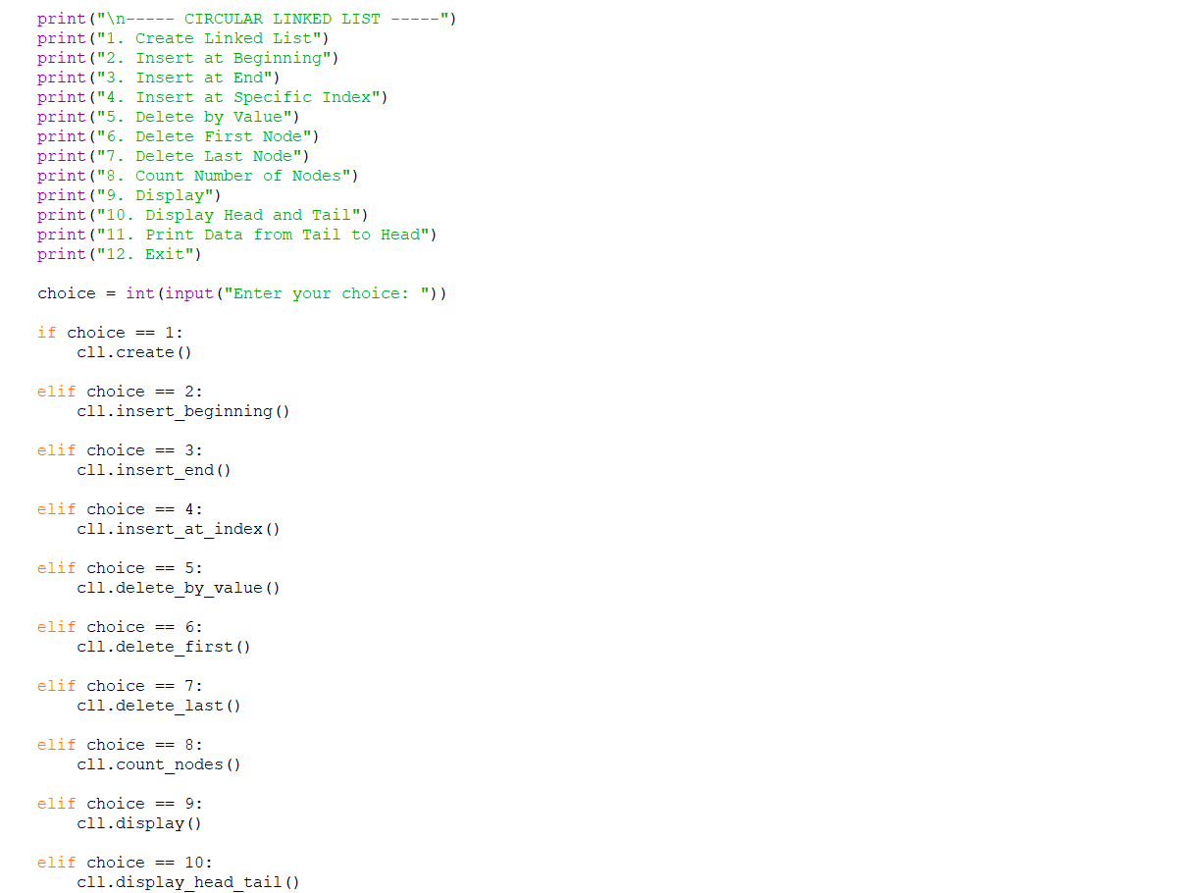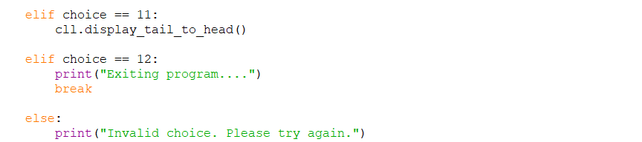

OUTPUT:
Positive Case;
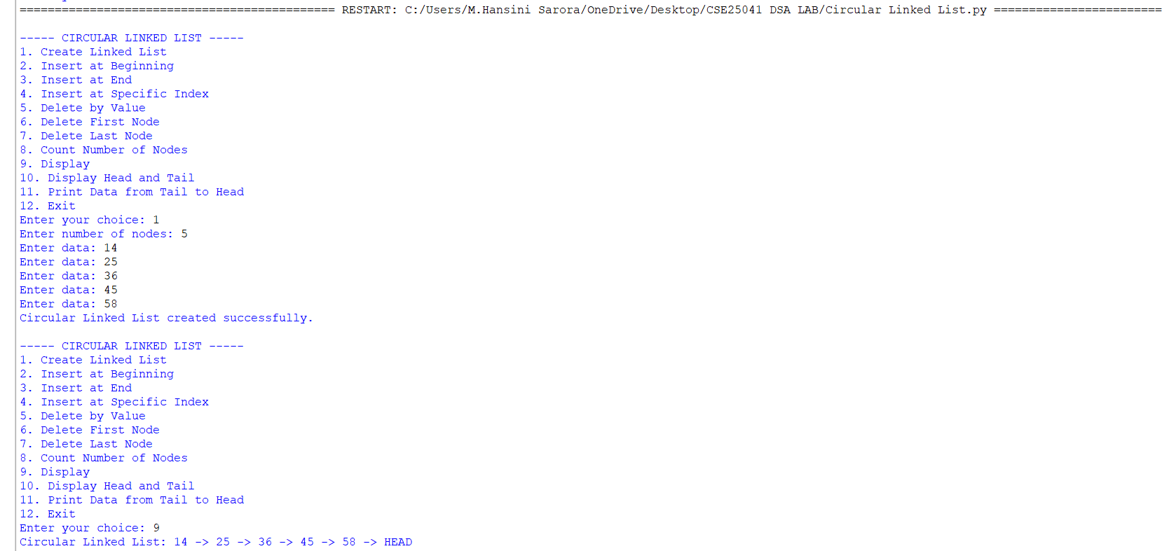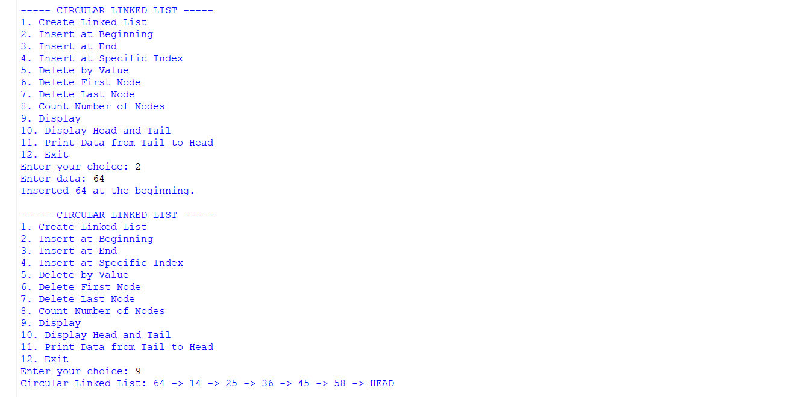

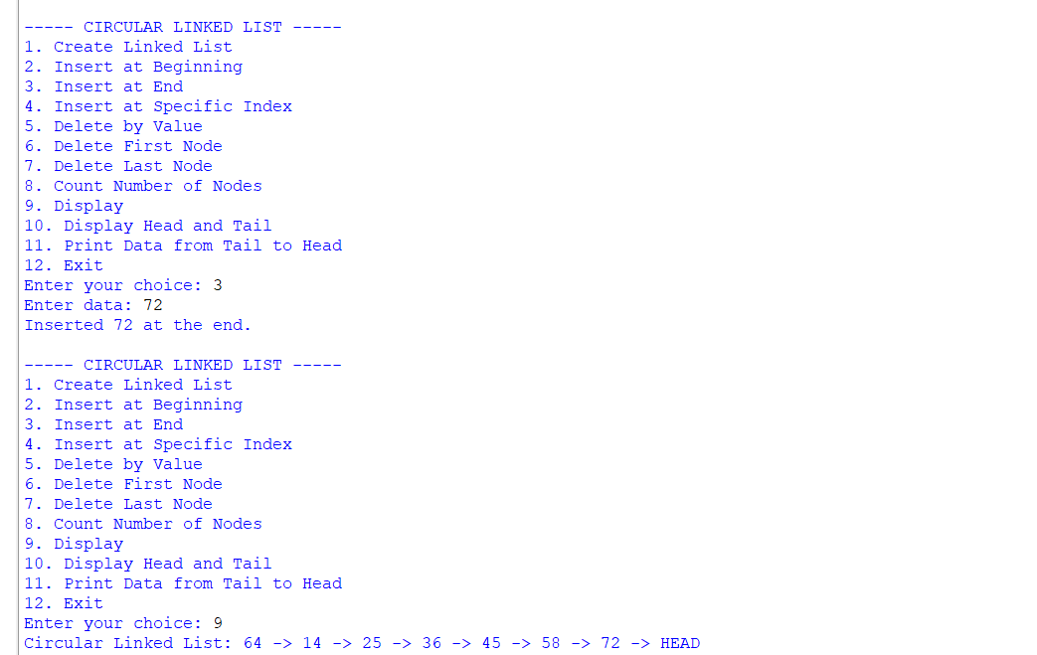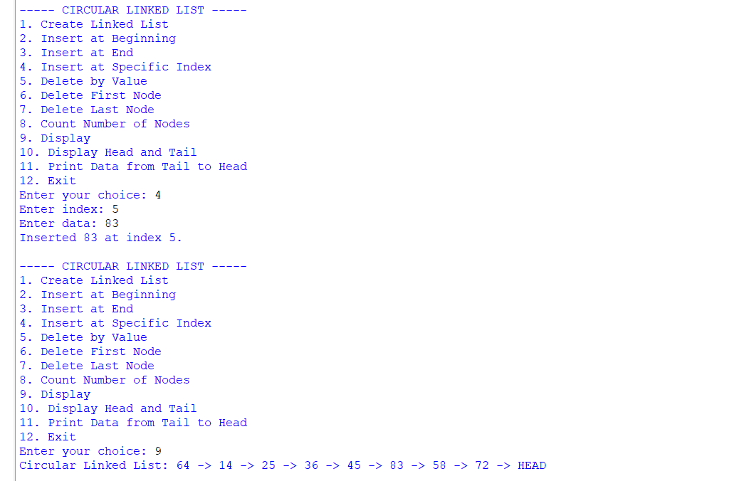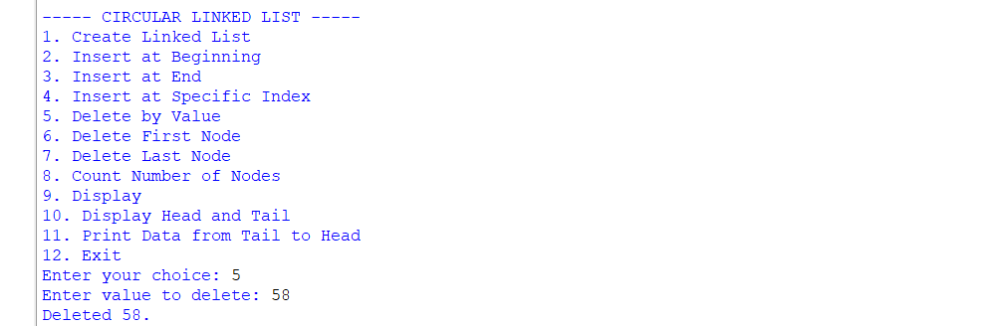
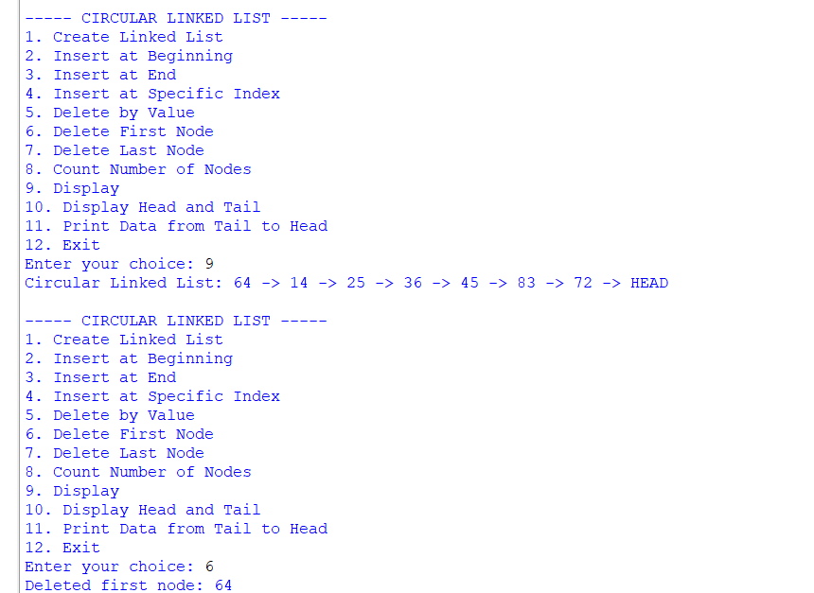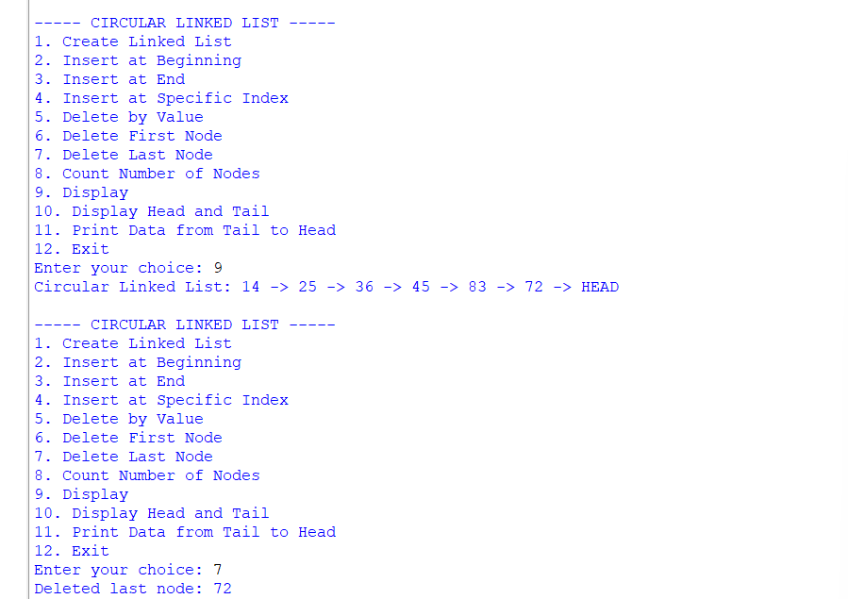
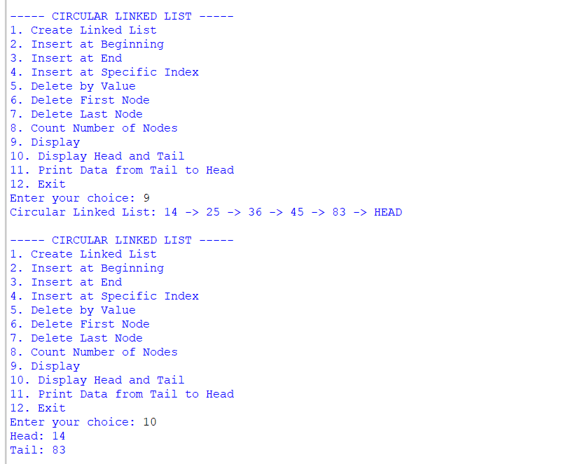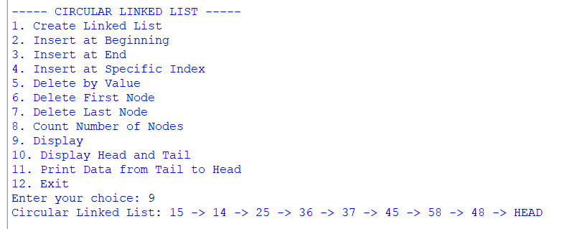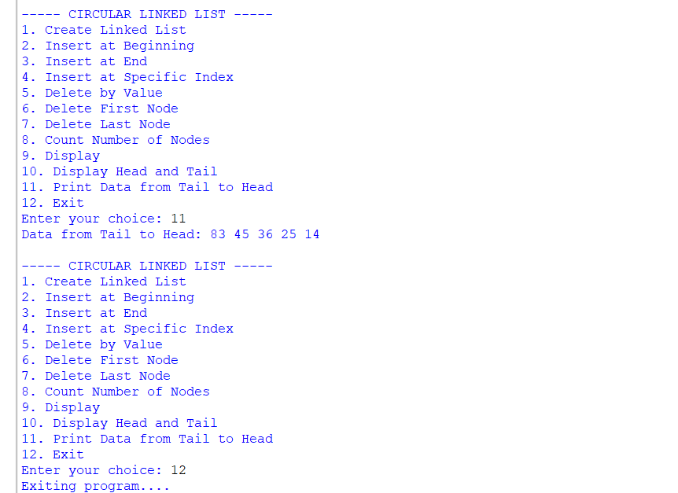

Negative Case;
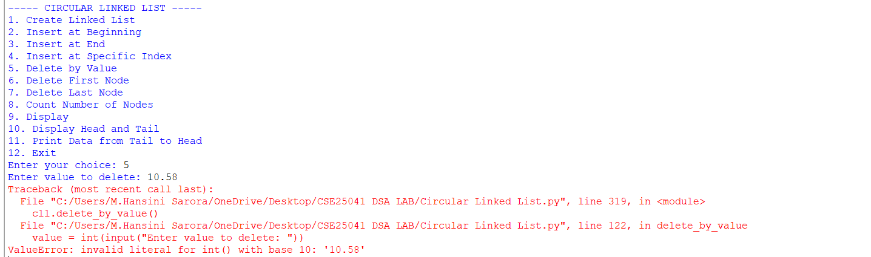

EXPLANATION:
1. Node Class
- Each node stores:
  - data: the value.
  - next: pointer to the next node.
- In a circular linked list, the last node’s next points back to the head, forming a circle.
2. Circular Linked List Class
This class manages the linked list. It starts with self.head = None (empty list). It provides several operations:
a. Create Linked List
- User specifies number of nodes.
- Each new node is linked at the end.
- The last node’s next points back to the head, ensuring circularity.

b. Insert at Beginning
- A new node is created.
- It becomes the new head.
- The last node’s next is updated to point to this new head.
c. Insert at End
- Traverse to the last node.
- Attach the new node after it.
- New node’s next points back to head.
d. Insert at Specific Index
- If index = 0 → same as inserting at beginning.
- Otherwise, traverse to the given position.
- Insert the new node between two nodes.
- Maintain circularity by adjusting next pointers.
e. Delete by Value
- Search for the node with the given value.
- If it’s the head:
- If only one node exists → set head to None.
Otherwise, adjust last node’s next to point to new head.
- If it’s in the middle → bypass the node by linking previous node’s next to the next node.
f. Delete First Node
- If only one node → set head to None.
- Otherwise, move head to the second node and update last node’s next.

g. Delete Last Node
- Traverse to the second-last node.
- Make its next point to head.
- Removes the last node.
h. Count Nodes
- Traverse until you return to head.
- Count nodes during traversal.
i. Display
- Print nodes starting from head.
- Stop when traversal returns to head.
- Shows circularity by ending with "HEAD".
j. Display Head and Tail
- Head = first node.
- Tail = last node (whose next points to head).
- Prints both values.
k. Print Data from Tail to Head
- Find tail.
- Traverse backward by repeatedly searching for the node whose next points to the current node.
- Prints values in reverse order until reaching head.
3. Main Program (Menu-Driven)
- Runs an infinite loop with give options.
- Based on user choice, the corresponding method is executed.

ERROR TABLE:

S.NO | Error Obtained | Rectification
1. | Display on empty list. | Add condition:  if self.head is None: → print "Circular Linked List is empty."
2. | Deleting from an empty list. | Before deletion, check if self.head is None: → print "Circular Linked List is empty."
3. |  | Ensure every insertion/deletion maintains circularity: last node’s next must always point to self.head.
  Infinite loop in traversal
  (if circularity broken).
4. | Reverse traversal  (Tail to Head) inefficient. | Current implementation repeatedly searches for predecessor. Rectify by using a doubly circular linked list if reverse traversal is frequent.

WEEK – 5
5. AIM: Write a python program to implement a stack using an Array, Linked list. Implement the stack operations such as push, pop, peak and also display the stack elements.
PROGRAM:

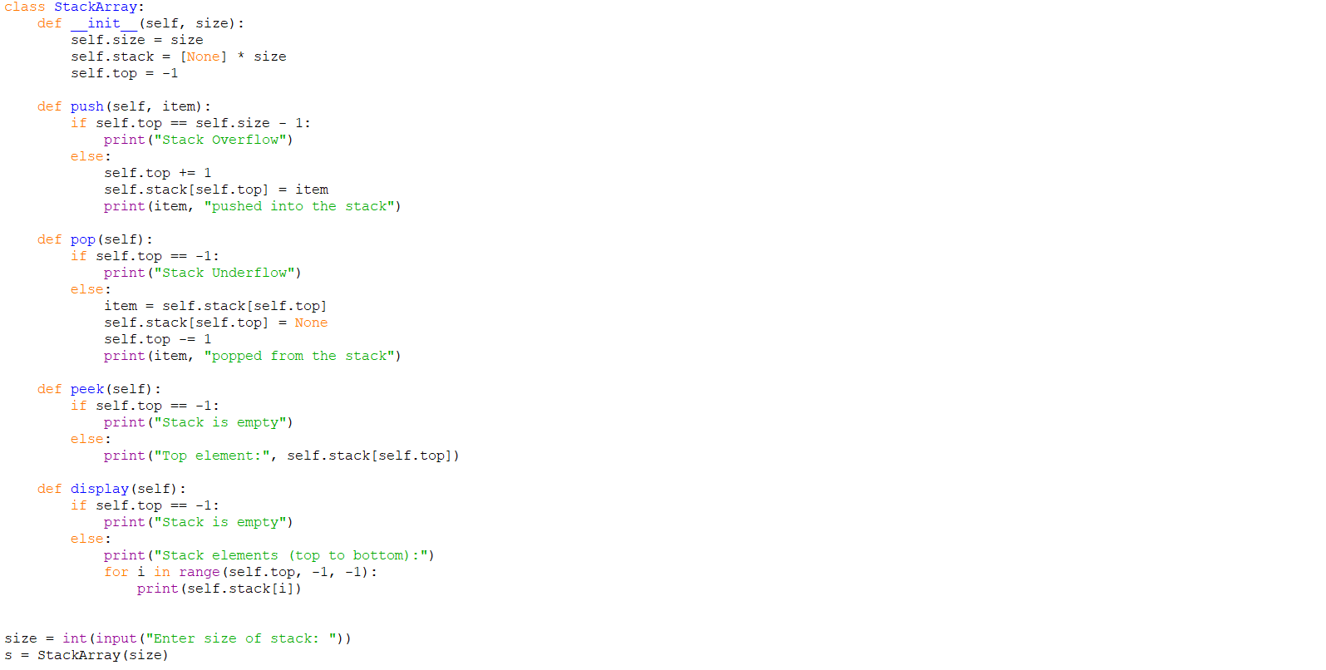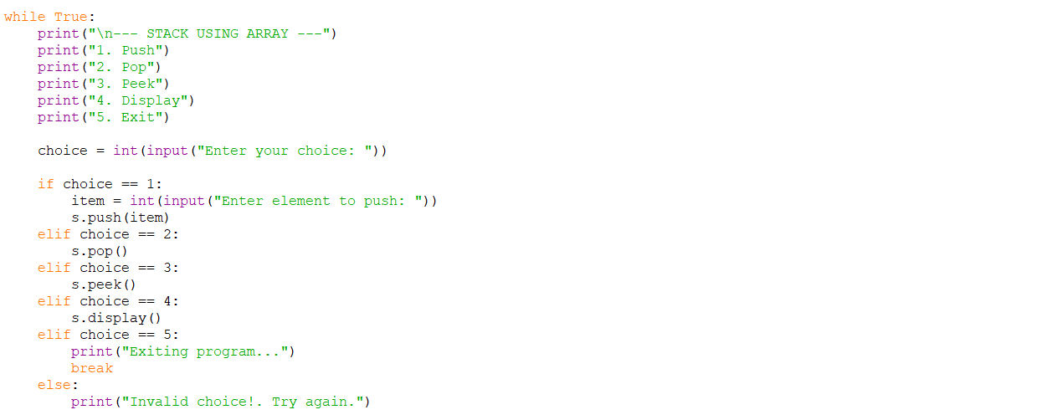

OUTPUT:
Positive Case;
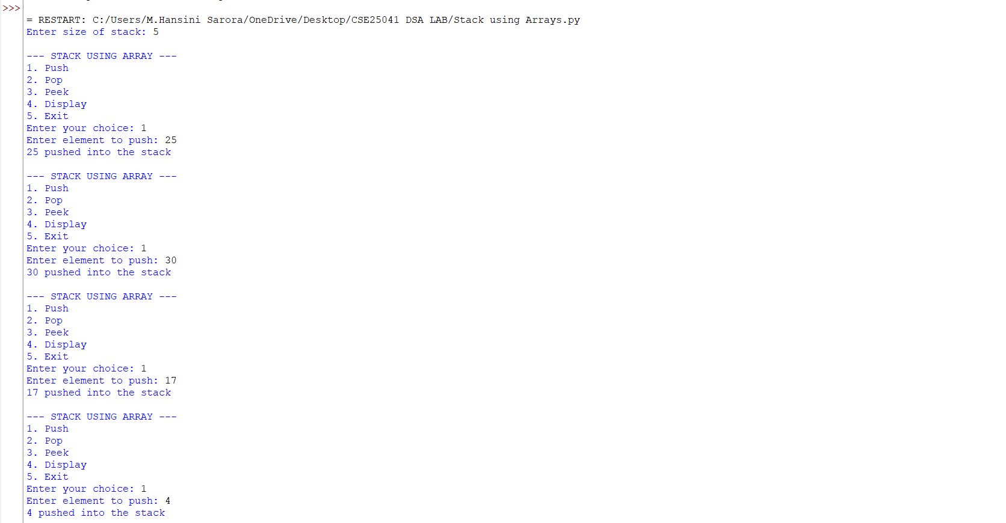
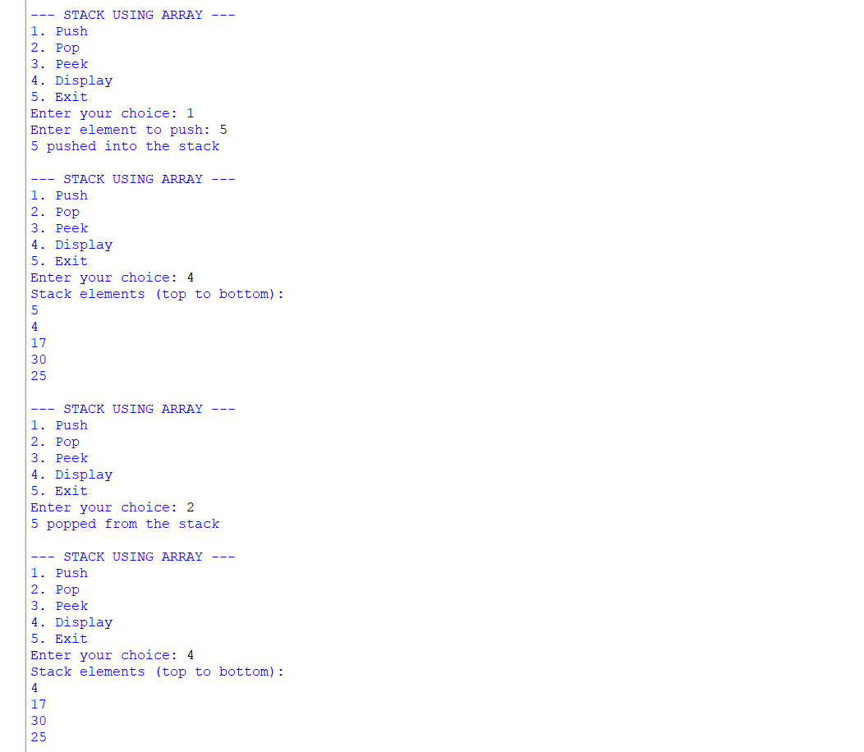
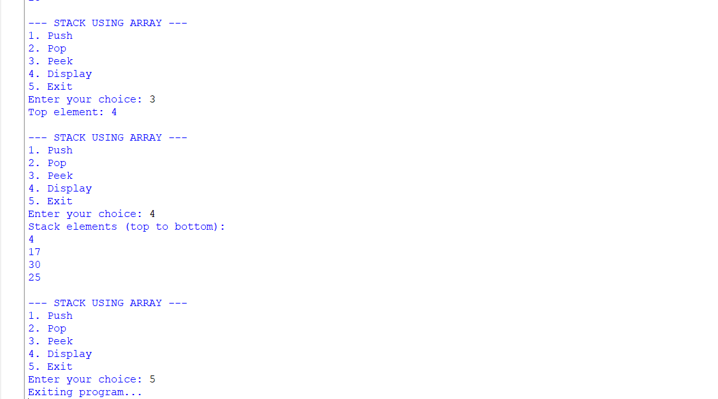
Negative Case;
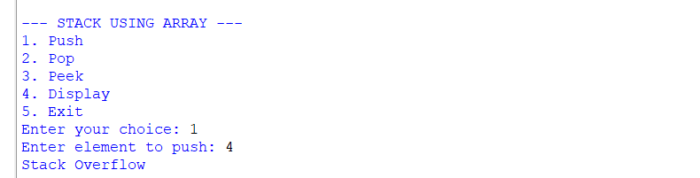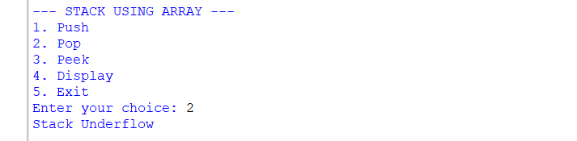
Stack Using Linked List;
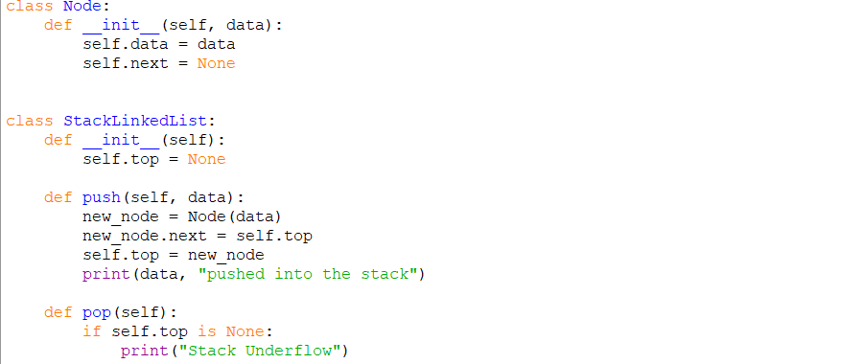

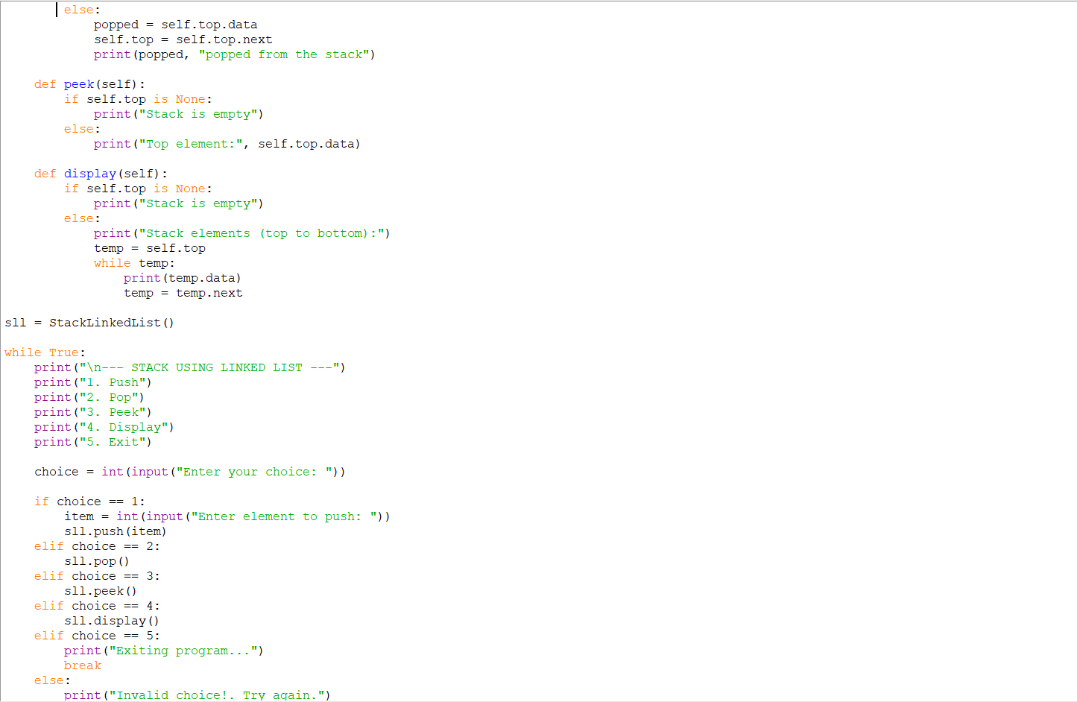
OUTPUT:
Positive Case;

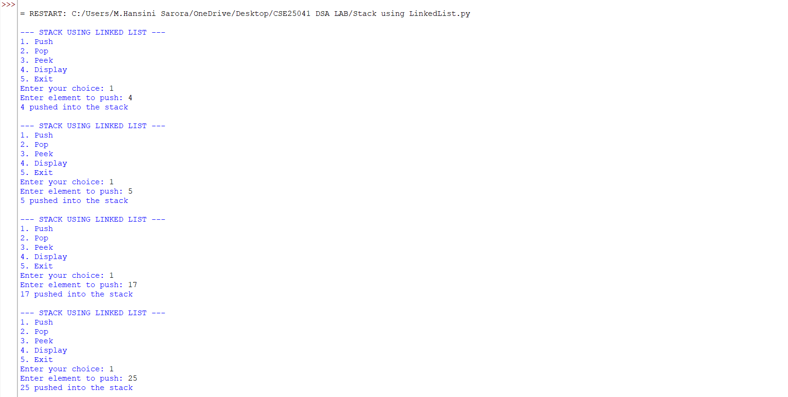
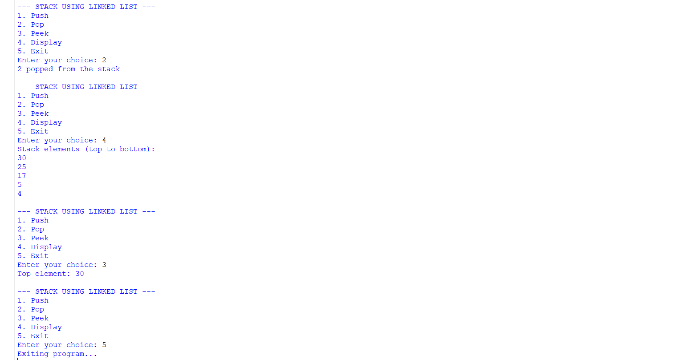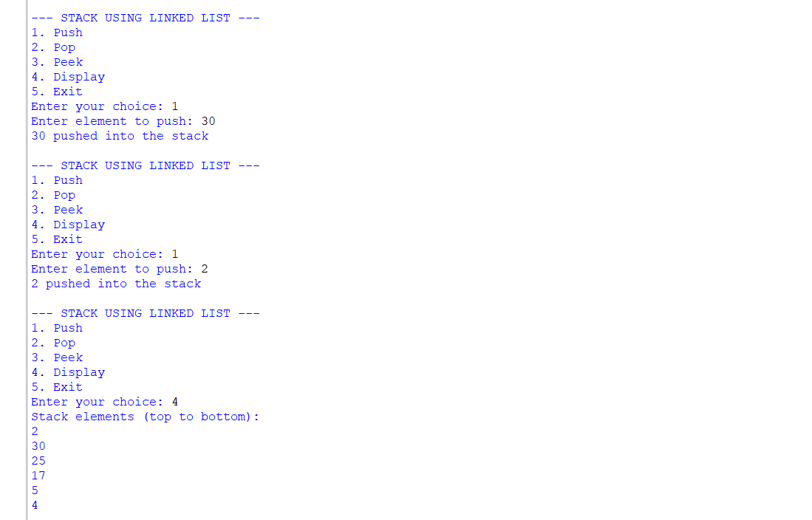
Negative Case;
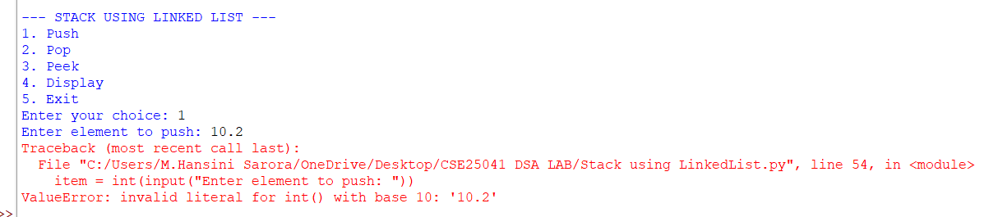

EXPLANATION:
🧩 Stack Using Array
Structure:
- Uses a Python list (self.stack) to store elements.
- self.top keeps track of the index of the last pushed element.
- self.size defines the maximum capacity.
Operations:
- Push
  - Check if top == size - 1 → Overflow.
  - Otherwise, increment top and insert the element at that position.
- Pop
  - Check if top == -1 → Underflow (empty stack).
  - Otherwise, remove the element at top, decrement top.
- Peek
  - Shows the element at top without removing it.
- Display
  - Prints elements from top down to 0 (top to bottom order).
🧩 Stack Using Linked List
Structure:
- Each element is a Node with:
  - data (value)
  - next (pointer to the next node).
- self.top points to the most recently pushed node.
Operations:
- Push
  - Create a new node.
  - Link its next to the current top.
  - Update top to this new node.
- Pop
  - If top is None → Underflow.
  - Otherwise, remove the node at top and update top to top.next.
- Peek
  - Shows the data at top.
- Display
  - Traverse from top downwards, printing each node’s data.

ERROR TABLE:
S.NO | Error Obtained | Rectification
1. | def _init_(self, size): | Python expects two underscores before and after init.
2. | Display on empty stack. | Add condition: if self.top is None: → print  "Stack is empty".
3. |  | Add a check: if self.top == self.size - 1: → print "Stack Overflow".
  Stack Overflow
  when pushing beyond the defined size
4. | Stack Underflow  when popping from empty stack | Add a check: if self.top is None: → print "Stack Underflow".
5. | Syntax error | Later it was rectified in the for loop of display section.
WEEK – 6
6. AIM: To implement Queue and its operations such as Enqueue, Dequeue, Peek, Display with a menu driven approach.
6a. Using Array, Linked list, Data structures.
6b. Circular Queue.
PROGRAM:
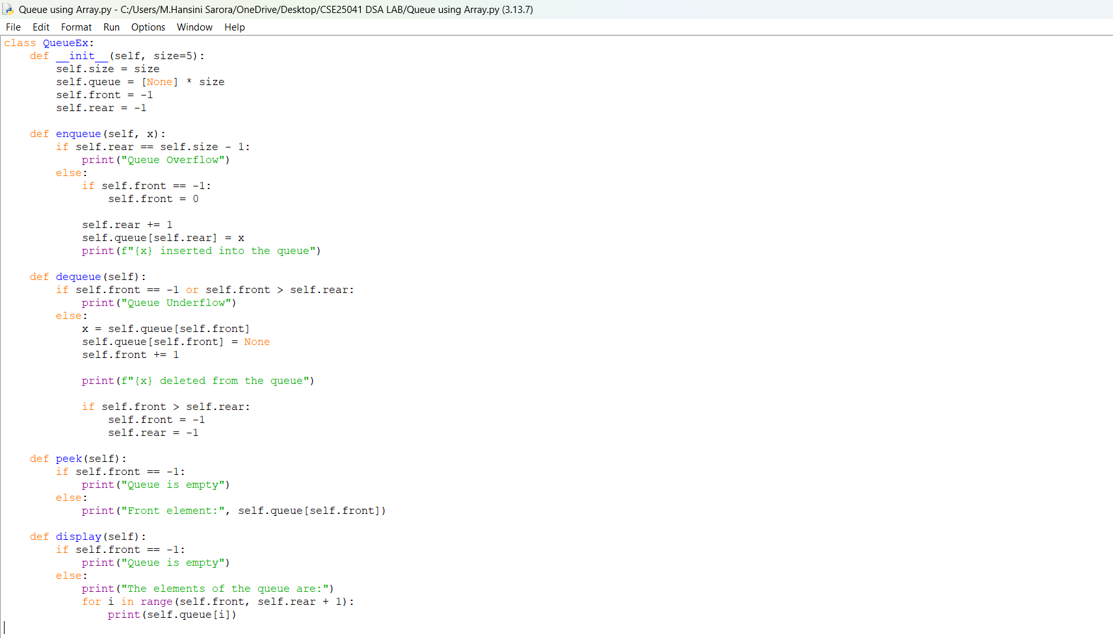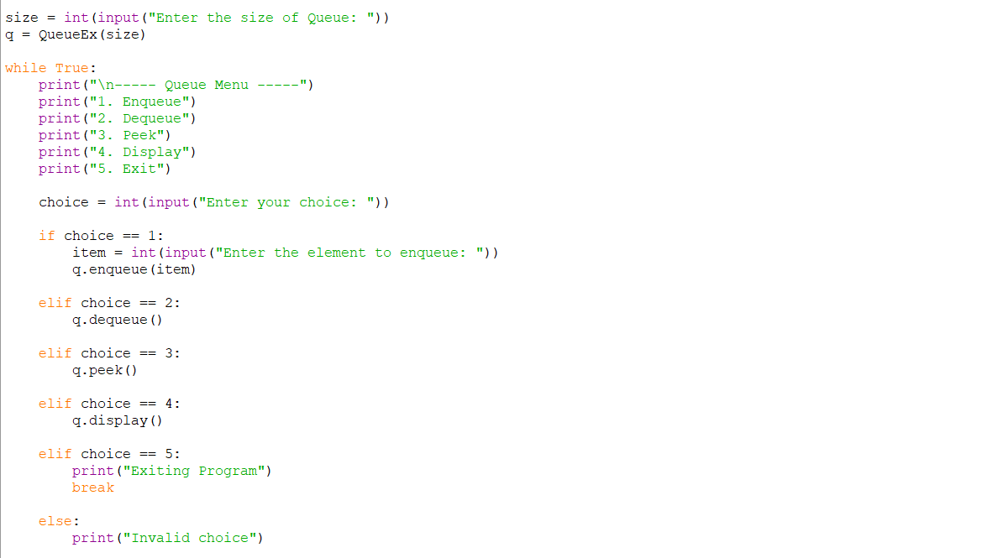
OUTPUT:
Positive Case;
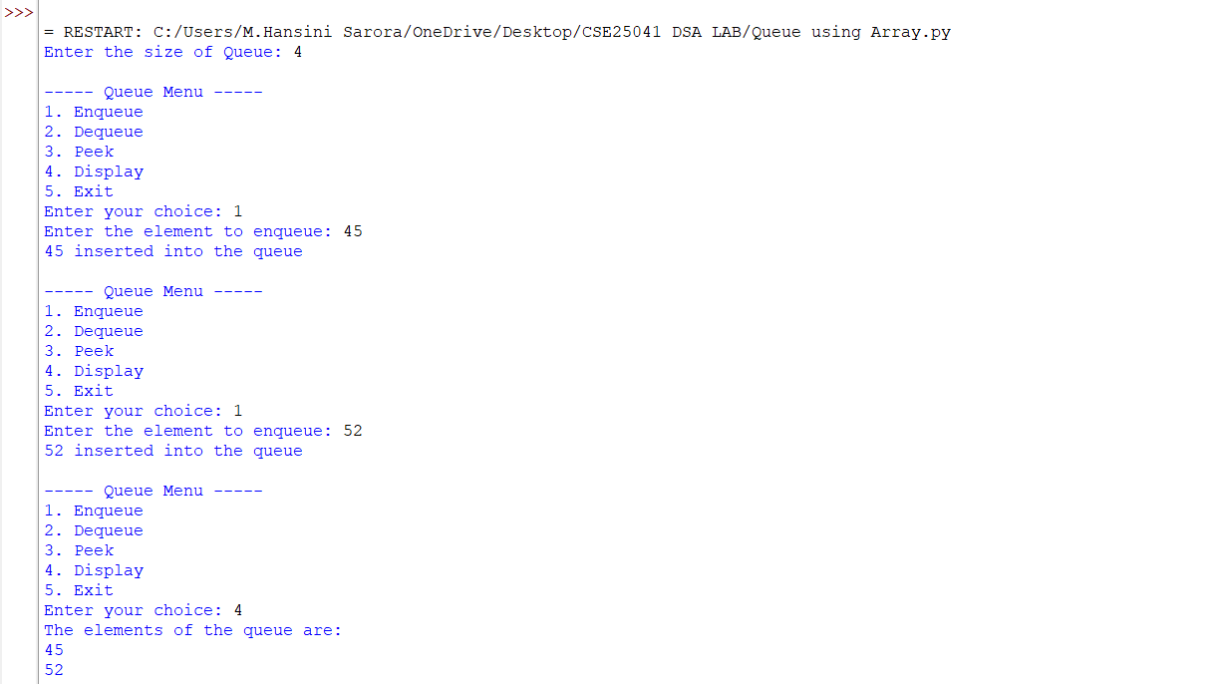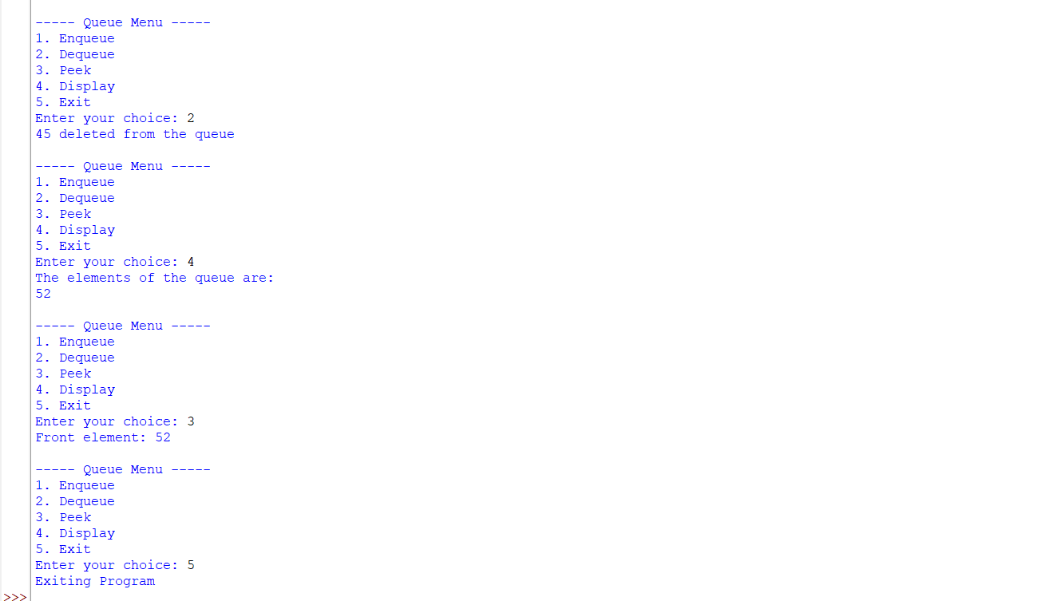

Negative Case;
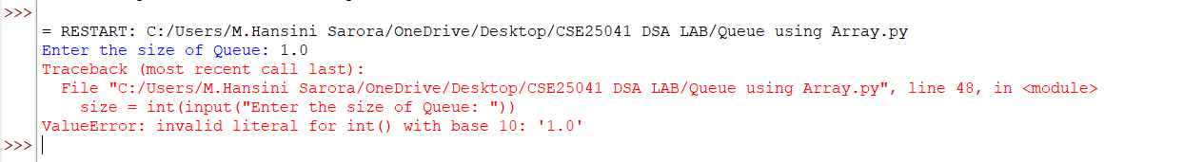

Linked List.,
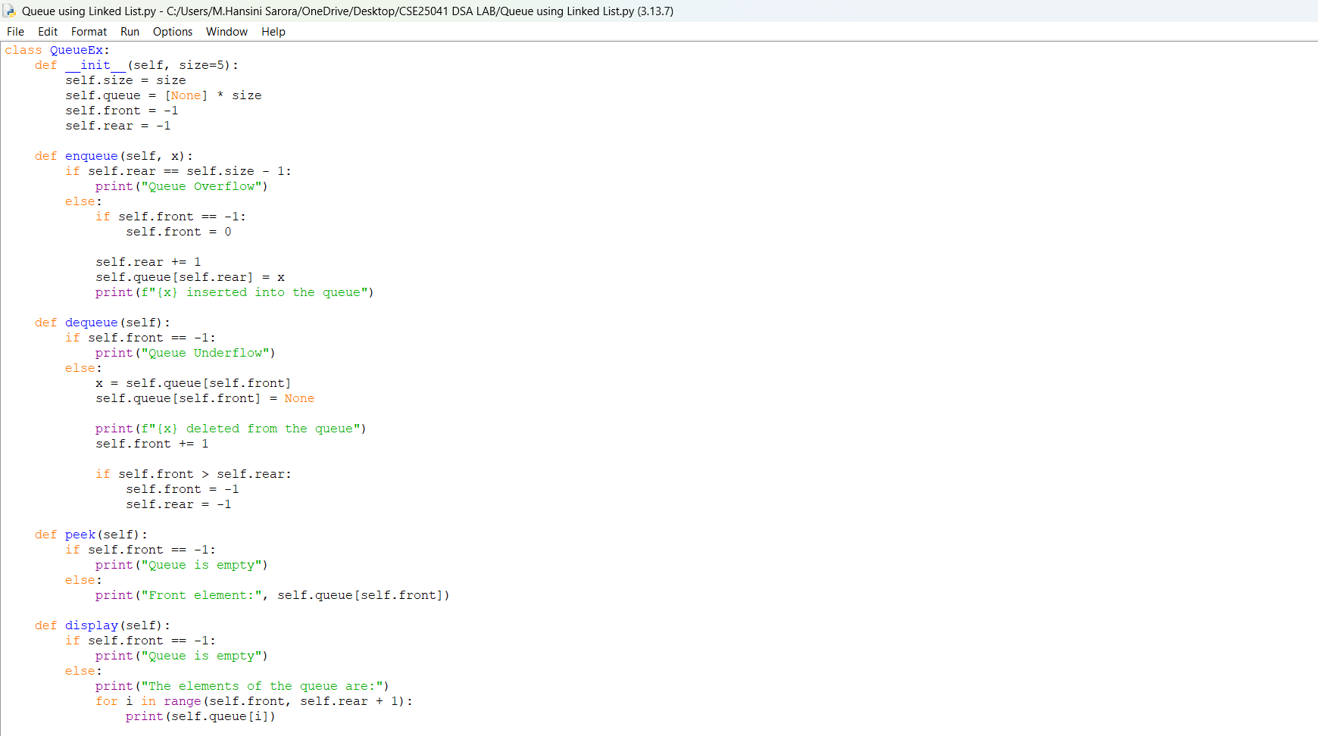
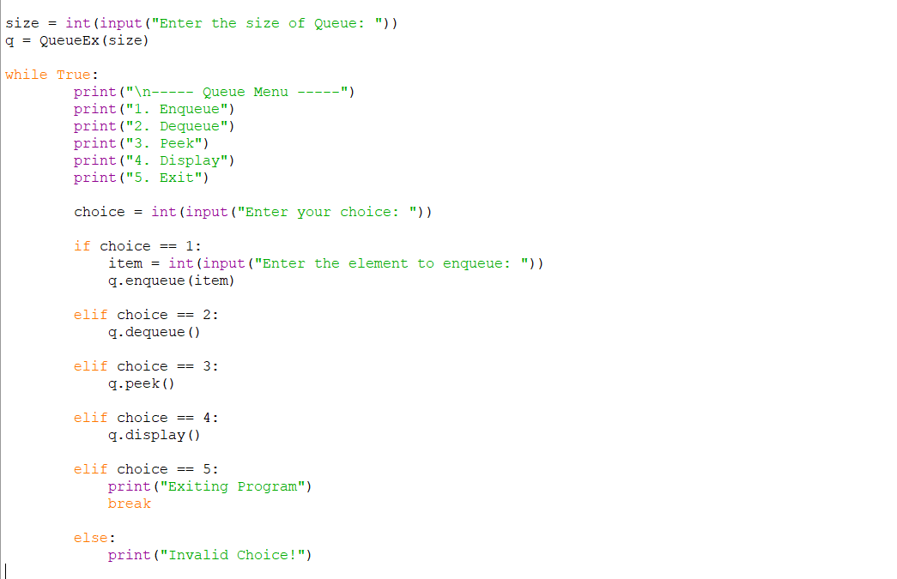
OUTPUT:
Positive Case;
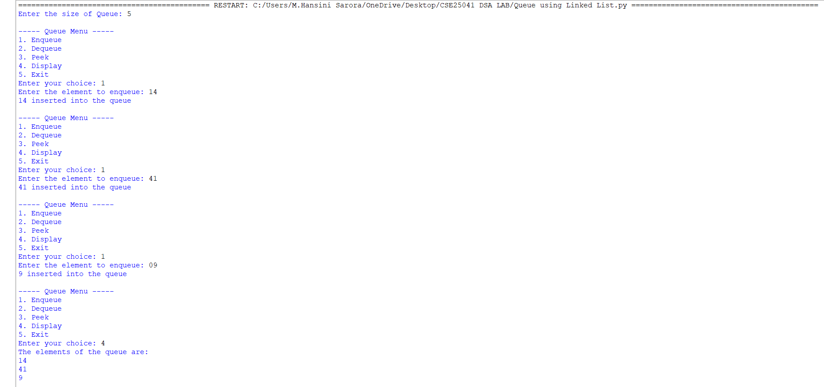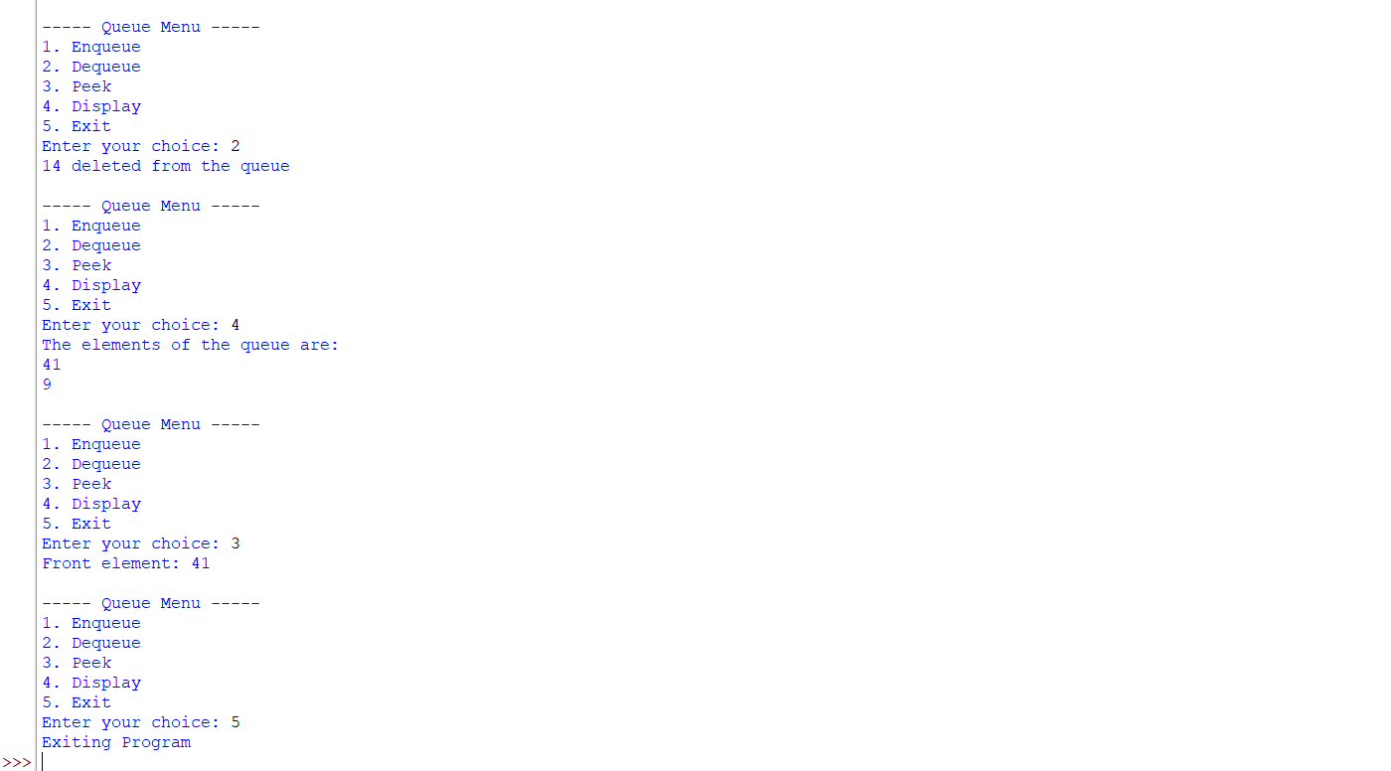
Negative Case;
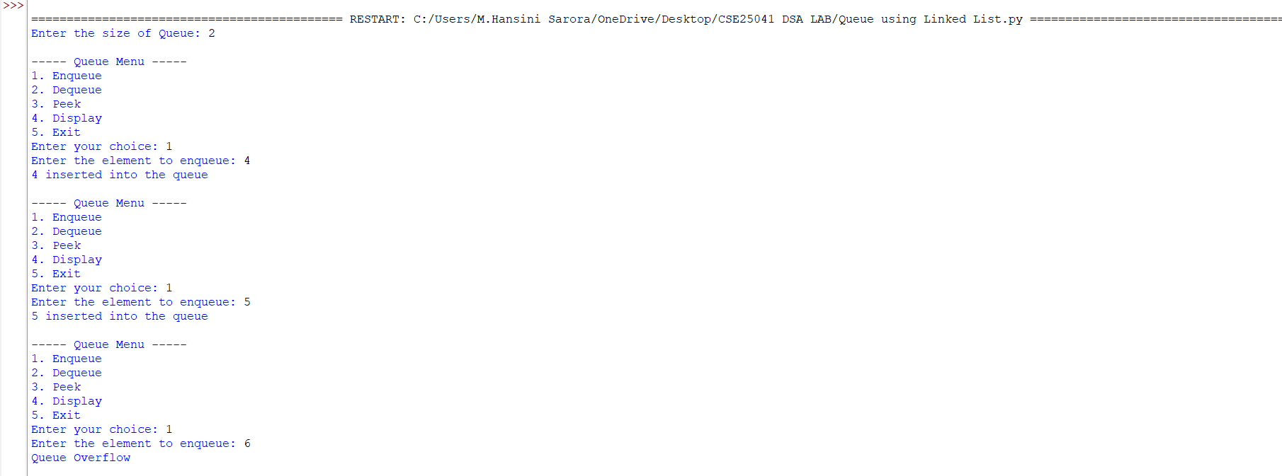
EXPLANATION:
🔹 What is a Queue?
- A Queue is a linear data structure that follows the FIFO (First In First Out) principle.
- Elements are inserted at the rear and removed from the front.
Arrays:
🔹 Components in the Code
- Initialization (__init__)
  - Creates a queue of fixed size.
  - Uses an array (self.queue) to store elements.
  - front and rear pointers track the first and last elements.
  - Both start at -1 (empty queue).
- Enqueue (Insertion)
  - Adds an element at the rear.
  - If rear == size - 1, → Overflow (queue full).
  - If queue is empty (front == -1), set front = 0.
  - Increment rear and insert the element.
- Dequeue (Deletion)
- Removes an element from the front.
- If queue is empty (front == -1 or front > rear), → Underflow.
- Deletes the element at front, increments front.
- If all elements are deleted (front > rear), reset both pointers to -1.
4. Peek
- Shows the element at the front without removing it.
- If empty, prints "Queue is empty".
5. Display
- Prints all elements between front and rear.
- If empty, prints "Queue is empty".
🔹 Menu-Driven Program
- User chooses operations from a menu:
  - Enqueue → Insert element.
  - Dequeue → Remove element.
  - Peek → Show front element.
  - Display → Show all elements.
  - Exit → End program.
- The loop continues until the user selects Exit.
🔹 Characteristics of This Queue
- It is a Linear Queue (not circular).
- Overflow occurs when rear == size - 1.
- Underflow occurs when queue is empty.
- Once rear reaches the end, no more insertions are possible even if earlier slots are freed (limitation of linear queue).
Linked List:
🔹 Structure in the Code
- Initialization (__init__)
  - Creates a queue of fixed size (default = 5).
  - Uses an array (self.queue) to store elements.
  - front and rear pointers track the first and last elements.
  - Both start at -1 (empty queue).
- Enqueue (Insertion)
  - Adds an element at the rear.
  - If rear == size - 1, → Overflow (queue full).
  - If queue is empty (front == -1), set front = 0.
  - Increment rear and insert the element.
- Dequeue (Deletion)
  - Removes an element from the front.
  - If queue is empty (front == -1), → Underflow.
  - Deletes the element at front, increments front.
  - If all elements are deleted (front > rear), reset both pointers to -1.
- Peek
  - Shows the element at the front without removing it.
  - If empty, prints "Queue is empty".
- Display
  - Prints all elements between front and rear.
  - If empty, prints "Queue is empty".
🔹 Characteristics of This Queue
- It is a Linear Queue (not circular).
- Overflow occurs when rear == size - 1.
- Underflow occurs when queue is empty (front == -1).
- Once rear reaches the end, no more insertions are possible even if earlier slots are freed (limitation of linear queue).

6b. To implement Circular Queue and its operation.
PROGRAM:
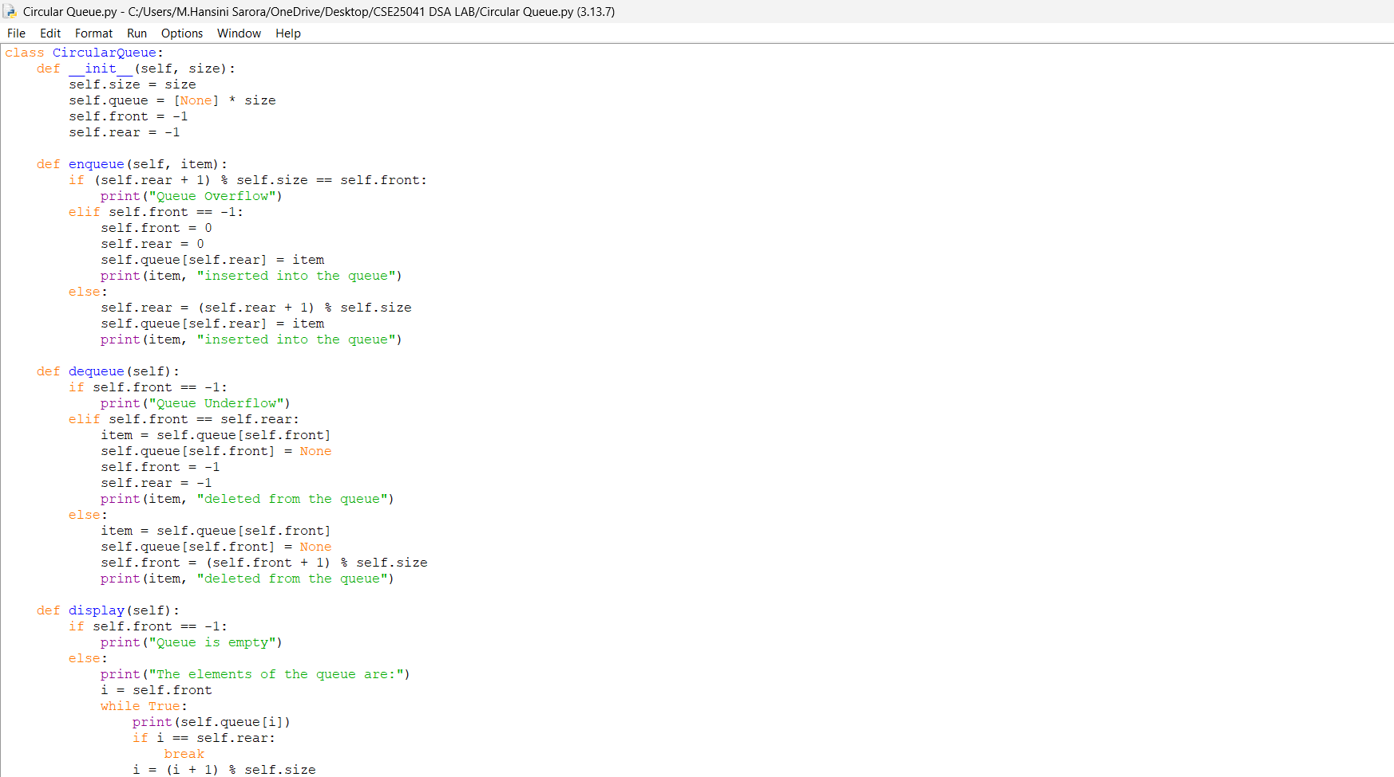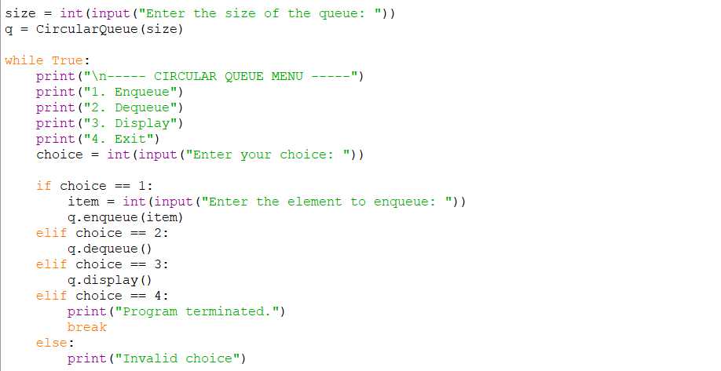

OUTPUT:
Positive Case;

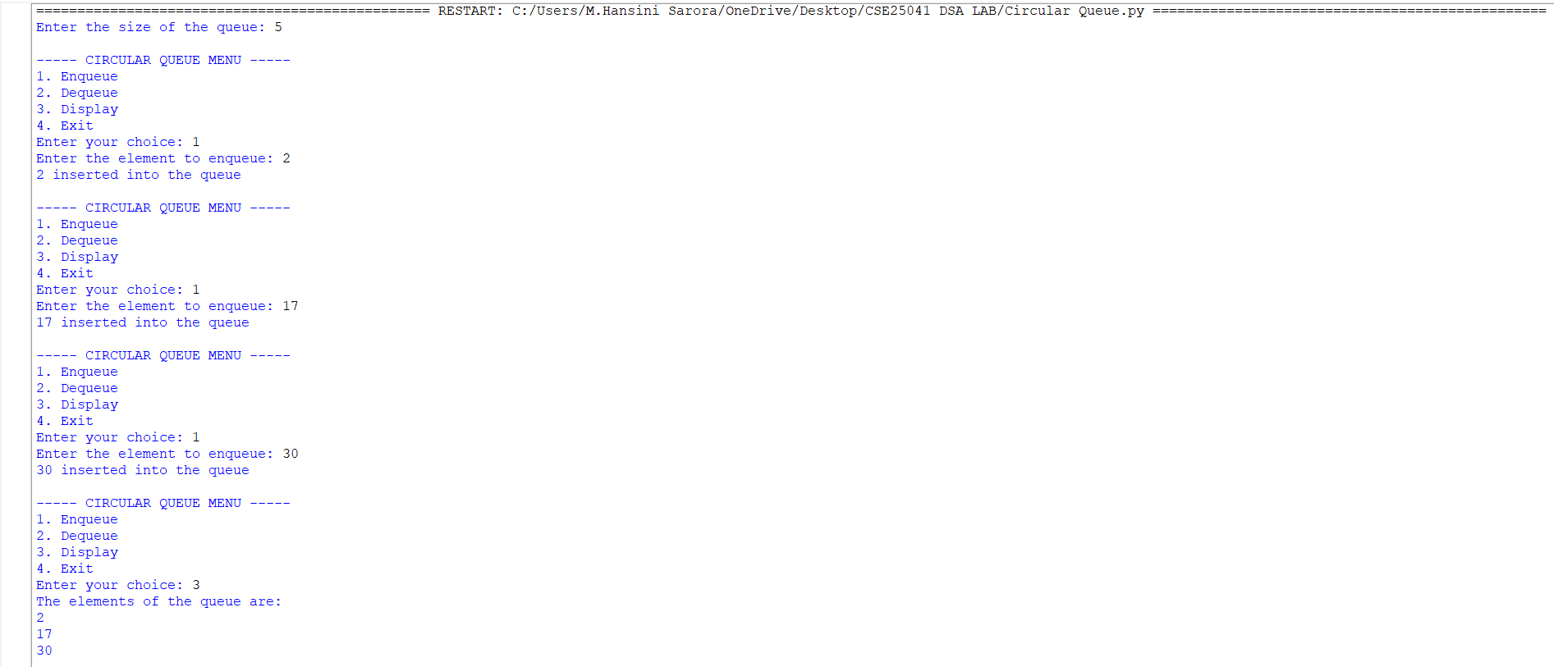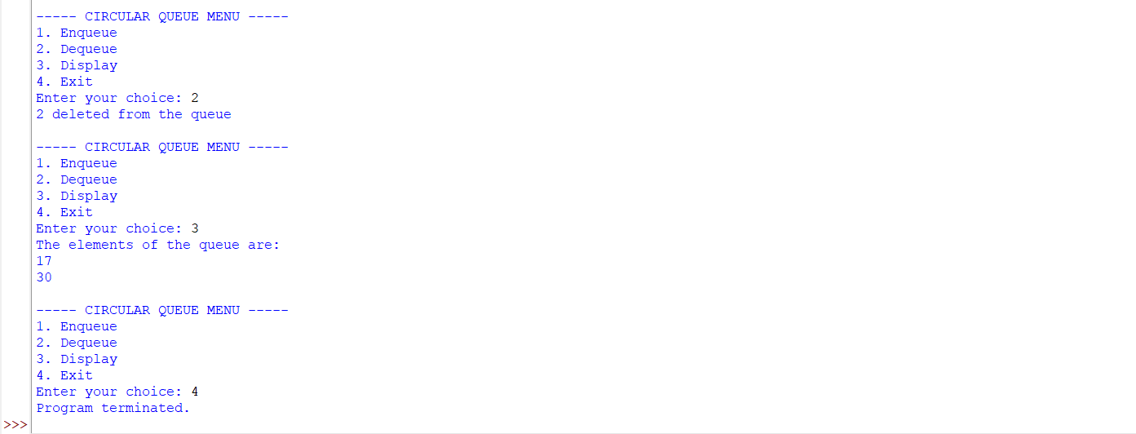
Negative Case;
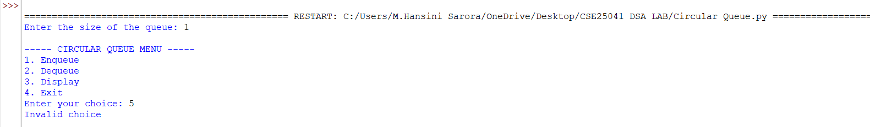

EXPLANATION:
🔹 Concept of Circular Queue
- A Circular Queue is a linear data structure that follows the FIFO (First In First Out) principle.
- Unlike a simple linear queue, the last position connects back to the first position, forming a circle.
- This design solves the problem of wasted space in a linear queue when elements are deleted from the front.
🔹 Structure in the Code
- Initialization (__init__)
  - Creates a queue of fixed size.
  - Uses an array (self.queue) to store elements.
  - front and rear pointers track the first and last elements.
  - Both start at -1 (empty queue).
- Enqueue (Insertion)
  - Adds an element at the rear.
  - Overflow occurs if (rear + 1) % size == front (queue full).
  - If queue is empty (front == -1), both front and rear are set to 0.
  - Otherwise, rear moves forward using modulo arithmetic: (rear + 1) % size.
3. Dequeue (Deletion)
- Removes an element from the front.
- Underflow occurs if front == -1 (queue empty).
- If only one element is left (front == rear), both pointers reset to -1.
- Otherwise, front moves forward using (front + 1) % size.
4.Display
- Prints all elements from front to rear using modulo arithmetic.
- Traverses circularly until it reaches the rear.
🔹 Menu-Driven Program
- User chooses operations from a menu:
  - Enqueue → Insert element.
  - Dequeue → Remove element.
  - Display → Show all elements.
  - Exit → End program.
- The loop continues until the user selects Exit.
🔹 Characteristics of Circular Queue
- Efficient use of memory: Freed spaces are reused.
- FIFO principle maintained.
- Overflow condition: (rear + 1) % size == front.
- Underflow condition: front == -1.

ERROR TABLE:
S.NO | Error Obtained | Rectification
1. | Redundant underflow check → Condition if self.front == -1 or self.front > self.rear: is slightly redundant because resetting pointers already handles empty state. | Simplify to if self.front == -1.
2. | Missing underflow condition → In dequeue, only checks if self.front == -1. If multiple deletions occur, front > rear is not handled, leading to incorrect behavior. | Add condition: if self.front == -1 or self.front > self.rear.
3. | Circular Queue: Display traversal limitation → Display prints values but not indices, making debugging harder. | Optional improvement: print both index and value.

WEEK – 7
7. AIM: Write a python program to implement binary tree
7a. Using Array, and
7b. Linked List
With all of its operation.
7a. Using Array,
PROGRAM:
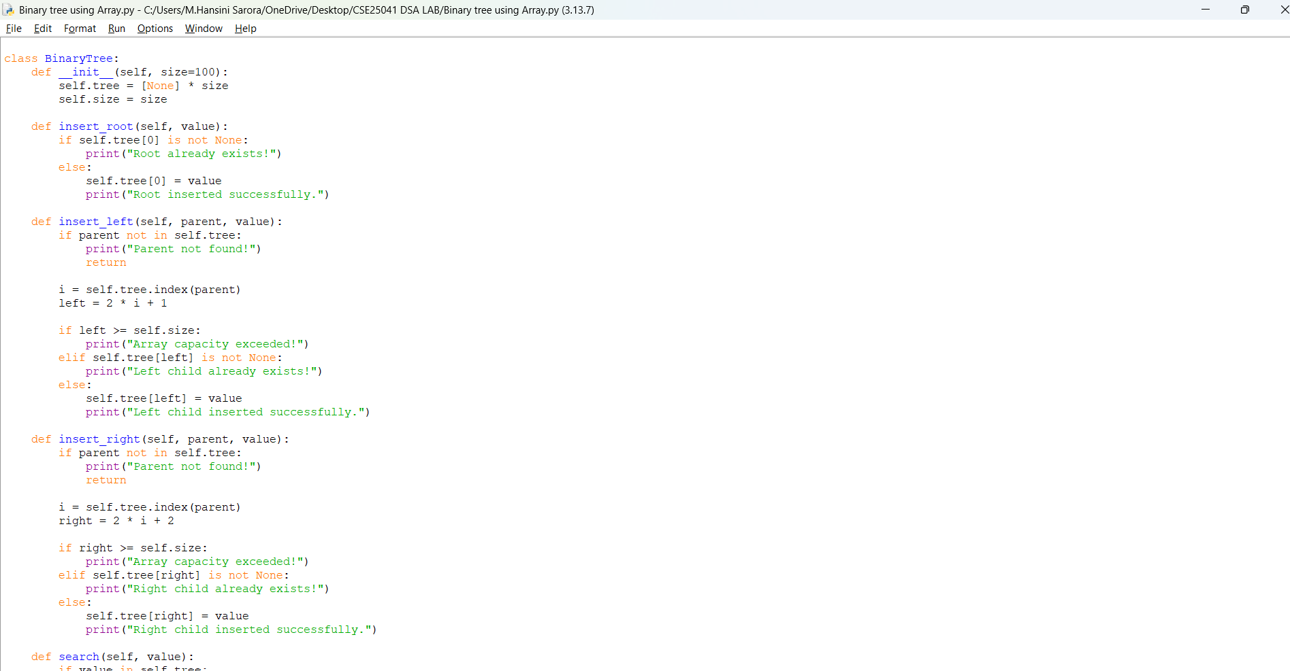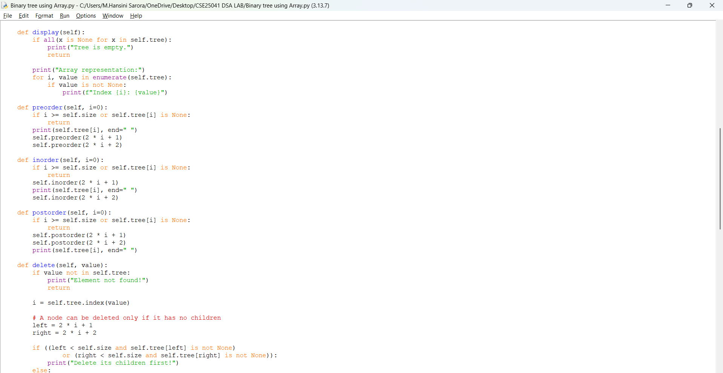
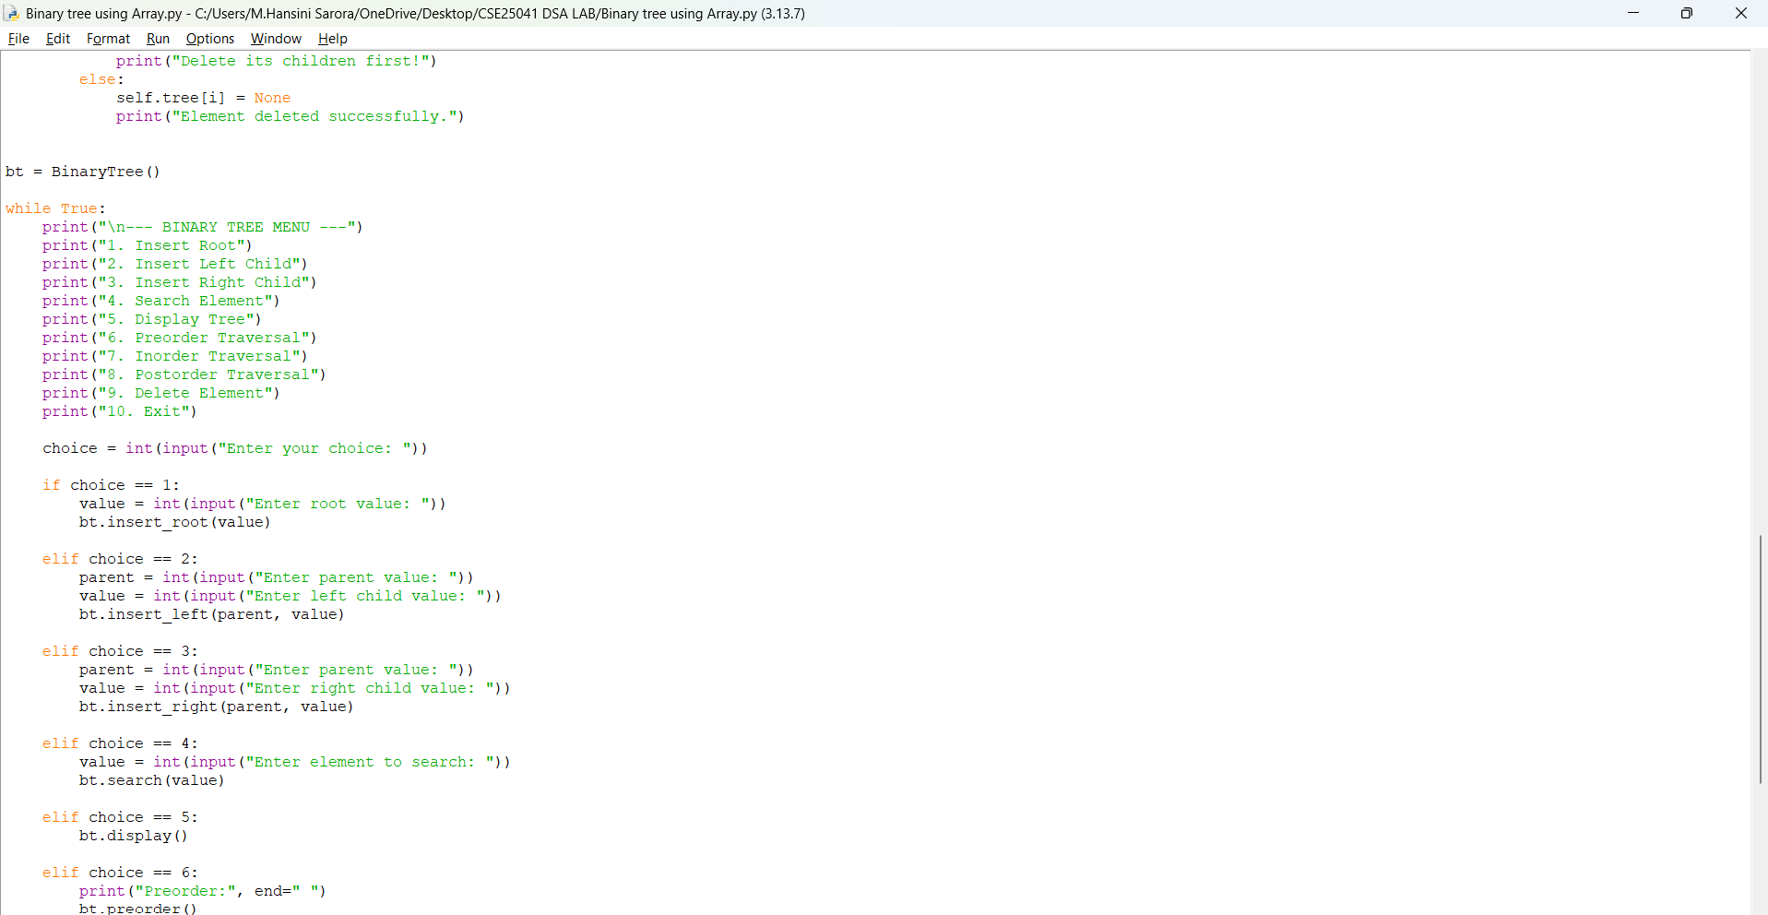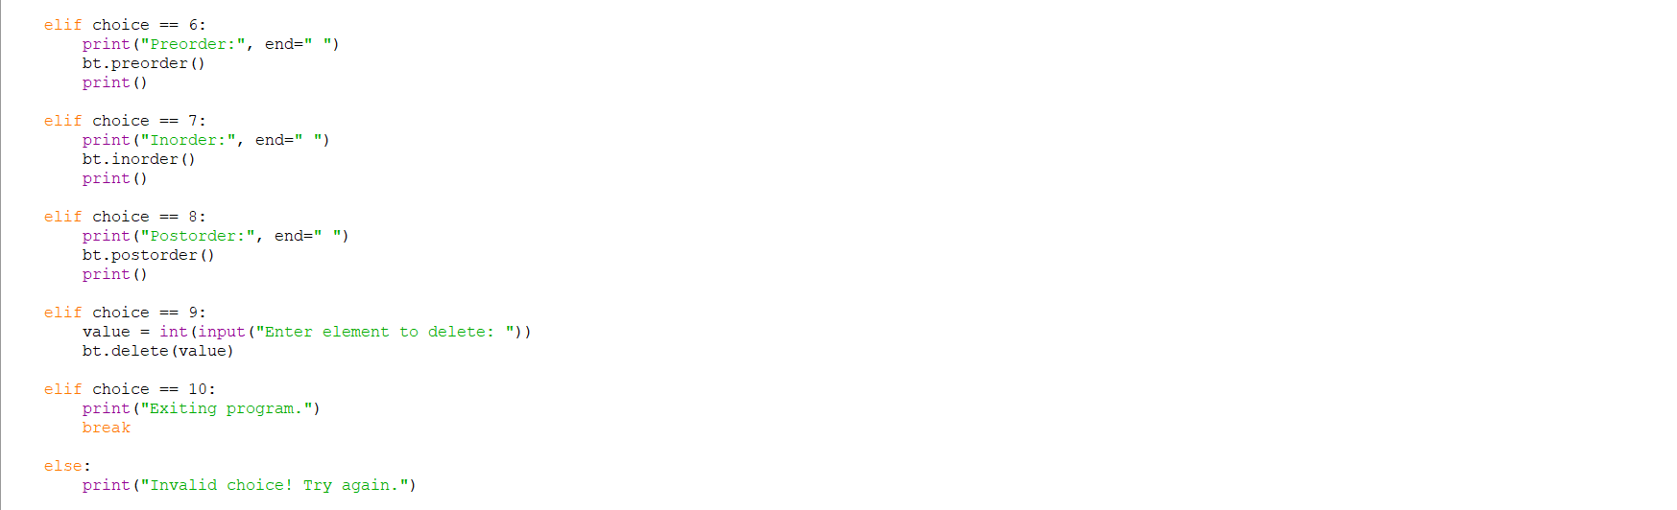

OUTPUT:
Positive Case;
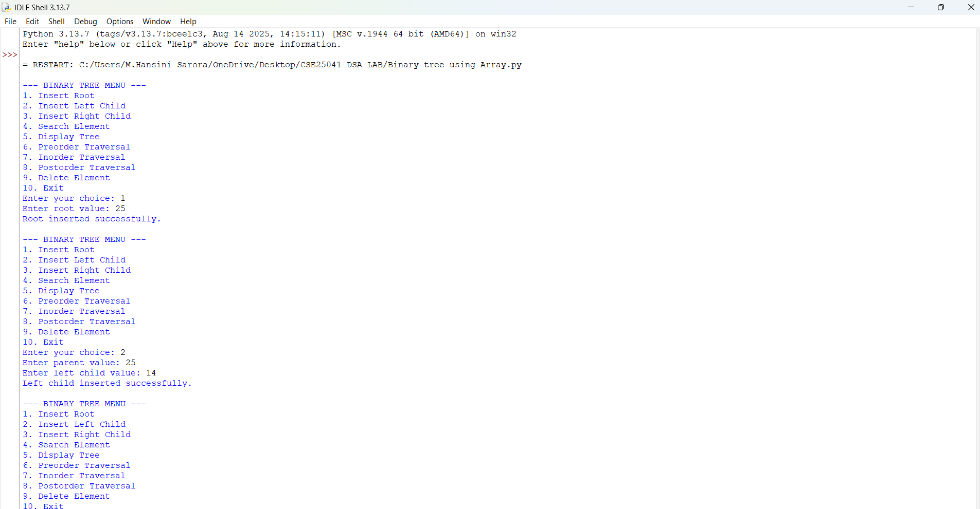
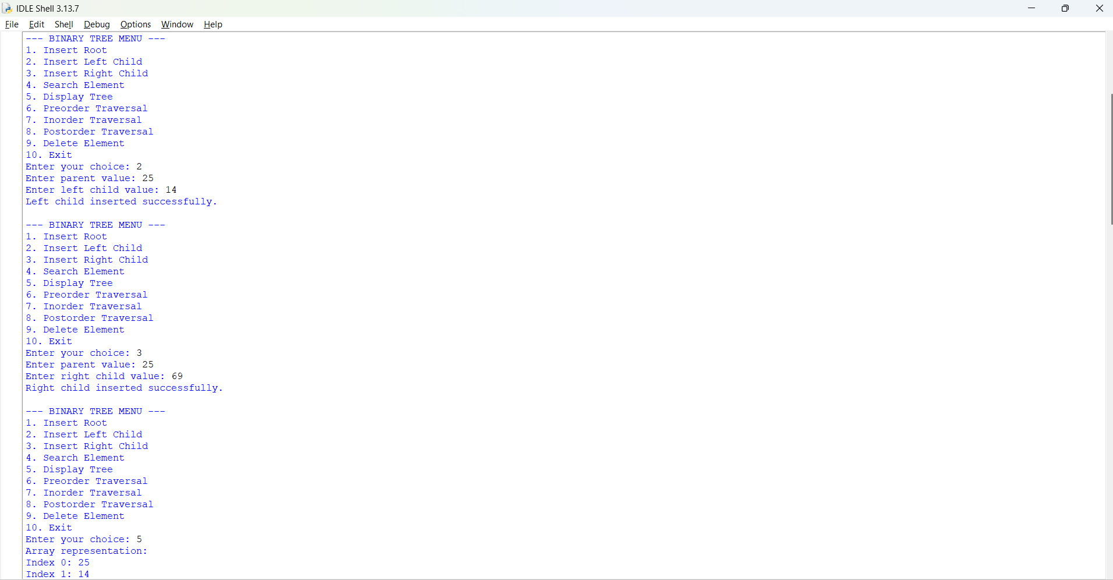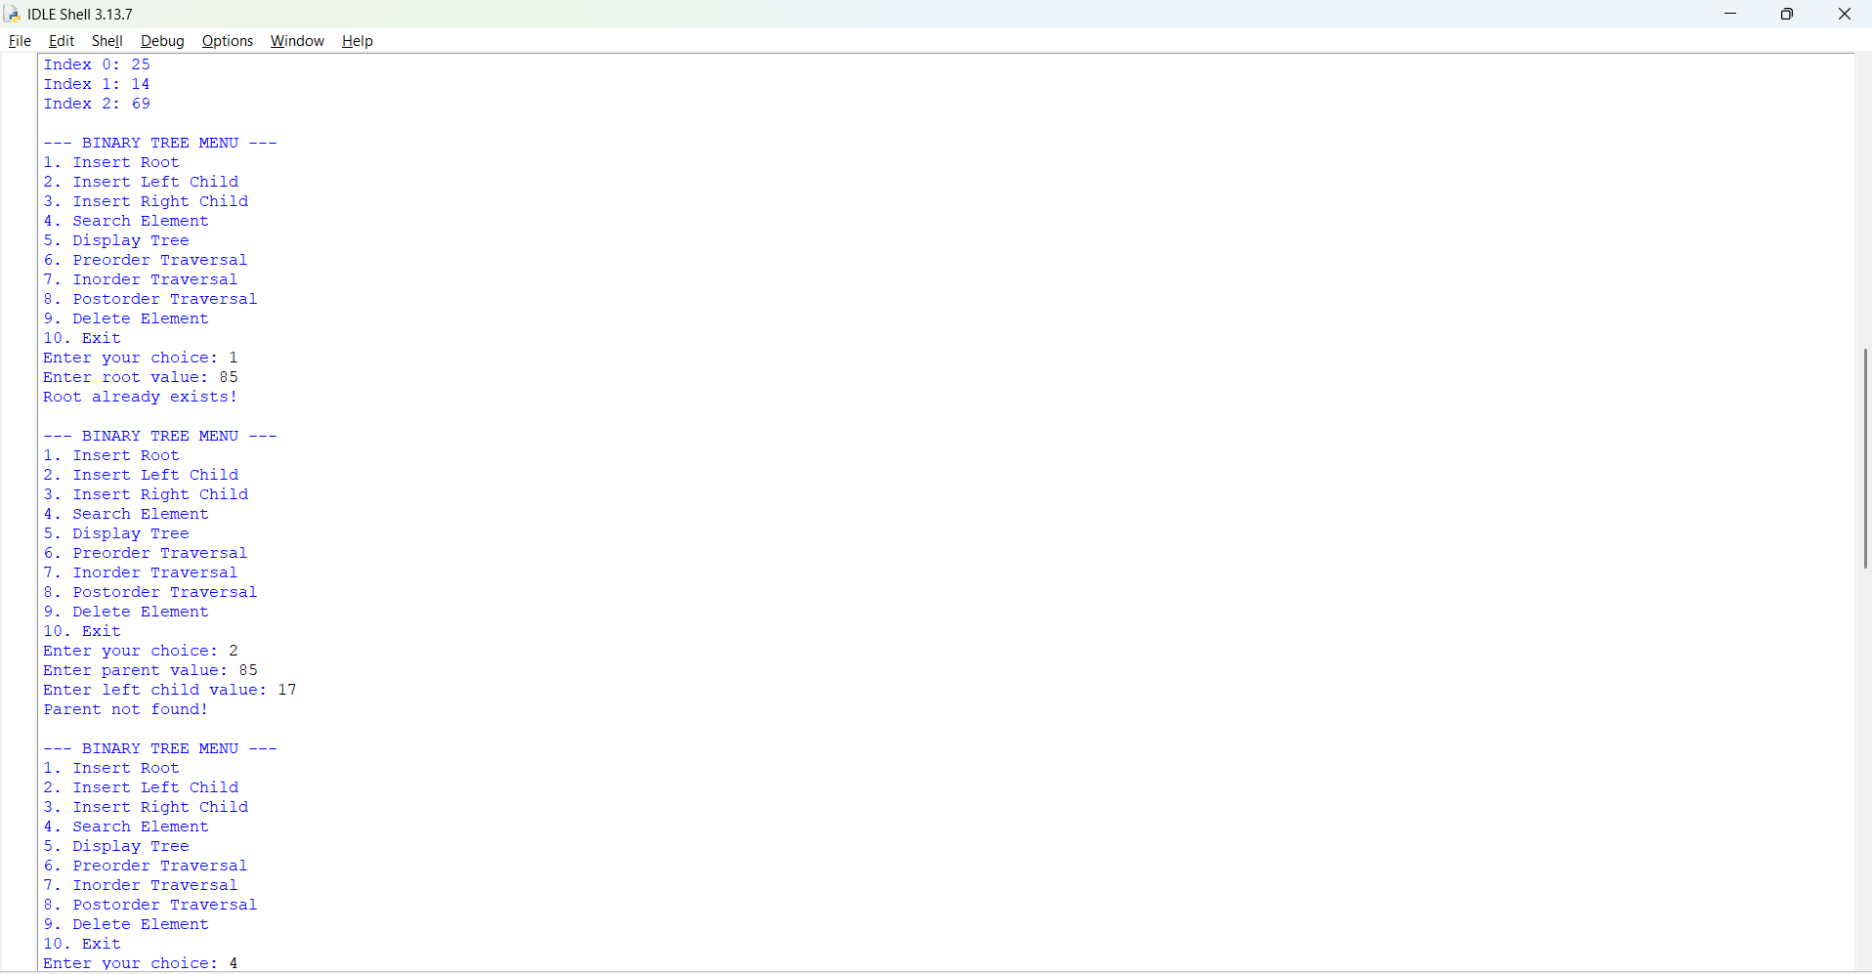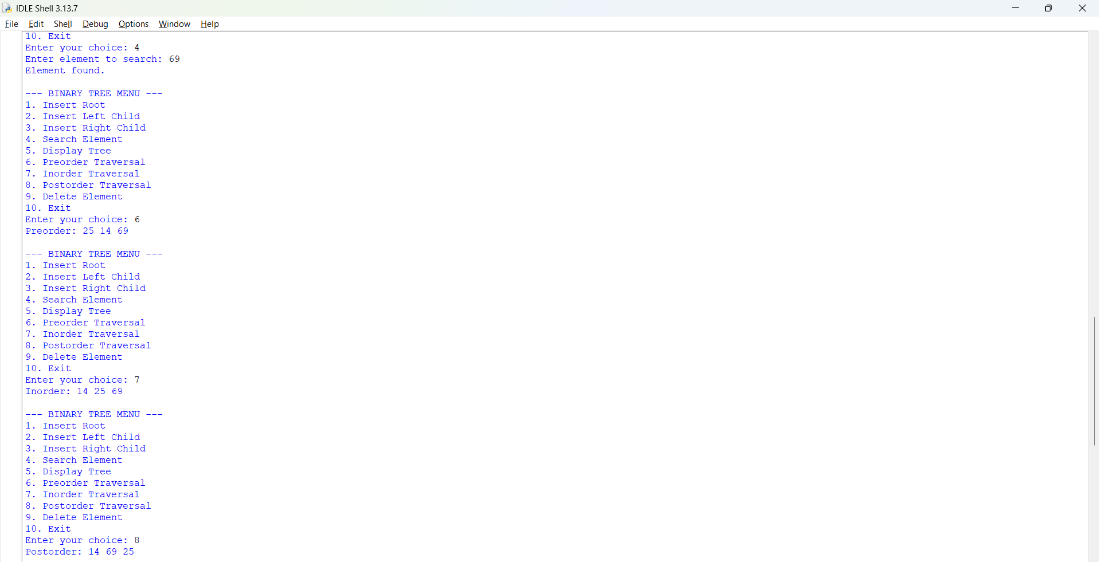
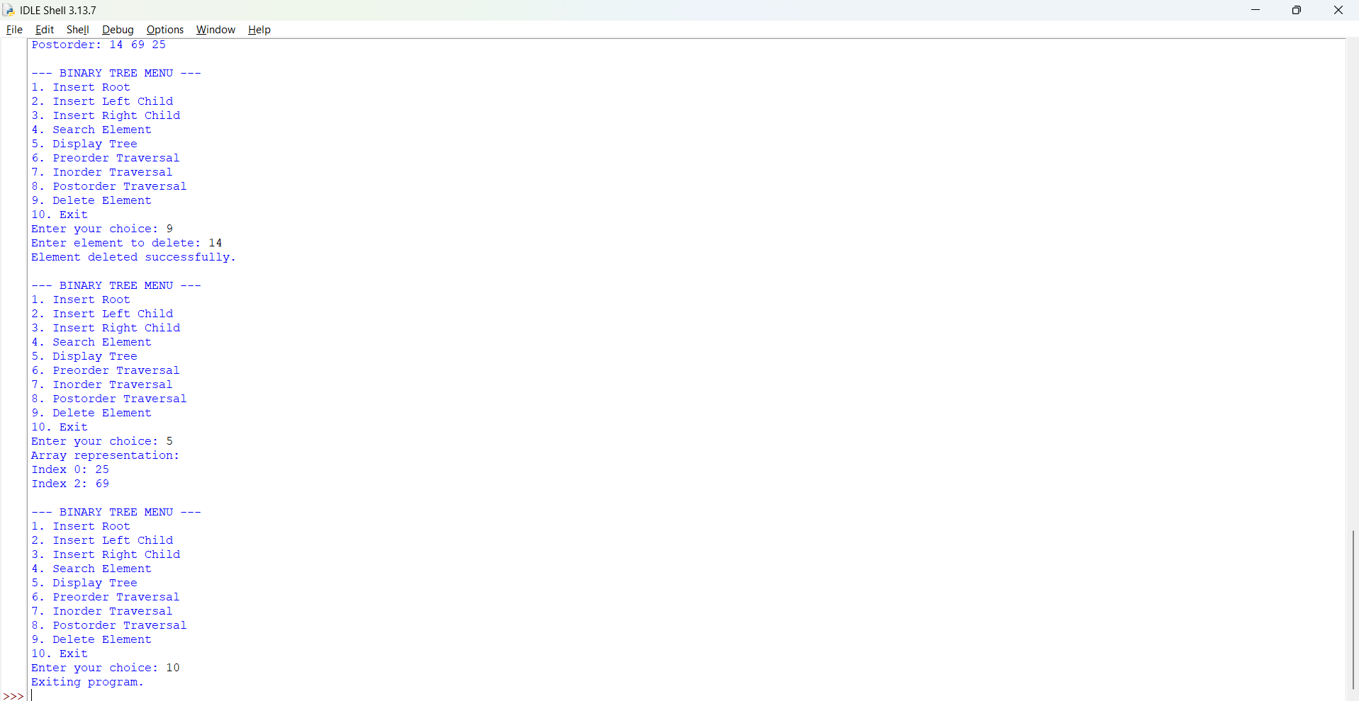
Negative Case;
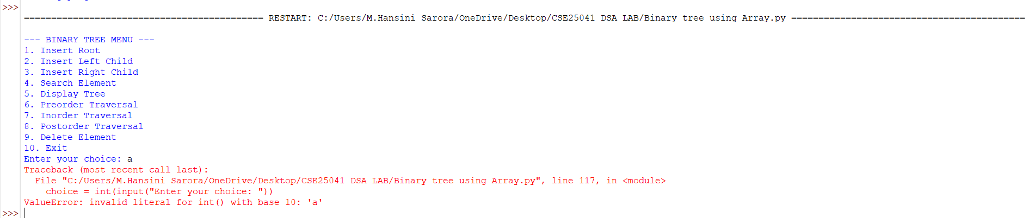

EXPLANATION:
1. Theoretical Foundation: Array-Based Binary Trees
Unlike pointer-based implementations (using nodes and references), an array-based binary tree maps nodes into a linear list (array) based on their hierarchical positions.
Assuming 0-based indexing where the root is at index 0, the relationships for any node at index i are defined mathematically:
- Left Child Index: $2×i+1$
- Right Child Index: $2×i+2$
- Parent Index: $\left(i-1\right)//2$ (integer division)
Advantages:
- No extra memory overhead for storing pointers/references.
- Direct access to children and parents using simple arithmetic.
Disadvantages:
- Fixed Size: The array capacity must be predefined (size=100), risking Array capacity exceeded errors if exceeded.
- Space Inefficiency: If the tree is skewed or sparse (e.g., a left-skewed tree), a significant portion of array elements remain None, wasting memory.
2. Breakdown of Class Methods
Initialization (__init__)
Sets up a fixed-size Python list initialized with None values to represent empty tree slots.
Insertion (insert_root, insert_left, insert_right)
- insert_root: Places the value at index 0 if it is currently vacant.
- insert_left & insert_right: First searches for the parent node's index using Python's. index() method. It then calculates the child's index ($2i+1$ or $2i+2$). Before insertion, it validates three conditions:
  - Does the parent exist?
  - Does the calculated child index stay within the array bounds (size)?
  - Is the target child position currently empty (None)?
Search & Display (search, display)
- search: Checks if the target value exists anywhere in the array using the in operator.
- display: Iterates through the list, ignoring None entries, and prints the indices and values of all active nodes.
Tree Traversals (preorder, inorder, postorder)
These are Depth-First Search (DFS) algorithms implemented recursively using array indices:
- Preorder (Root, Left, Right): Processes the current index i, then recursively visits the left child ($2i+1$) and right child ($2i+2$).
- Inorder (Left, Root, Right): Recursively visits the left child, processes the current index i, then visits the right child.
- Postorder (Left, Right, Root): Recursively visits both children before processing the current index i.
Deletion (delete)
- Locates the element's index in the array.
- Implements a strict structural constraint: A node can only be deleted if it has no children (i.e., both its left and right child positions are either out of bounds or None). If children exist, it prompts the user to delete the children first to prevent breaking sub-tree linkages.
3. Interactive Menu Loop
The while True loop provides a continuous command-line menu interface, capturing user choices (int(input)) and dispatching them to the appropriate BinaryTree methods until the user selects option 10 to exit.
7b. Linked List,
PROGRAM:
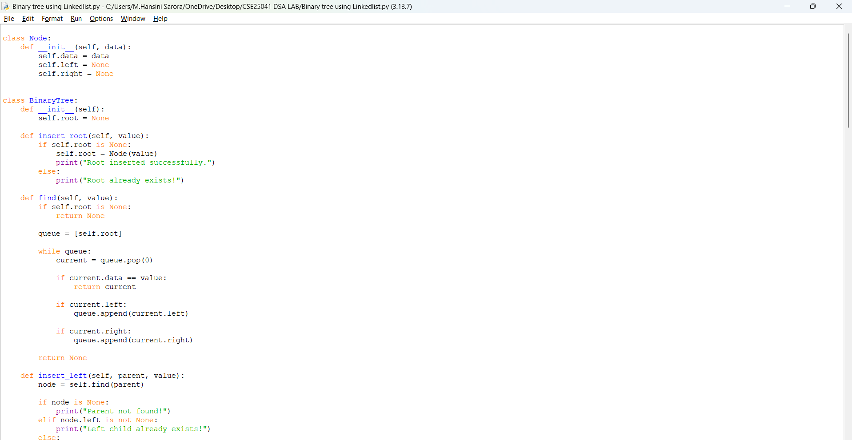
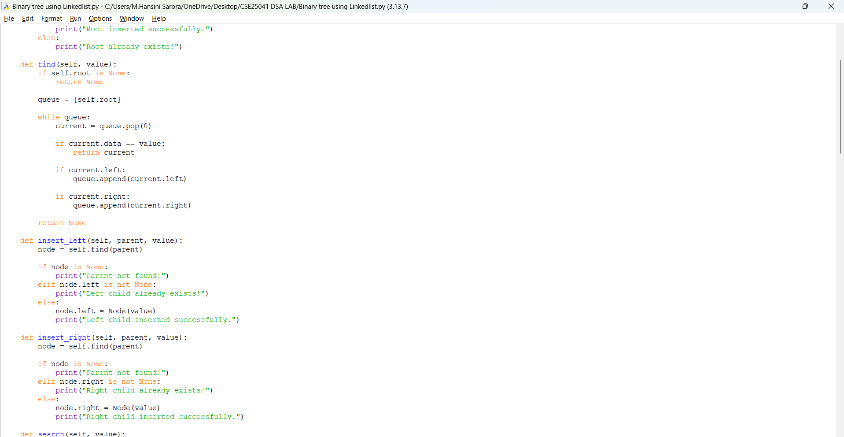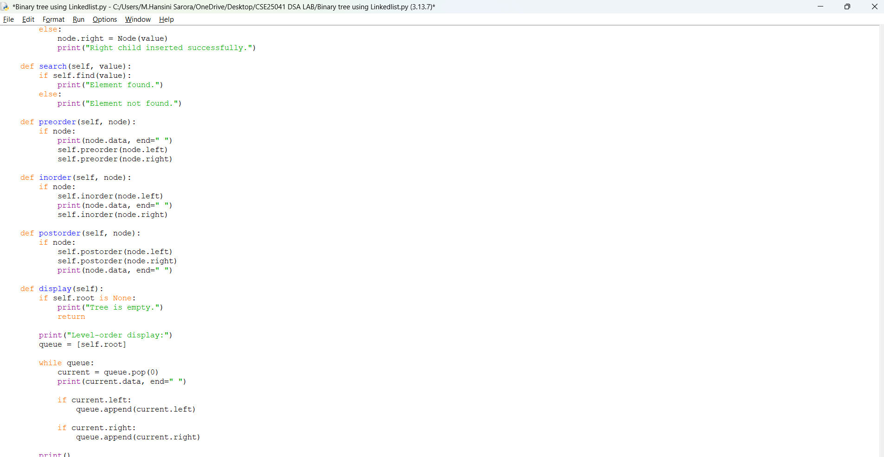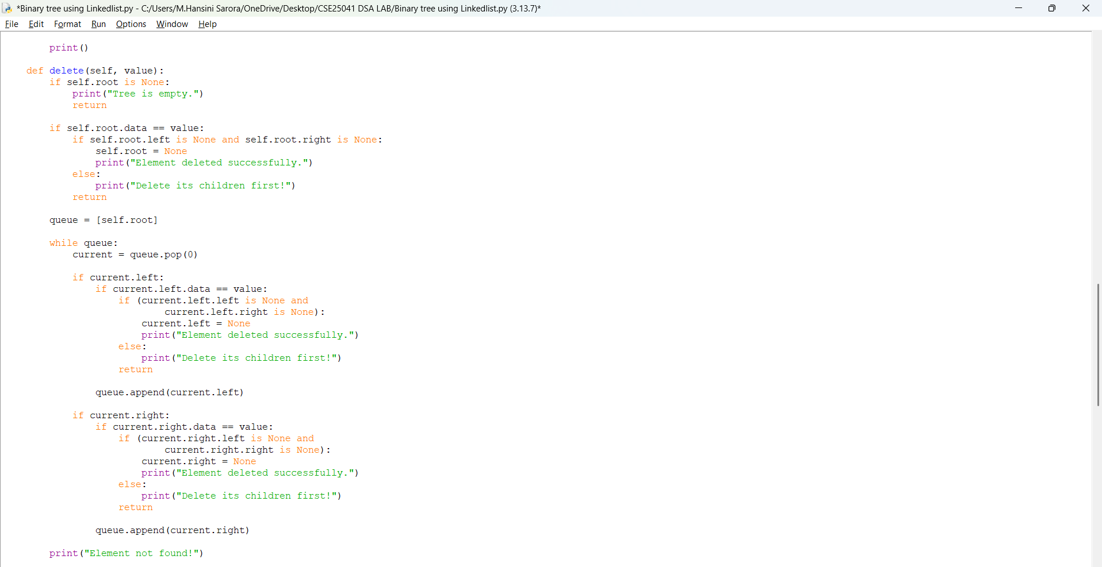
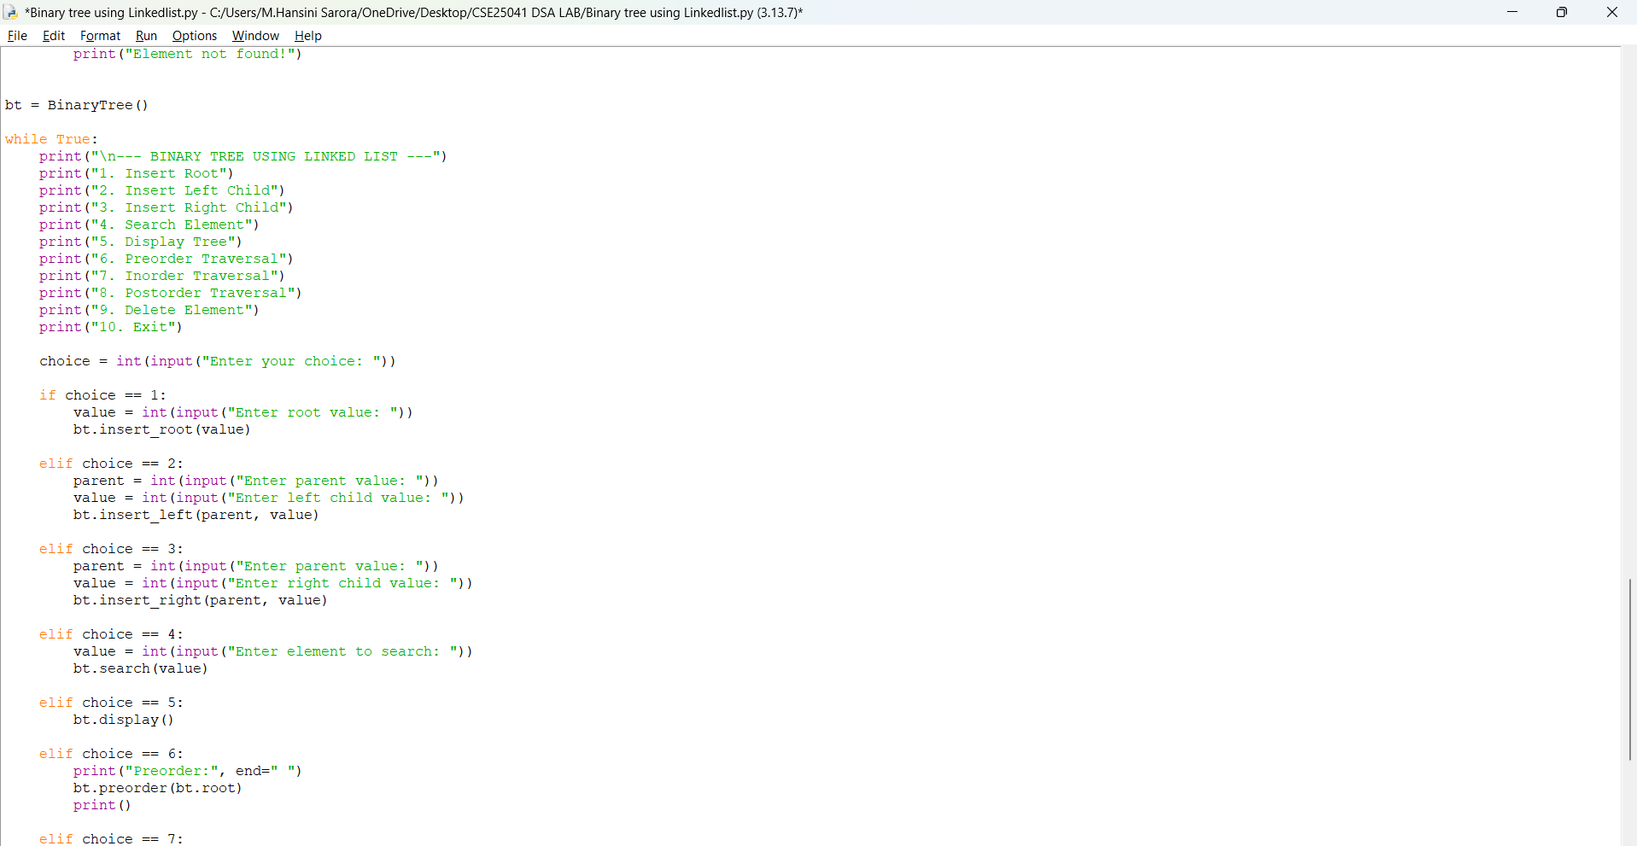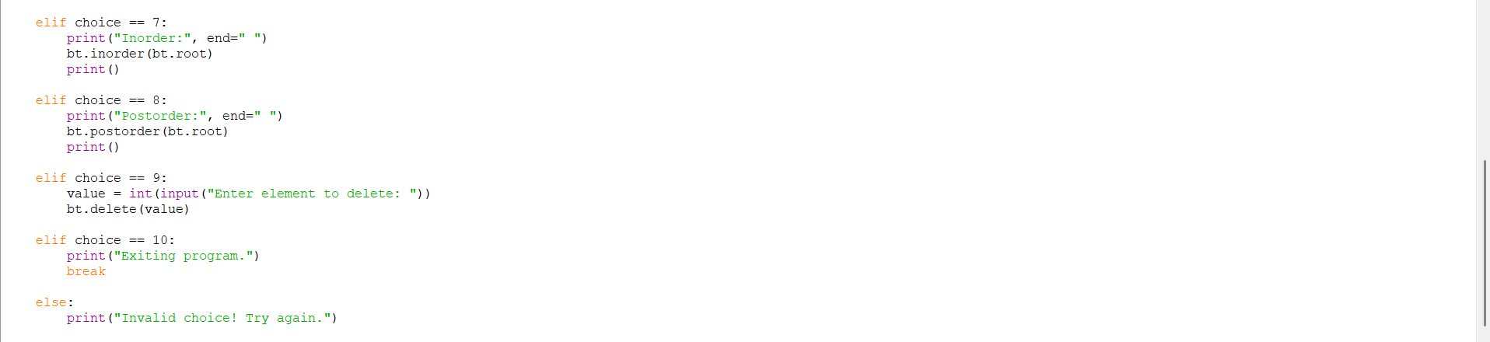

OUTPUT:
Positive Case;
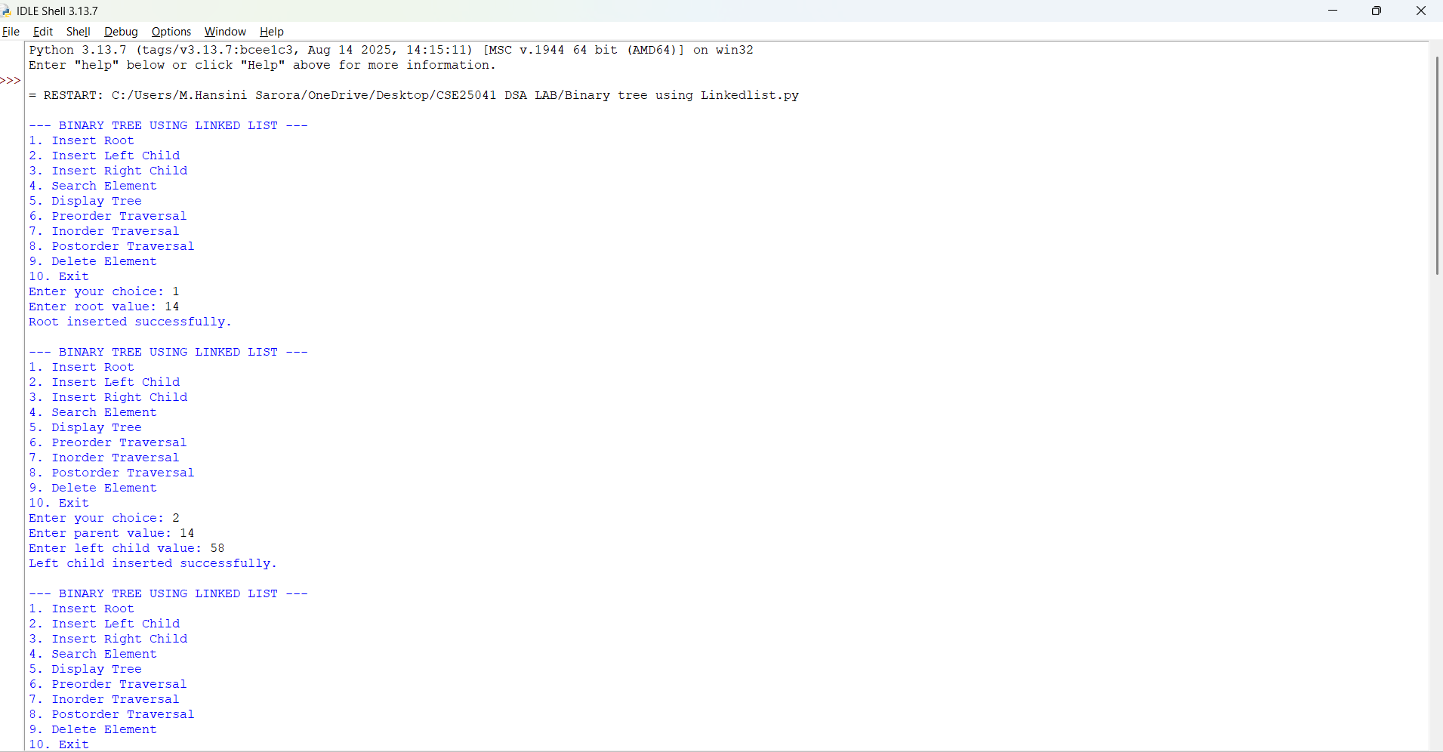
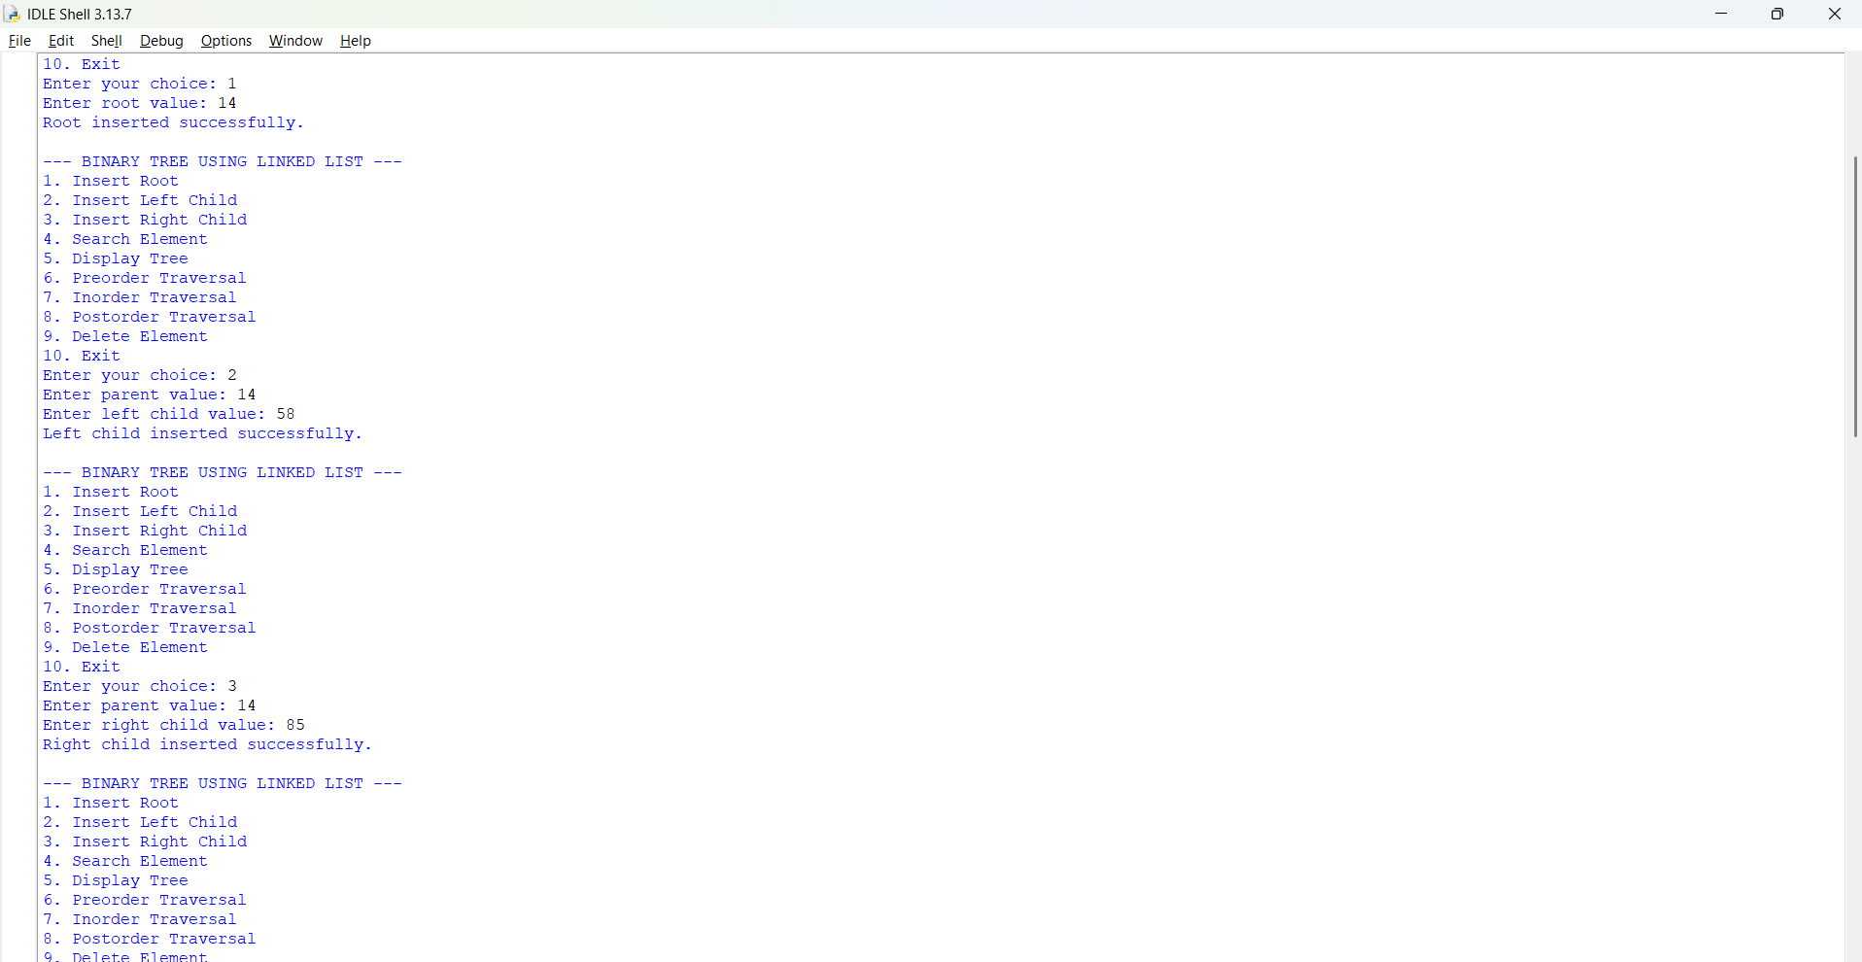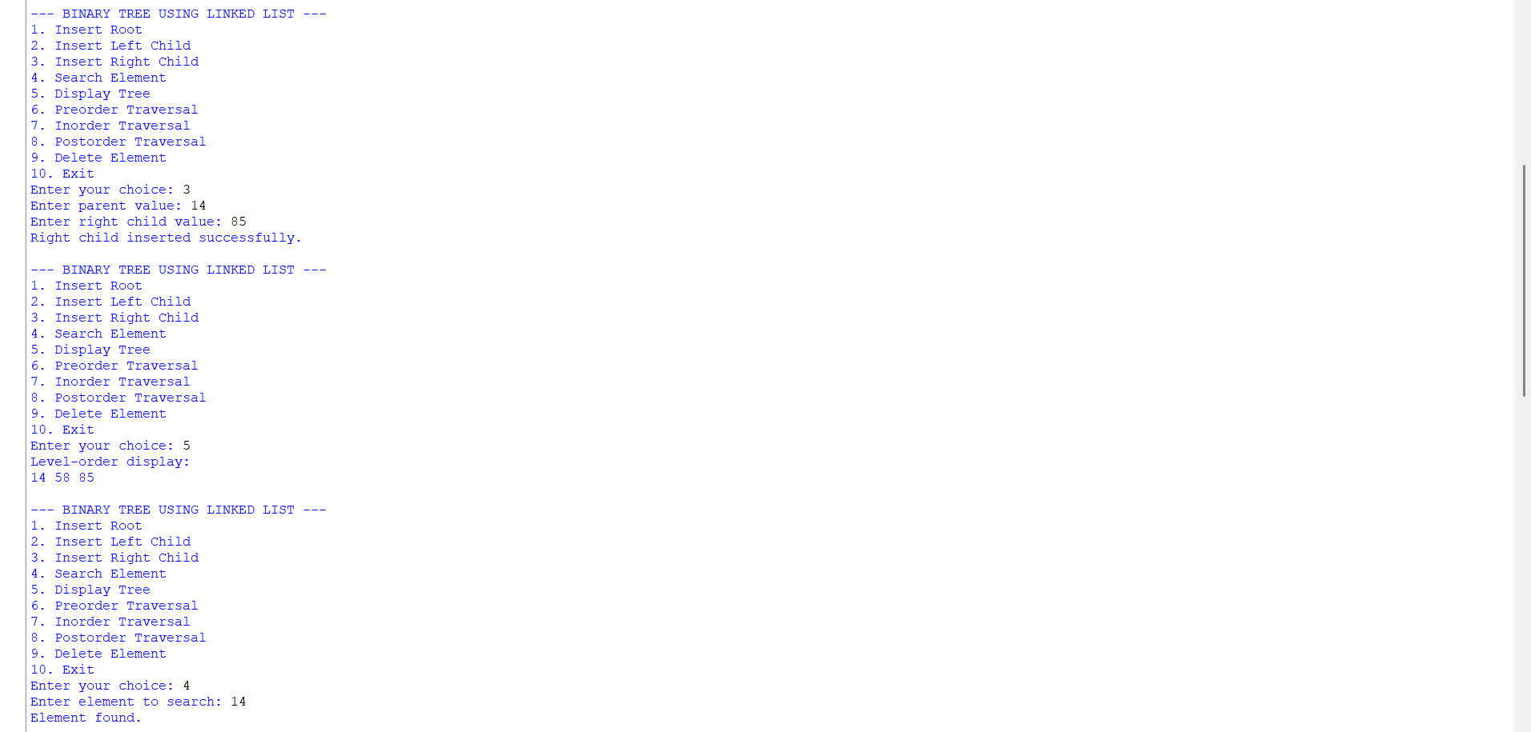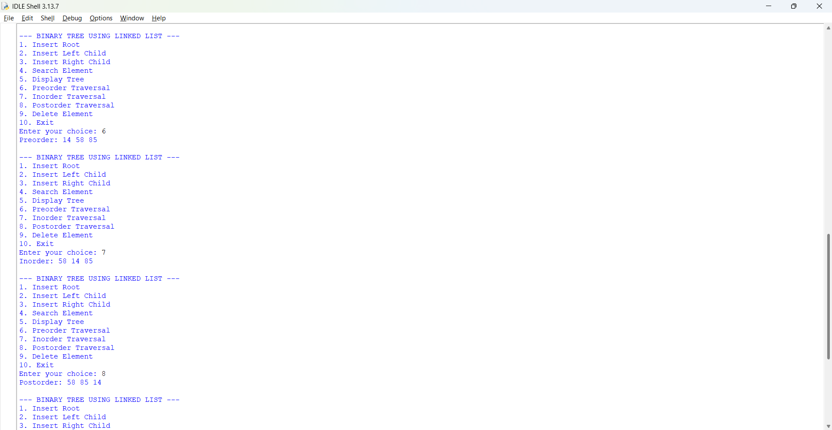
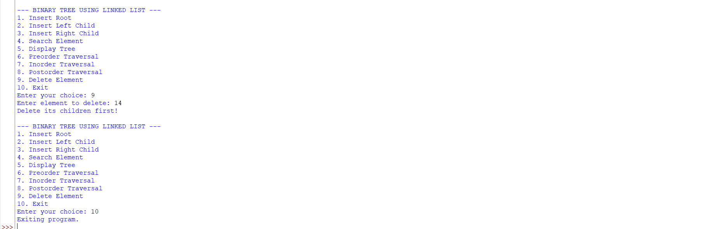
Negative Case;
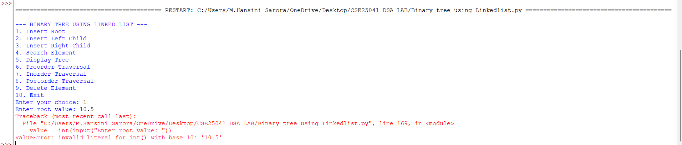
EXPLANATION:
1. Linked Representation:
Unlike the array-based approach where child and parent locations are computed using mathematical indices, a linked representation uses independent Node objects allocated dynamically in memory. Each node contains three fields:
- data: The value stored in the node.
- left: A reference (pointer) to the left child node.
- right: A reference (pointer) to the right child node.
Advantages:
- Dynamic Size: The tree can grow or shrink as needed without a predefined capacity limit.
- Memory Efficient for Sparse Trees: It only allocates memory for nodes that actually exist, avoiding wasted space.
Disadvantages:
- Extra Memory Overhead: Pointers (left and right) require additional memory space per node.
- Slower Lookups: Finding a parent node or checking a value requires searching through the tree (often $O\left(N\right)$ time complexity) because nodes do not store references back to their parents.
2. Breakdown of Classes and Key Methods
The Node Class
Acts as the basic building block, creating an independent container for data and reference pointers initialized to None.
The BinaryTree Class & Key Mechanics
- find(value) (Breadth-First Search / Level-Order Search): Since there is no index arithmetic, finding a specific node requires traversing the tree. This method uses a Queue (implemented via a Python list) to perform a level-order traversal, visiting nodes layer by layer from top to bottom until the target value is found.
- Insertion (insert_root, insert_left, insert_right):
  - insert_root creates the root node if self.root is empty.
  - insert_left and insert_right first call find(parent) to locate the parent node reference. If found and the target child slot is empty (None), a new Node is attached.
- Tree Traversals (preorder, inorder, postorder): These are recursive Depth-First Search (DFS) algorithms that take a starting node:
  - Preorder (Root, Left, Right): Visits the current node, then recursively traverses left and right subtrees.
  - Inorder (Left, Root, Right): Recursively traverses the left subtree, visits the current node, then traverses the right subtree.
  - Postorder (Left, Right, Root): Recursively traverses both subtrees before visiting the current node.
- Level-Order Display (display): Uses a queue to print all node values level by level, providing an intuitive view of the tree's hierarchical structure.
- Deletion (delete): Locates the target node via queue traversal. Just like the array version, it enforces a structural safety rule: a node can only be deleted if it is a leaf node (both its left and right pointers are None). If valid, the parent's pointer to it is severed by setting it to None.
3. Interactive Menu Loop
The while True loop runs a continuous command-line interface that captures user selections, executes the corresponding linked-tree methods, and prints status updates until option 10 is chosen to break the loop.

WEEK – 8
8. AIM: Write a python program to implement Binary Search tree with its operation.
PROGRAM:
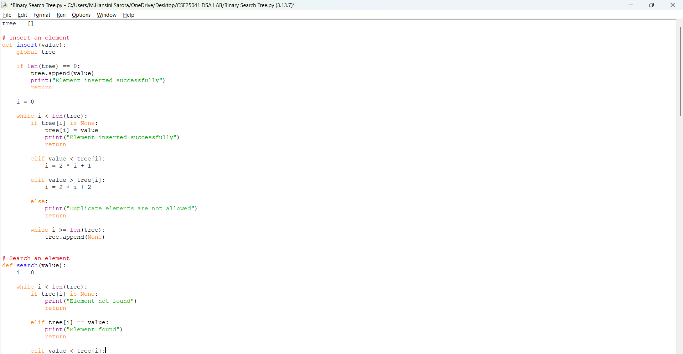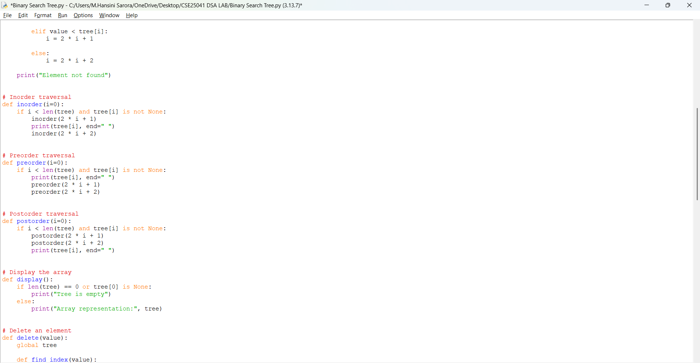

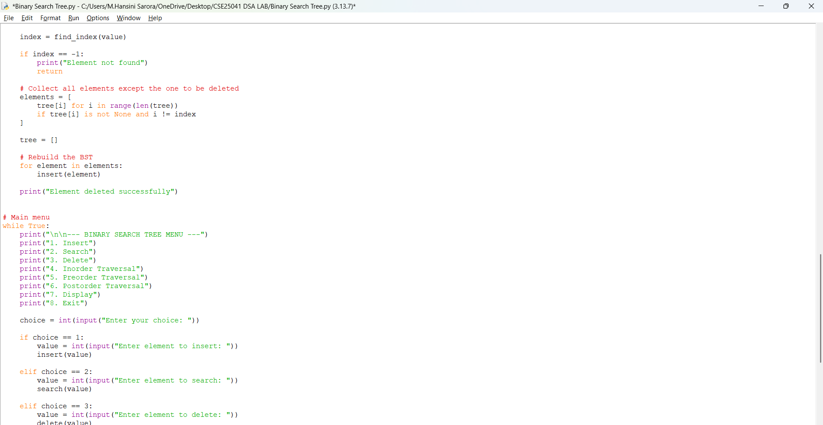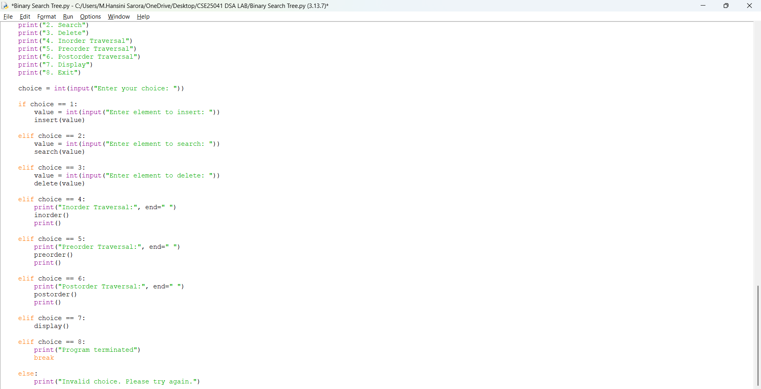
OUTPUT:
Positive Case;
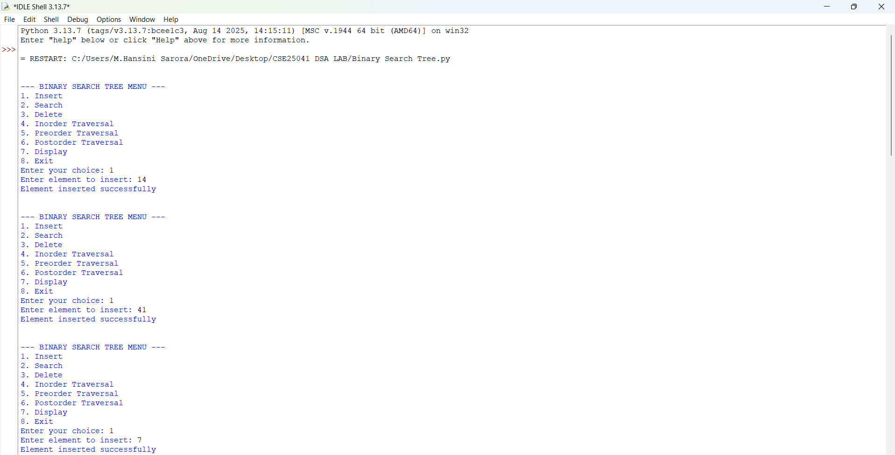
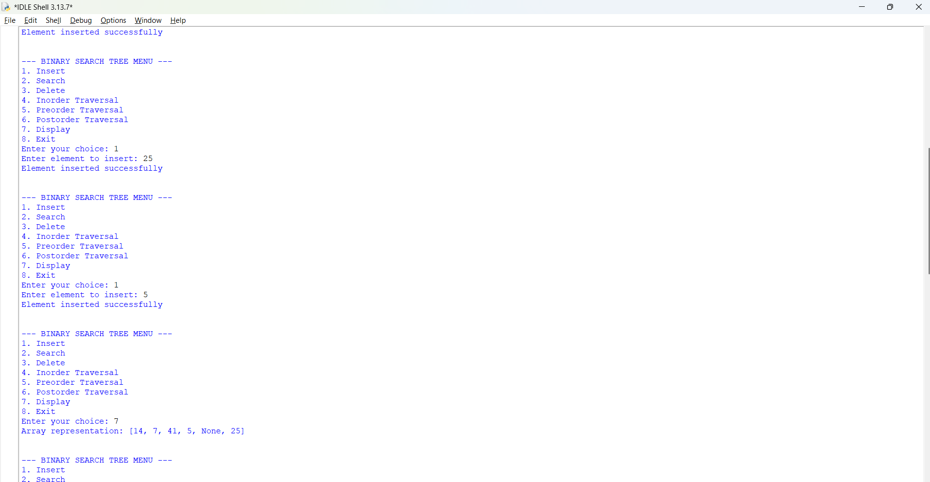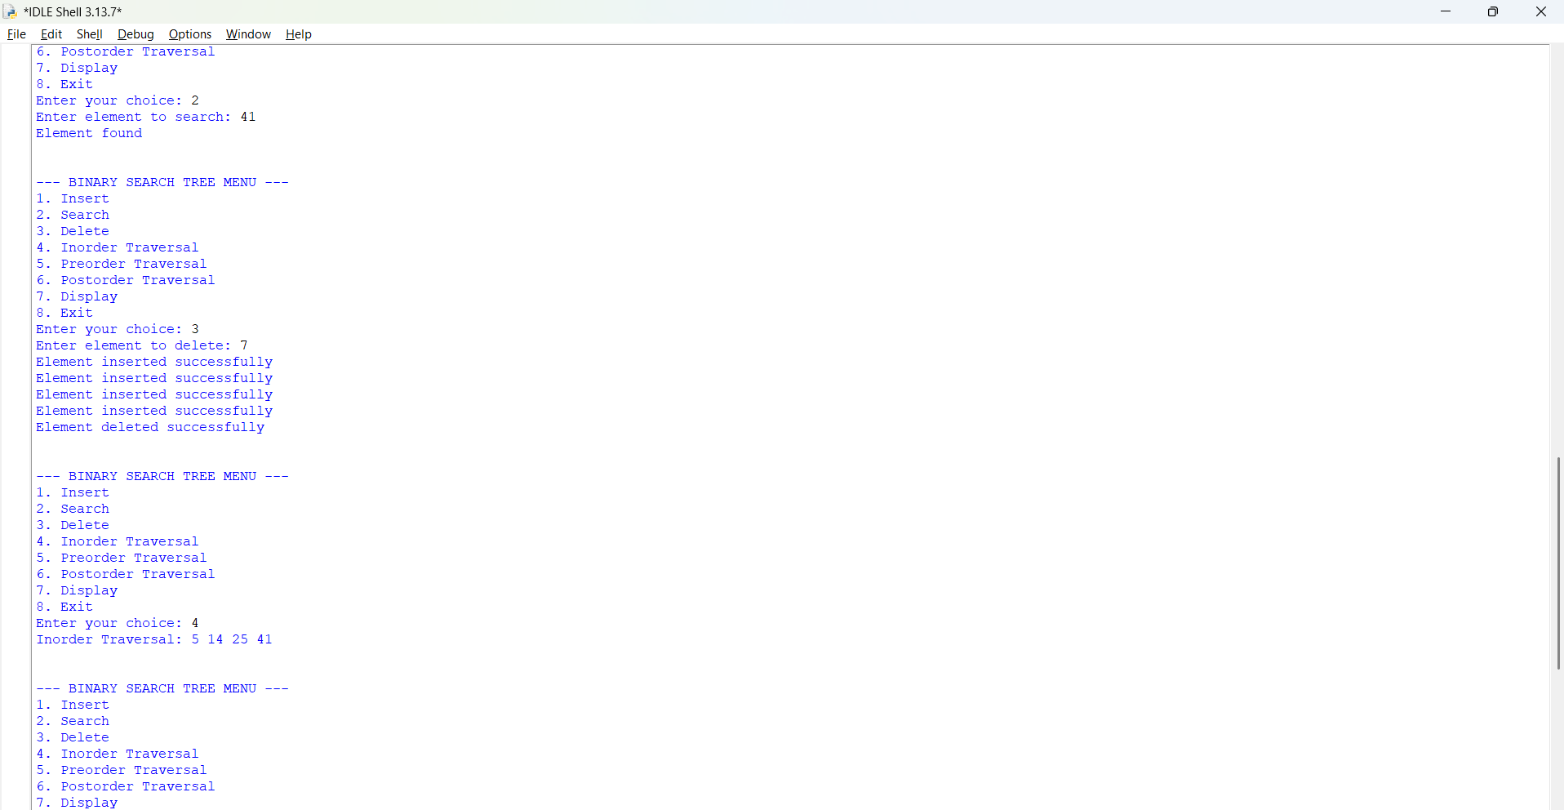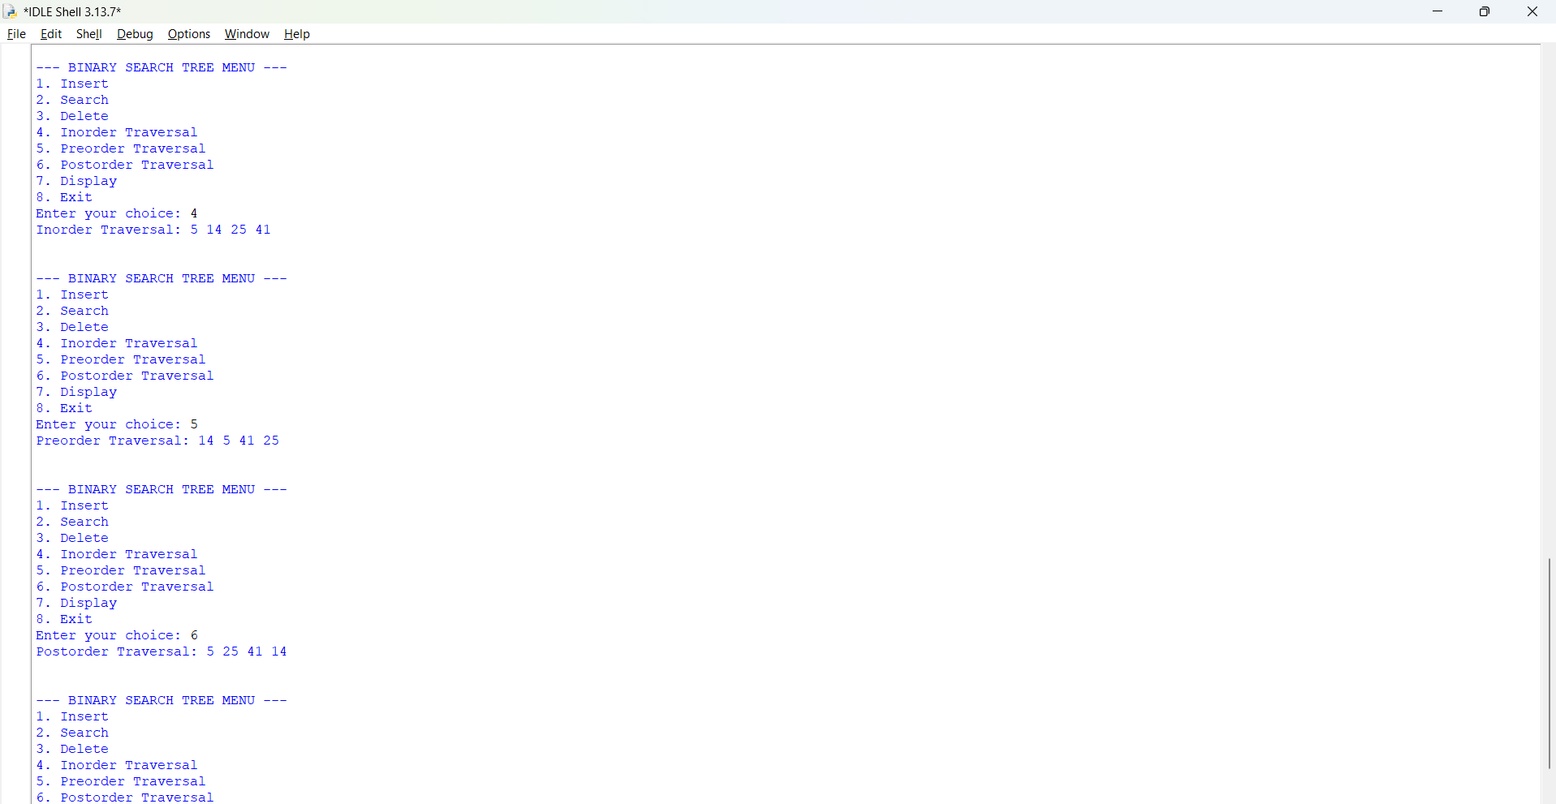
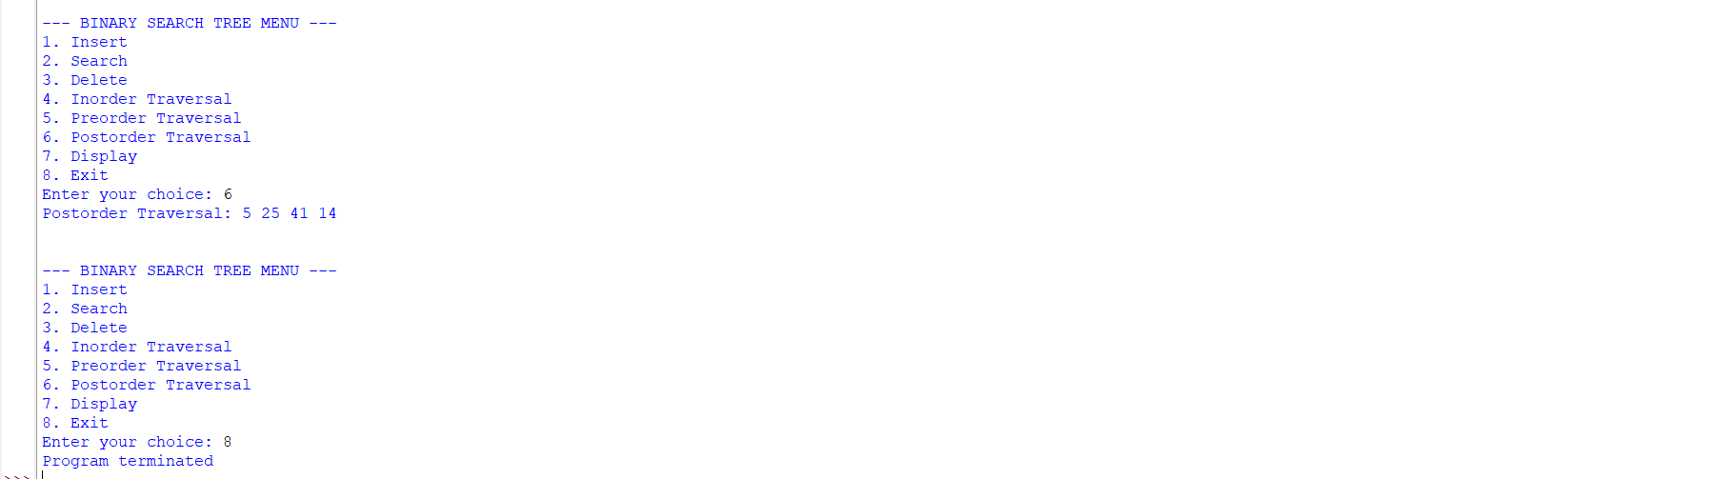
Negative Case;
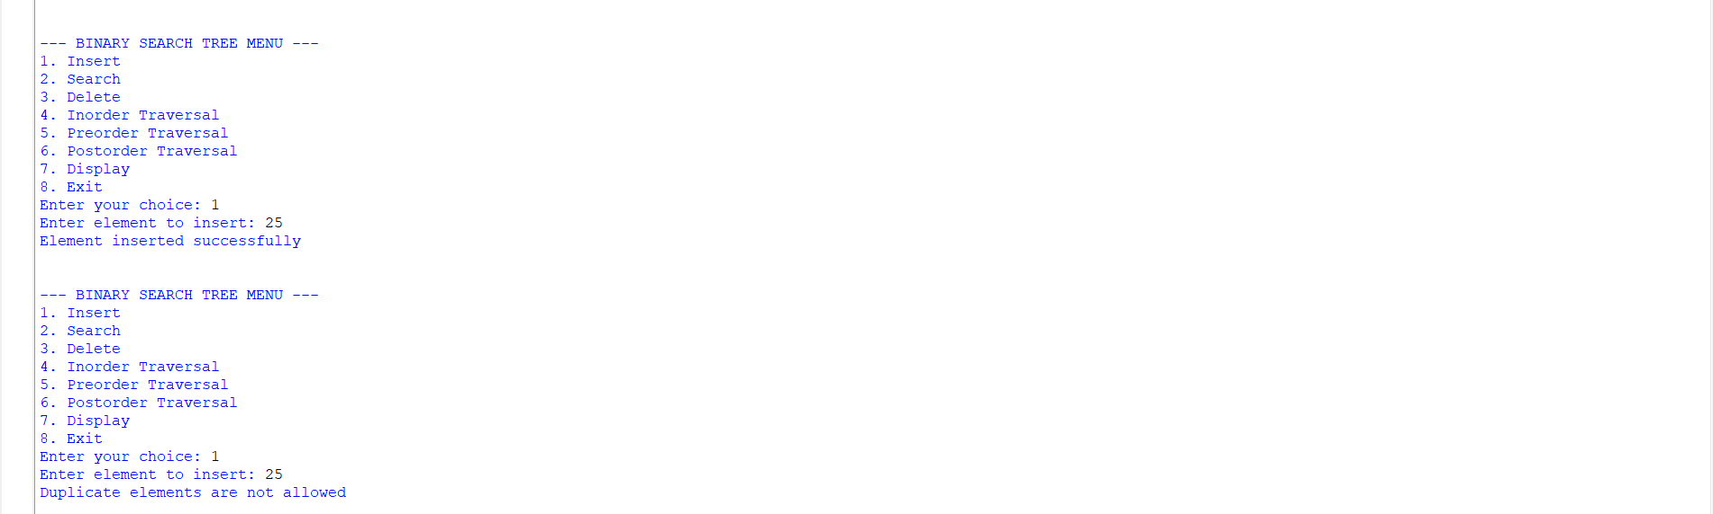
EXPLANATION:
1. Dynamic Array-Based BST:
Unlike the first fixed-size array implementation (which pre-allocated a static list of 100 elements), this version uses a dynamic array that automatically grows by appending None values whenever an insertion requires an index beyond the current list length.
It combines two core concepts:
- Binary Search Tree Property: For any given node, all elements in its left subtree are smaller, and all elements in its right subtree are larger.
- Sequential Mapping: Nodes are mapped to a linear list using the same index formulas ($2i+1$ for left child, $2i+2$ for right child), but the list expands dynamically on demand.
Advantages:
- No fixed size limits (unlike a static array).
- Maintains the arithmetic simplicity of array-based trees.
Disadvantages:
- High Memory Overhead for Sparse Trees: If the tree becomes heavily skewed (e.g., elements inserted in ascending order), the array will require massive padding with None values, consuming exponential amounts of memory relative to the number of nodes.
2. Breakdown of Key Operations
Insertion (insert)
- If the list is empty, the value becomes the root at index 0.
- Otherwise, it traverses the array using BST rules: moving to index 2 * i + 1 if the value is smaller, or 2 * i + 2 if it is larger.
- Dynamic Expansion: If the traversal index exceeds or equals the current length of the tree list (i >= len(tree)), the code enters a loop that appends None to the list until the target index becomes valid.
Search (search)
- Traverses the array using the same BST comparison logic.
- If it encounters a None slot or reaches the end of the array without finding the value, it concludes that the element is absent.
Traversals (inorder, preorder, postorder)
- Implemented recursively using array index formulas.
- Because it is a BST, an Inorder traversal naturally prints elements in sorted ascending order.
Deletion (delete)
Instead of handling complex pointer rewiring or structural rebalancing (like standard BST node deletion), this program uses a clever re-insertion strategy:
- It finds the index of the target value.
- If found, it extracts all valid (non-None) elements from the tree except the target value into a temporary list.
- It resets the tree to an empty list (tree = []).
- It loops through the remaining elements and re-inserts them one by one using the insert () function, effectively rebuilding a valid BST without the deleted node.
3. Interactive Menu Loop
The while True loop provides a continuous command-line interface, capturing user selections and executing the corresponding tree operations until option 8 is chosen to terminate the program.

